**MINISTRY OF EDUCATION AND TRAINING**

**FPT UNIVERSITY**

Capstone Project Document

**Office Task Management**

|  |  |
| --- | --- |
| **Group 3** | |
| **Group member** | Nguyen Cu Dat – SE61010  Lu Cam Toan – SE60633  Le Hai Trieu - SE61146  Tran Thi Kim Anh – SE60909 |
| **Supervisor** | Mr. Lai Duc Hung |
| **Ext. Supervisor** | N/A |
| **Capstone Project code** | OTM |

-Ho Chi Minh City, 13/05/2015-

*We would like to say thank you to all of my lecturers who have supported us to finish this project.*

# Table of Contents

Table of Contents 3

List of Tables 7

List of Figures 12

Definitions, Acronyms, and Abbreviations 16

A. Introduction 17

1. Project Information 17

2. Introduction 17

3. Current Situation 17

4. Problem Definition 17

5. Proposed Solution 18

5.1 Feature functions 18

5.2 Advantage and disadvantage 18

6. Functional Requirement 19

6.1 Administrative Access 19

6.2 Project Management 19

6.3 Create Function 19

6.4 Update Function 19

6.5 Task Management 19

6.6 Review and Approve task with Files 20

6.7 Group discussion 20

6.8 Report 21

6.9 Assessment 21

7. Role and Responsibility 22

B. Software Project Management Plan 23

1. Problem Definition 23

1.1 Name of this Capstone project 23

1.2 Problem Abstract 23

1.3 Project Overview 23

2. Project organization 25

2.1 Software Process Model 25

2.2 Roles and responsibilities 26

2.3 Tools and Techniques 27

3. Project Management Plan 27

3.1 Software development life cycle 28

3.2 Phase Detail 29

3.3 All Meeting Minutes 31

4. Coding Convention 31

C. Software Requirement Specification 33

1. User Requirement Specification 33

1.1 Guest Requirement 33

1.2 Admin Requirement 33

1.3 Director Requirement 33

1.4 Manager Requirement 33

1.5 Staff Requirement 34

2. System Requirement Specification 34

2.1 External Interface Requirement 34

2.2 System Overview Use Case 34

2.3 List of Use Case 35

3. Software System Attribute 130

3.1 Usability 130

3.2 Reliability 130

3.3 Availability 130

3.4 Security 130

3.5 Maintainability 130

3.6 Portability 130

3.7 Performance 130

4. Conceptual Diagram 131

D. Software Design Description 133

1. Design Overview 133

2. System Architectural Design 133

2.1 Web application architecture description 134

2.2 Mobile application architecture description 134

3. Component Diagram 135

4. Detailed Description 136

4.1 Class Diagram 136

4.2 Class Diagram Explanation 137

4.3 Interaction Diagram 147

5. User Interface Design 172

5.1 Guest Interface Design 172

5.2 Admin Interface Design 173

5.3 Director Interface Design 178

5.4 Manager Interface Design 184

5.5 Staff Interface Design 193

6. Database Design 196

6.1 Logical Diagram 196

6.2 Data Dictionary 196

7. Algorithms 204

7.1 Alternating Decision Tree 204

E. System Implementation & Test 208

1. Introduction 208

1.1 Overview 208

1.2 Test Approach 208

2. Database Relationship Diagram 209

2.1 Physical Diagram 209

2.2 Data Dictionary 209

3. Performance Measures 210

3.1 Assign Performance 210

4. Test Plan 210

4.1 Features to be tested 210

4.2 Features not to be tested 211

5. System Testing Test Case 211

5.1 <Guest> Login 213

5.2 <Guest> Reset Password 216

5.3 <User> Logout 217

5.4 Admin Test Case 218

5.5 Project Flow: 239

5.6 Task Flow: 256

F. ソフトウェアユーザーマニュアル（日本語） 273

1. インストレーションガイド 273

1.1 サーバー側で環境を設定 273

1.2 サーバー側での展開 274

1.3 クライアント側の環境を設定する 276

2. アプリケーションのユーザーガイド 276

2.1 ウェブサイトのガイド 276

2.2 Androidデバイスのガイド 287

G. Software User’s Manual (English) 292

1. Installation Guide: 292

1.1 Set the environment on server 292

1.2 Deployment on server: 292

1.3 Configure the client environment: 294

2. Application User Guide 294

2.1 Website guide: 294

2.2 Android device: 304

H. Appendix 309

# List of Tables

Table 1: Role and Responsibility 22

Table 2: <Hardware Requirements> Server 25

Table 3: <Hardware Requirement> Mobile 25

Table 4: <Project Organization> Role and Responsibility 27

Table 5: Software Development Life Cycle 29

Table 6: <Phase Detail> Phase 1 30

Table 7: <Phase Detail> Phase 2 30

Table 8: <Phase Detail> Phase 3 31

Table 9: <Phase Detail> Phase 4 31

Table 10: <Phase Detail> Phase 5 31

Table 11: <Phase Detail> Phase 6 31

Table 12: <Use Case> Login 37

Table 13: < Use Case > Reset Password 39

Table 14:< Use Case > Search Account 42

Table 15:< Use Case > Add Account 44

Table 16: < Use Case > Edit Account 46

Table 17: < Use Case > Search Skills 47

Table 18: < Use Case > Add Skill 49

Table 19: < Use Case > Update Skill 51

Table 20: < Use Case > Update Category 53

Table 21: < Use Case > Add Category 55

Table 22: < Use Case > Search Criterion 56

Table 23: < Use Case > Create Criterion 58

Table 24: < Use Case > Edit Criterion 60

Table 25: < Use Case > Edit Period Assessment 62

Table 26: < Use Case > Create Project 65

Table 27: < Use Case > Edit Project 67

Table 28: < Use Case > Close and Assess Project 69

Table 29: < Use Case > Remove Project 70

Table 30: < Use Case > View Report of Work 72

Table 31: < Use Case > Search Assessments 74

Table 32: < Use Case > Search Period Assessment 76

Table 33: < Use Case > Create Period Assessment 79

Table 34: < Use Case > Edit Period Assessment 82

Table 35: < Use Case > Edit Period Assessment 84

Table 36: < Use Case > Add Staffs into Project 87

Table 37: < Use Case > Remove Staffs from Project 89

Table 38: < Use Case > Start Project 90

Table 39: < Use Case > Create Task 93

Table 40: < Use Case > Edit Task 95

Table 41: < Use Case > Approve and Assess Task 98

Table 42: < Use Case > Remove Task 99

Table 43: < Use Case > Add Assessment 101

Table 44: < Use Case > Edit Assessment 104

Table 45: < Use Case > View Report of Work 106

Table 46: < Use Case > Review Employee Assessment 109

Table 47: < Use Case > View Task Detail 111

Table 48: < Use Case > Update Task 113

Table 49: < Use Case > Logout 115

Table 50: < Use Case >Edit Profile 117

Table 51: < Use Case > Search Topic 118

Use Case 52: < Use Case > Add Topic 121

Table 53: < Use Case > Post Comment 122

Table 54: < Use Case > Search Tasks 124

Table 55: < Use Case > View All Tasks 125

Table 56: < Use Case > View Project Detail 130

Table 57: <Conceptual Diagram> Dictionary 132

Table 58: <Component> Description 135

Table 59: <Class diagram> Dictionary 137

Table 60: <Employee> Attribute 138

Table 61: <Employee> Method 138

Table 62: <Project> Attribute 139

Table 63: <Project> Method 139

Table 64: <Project Member> Attribute 139

Table 65: <Project Member> Method 139

Table 66: <Task> Attribute 140

Table 67: <Task> Method 140

Table 68: <Role> Attribute 140

Table 69: <Role> Method 140

Table 70: <Task change log> Attribute 141

Table 71: <Task Changelog> Method 141

Table 72: <Topic> Attribute 141

Table 73: <Topic> Method 141

Table 74: <Topic Comment> Attribute 142

Table 75: <Topic Comment> Method 142

Table 76: <Task Comment> Attribute 142

Table 77: <Task Comment> Method 142

Table 78: <File> Attribute 143

Table 79: <File> Method 143

Table 80: <Comment File> Attribute 143

Table 81: <Comment File> Method 143

Table 82: <Assessment Result> Attribute 144

Table 83: <Assessment Result> Method 144

Table 84: <Employee Assessment> Attribute 144

Table 85: <Employee Assessment> Method 144

Table 86: <Period Assessment> Attribute 145

Table 87: <Period Assessment> Method 145

Table 88: <Skill> Attribute 145

Table 89: <Skill> Method 145

Table 90: <Category> Attribute 146

Table 91: <Category> Method 146

Table 92: <Criterion> Attribute 146

Table 93: <Criterion> Method 146

Table 94: <Criterion> Attribute 146

Table 95: <Criterion> Method 147

Table 96: <PeriodCriterion> Attribute 147

Table 97: <PeriodCriterion> Method 147

Table 98: <AssessmentDetail> Attribute 147

Table 99: <AssessmentDetail> Method 147

Table 100: <Notification> Activity Diagram Description 172

Table 101: <Interface-Fields> Login 172

Table 102: <Interface-Buttons/Hyperlinks> Login 173

Table 103: < Interface-Fields > Reset Password 173

Table 104: <Interface-Buttons/Hyperlinks> Reset Password 173

Table 105: < Interface-Fields > Add Account 174

Table 106: <Interface-Buttons/Hyperlinks> Add Account 174

Table 107: < Interface-Fields > Add Skill 175

Table 108: <Interface-Buttons/Hyperlinks> Add Skill 175

Table 109: < Interface-Fields > Add Category 176

Table 110: <Interface-Buttons/Hyperlinks> Add Category 176

Table 111: < Interface-Fields > Add Period Assessment 177

Table 112: <Interface-Buttons/Hyperlinks> Add Period Assessment 177

Table 113: < Interface-Fields > Add Criterion 178

Table 114: <Interface-Buttons/Hyperlinks> Add Criterion 178

Table 115: < Interface-Fields > Project 179

Table 116: <Interface-Buttons/Hyperlinks> Project 179

Table 117: <Interface-Buttons/Hyperlinks> 180

Table 118: < Interface-Fields > Create Project 181

Table 119: <Interface-Buttons/Hyperlinks> Create Project 181

Table 120: < Interface-Fields > Edit Project 183

Table 121: <Interface-Buttons/Hyperlinks> Edit Project 183

Table 122: < Interface-Fields > View Report of Project 183

Table 123: <Interface-Buttons/Hyperlinks> View Report of Project 183

Table 124: < Interface-Fields > Close and Assess Project 184

Table 125: <Interface-Buttons/Hyperlinks> Close and Assess Project 184

Table 126: < Interface-Fields > Dashboard Manager 184

Table 127: <Interface-Buttons/Hyperlinks> Dashboard Manager 185

Table 128: < Interface-Fields > Create Task 186

Table 129: <Interface-Buttons/Hyperlinks> Create Task 186

Table 130: < Interface-Fields > Edit Task 188

Table 131: <Interface-Buttons/Hyperlinks> Edit Task 188

Table 132: <Interface-Buttons/Hyperlinks> Task Detail 189

Table 133: < Interface-Fields > View Report of Task 189

Table 134: <Interface-Buttons/Hyperlinks> View Report of Task 189

Table 135: < Interface-Fields > Approve and Assess Task 190

Table 136: <Interface-Buttons/Hyperlinks> Approve and Assess Task 190

Table 137: < Interface-Fields > Add Assessment 191

Table 138: <Interface-Buttons/Hyperlinks> Add Assessment 191

Table 139: < Interface-Fields > Edit Assessment 192

Table 140: <Interface-Buttons/Hyperlinks> Edit Assessment 193

Table 141: < Interface-Fields > Staff Dashboard 193

Table 142: <Interface-Buttons/Hyperlinks> Staff Dashboard 193

Table 143: < Interface-Fields > Forum 194

Table 144: <Interface-Buttons/Hyperlinks> Forum 194

Table 145: < Interface-Fields > Create Topic 195

Table 146: <Interface-Buttons/Hyperlinks> Create Topic 195

Table 147: <Interface-Buttons/Hyperlinks> Review Employee Assessment 195

Table 148: <Logical Diagram> Dictionary 1 197

Table 149: <Logical Diagram> Dictionary 2 204

Table 150: <Physical Diagram> Dictionary 210

Table 151: <Test Case> Login 216

Table 152: <Test case> Reset Password 217

Table 153: <Test case> Logout 218

Table 154: <Test case> Add Account 219

Table 155: <Test case> Add Category 221

Table 156: <Test case> Add Skill 223

Table 157: <Test case> Add Period Assessment 226

Table 158: <Test case> Add Criterion 229

Table 159: <Test case> Edit Account 229

Table 160: <Test case> Edit Skill 230

Table 161: <Test case> Edit Period Assessment 231

Table 162: <Test case> Edit Criterion 232

Table 163: <Test case> Search Accounts 234

Table 164: <Test case> Search Skills 236

Table 165: <Test case> Search Period Assessments 237

Table 166: <Test case> Search Criterions 239

Table 167: <Test case> View Project 241

Table 168: <Test case> Create Project 243

Table 169: <Test case> Director View Project Detail 244

Table 170: <Test case> Edit Project 246

Table 171: <Test case> Start Project 247

Table 172: <Test case> Close Project 249

Table 173: <Test case> Remove Project 250

Table 174: <Test case> Change Manager 251

Table 175: <Test case> List Project 252

Table 176: <Test case> Manager View Project Detail 253

Table 177: <Test case> Add Staffs into Project 254

Table 178: <Test case> Remove Staff from Project 256

Table 179: <Test case> Create Task 258

Table 180: <Test case> Assign Task 259

Table 181: <Test case> Search Task 259

Table 182: <Test case> View Task Detail 262

Table 183: <Test case> Edit Task 263

Table 184: <Test case> Remove Task 264

Table 185: <Test case> Upload/Download Files 266

Table 186: <Test case> Comment Task 267

Table 187: <Test case> Cancel Task 268

Table 188: <Test case> Approve and Assess Task 270

Table 189: <Test case> Reject Task 271

Table 190: <Test case> Receive Task 272

Table 191: <Test case> Done Task 273

Table 192: <Web> Login 295

Table 193: <Web> Project Page 296

Table 194: <Web> Create Project 297

Table 195: <Web> Project Detail 298

Table 196: <Web> Member of Project 299

Table 197: <Web> Project Assessment 300

Table 198: <Web> Dashboard Manager 301

Table 199: <Web> Task Detail 302

Table 200: <Web> Create Task 303

Table 201: <Web> Task Assessment 304

Table 202: <Mobile> Login 305

Table 203: <Mobile> Dashboard of Manager 306

Table 204: <Mobile> Task Detail 307

Table 205: <Mobile> Task Assessment 308

# List of Figures

Figure 1: State Diagram of Project 19

Figure 2: State Diagram of Task 20

Figure 3: State Diagram of Assessment 21

Figure 4: Assessment Timeline 22

Figure 5: <Software Process Model> Waterfall 26

Figure 6: <Web> System Overview Use Case 35

Figure 7: <Mobile> System Overview Use Case 35

Figure 8: < Use Case >Overview Use Case 36

Figure 9: < Use Case > Login 36

Figure 10: < Use Case > Reset Password 38

Figure 11: < Use Case > Admin Overview Use Case 40

Figure 12: < Use Case > Search Accounts 40

Figure 13: < Use Case > Add Account 42

Figure 14: < Use Case > Edit Account 44

Figure 15: < Use Case > Search Skills 46

Figure 16: < Use Case > Add Skill 48

Figure 17: < Use Case > Update Skill 50

Figure 18: < Use Case > Remove Skill 52

Figure 19: < Use Case > Add Category 53

Figure 20: < Use Case > Search Criterions 55

Figure 21: < Use Case > Create Criterion 57

Figure 22: < Use Case > Edit Criterion 59

Figure 23: < Use Case > Remove Criterion 61

Figure 24: < Use Case > Director Overview Use Case 63

Figure 25: < Use Case > Create Project 63

Figure 26: < Use Case > Edit Project 65

Figure 27: < Use Case > Close and Assess Project 67

Figure 28: < Use Case > Remove Project 69

Figure 29: < Use Case > View Report of Work 71

Figure 30: < Use Case > Search Assessments 73

Figure 31: < Use Case > Search Period Assessment 74

Figure 32: < Use Case > Create Period Assessment 76

Figure 33: < Use Case > Edit Period Assessment 80

Figure 34: < Use Case > Remove Period Assessment 83

Figure 35: < Use Case > Manager Overview Use Case 85

Figure 36: < Use Case > Add Staffs into Project 85

Figure 37: < Use Case > Remove Staffs from Project 87

Figure 38: < Use Case > Start Project 89

Figure 39: < Use Case > Create Task 91

Figure 40: < Use Case > Edit Task 93

Figure 41: < Use Case > Approve and Assess Task 96

Figure 42: < Use Case > Remove Task 98

Figure 43: < Use Case > Add Assessment 100

Figure 44: < Use Case > Edit Assessment 102

Figure 45: < Use Case > View Report of Work 105

Figure 46: < Use Case > Staff Overview Use Case 106

Figure 47: < Use Case > Review Employee Assessment 107

Figure 48: < Use Case > View Task Detail 109

Figure 49: < Use Case > Update Task 111

Figure 50: < Use Case > Authenticated Overview Use Case 113

Figure 51: < Use Case > Logout 114

Figure 52: < Use Case > Edit Profile 115

Figure 53: < Use Case > Search Topics 117

Figure 54: < Use Case > Add Topic 119

Figure 55: < Use Case > Post Comment 121

Figure 56: < Use Case > Search Task 122

Figure 57: < Use Case > View All Tasks 124

Figure 58: < Use Case > Search Project 126

Figure 59: < Use Case > Search Projects 128

Figure 60: < Use Case > View Project Details 128

Figure 61: Conceptual Diagram 131

Figure 62: System Architectural Diagram 134

Figure 63: Component Diagram 135

Figure 64: Class Diagram 136

Figure 65: <Guest> Login 148

Figure 66: <Sequence Diagram> Reset Password 148

Figure 67: <Sequence Diagram> Logout 149

Figure 68: <Sequence Diagram> Search Accounts 149

Figure 69: <Sequence Diagram> Add Account 150

Figure 70: <Sequence Diagram> Edit Account 150

Figure 71: <Sequence Diagram> Search Skills 151

Figure 72: <Sequence Diagram> Add Skill 151

Figure 73: <Sequence Diagram> Edit Skill 152

Figure 74: <Sequence Diagram> Add Category 152

Figure 78: <Sequence Diagram> Search Criterions 153

Figure 79: <Sequence Diagram> Create Criterion 153

Figure 80: <Sequence Diagram> Edit Criterion 154

Figure 81: <Sequence Diagram> Create Project 154

Figure 82: <Sequence Diagram> Edit Project 155

Figure 83: <Sequence Diagram> Start Project 155

Figure 84: <Sequence Diagram> Close and Assess Project 156

Figure 85: <Sequence Diagram> Remove Project 156

Figure 86: <Sequence Diagram> View Report of Project 157

Figure 75: <Sequence Diagram> Search Period Assessments 157

Figure 76: <Sequence Diagram> Create Period Assessment 158

Figure 77: <Sequence Diagram> Edit Period Assessment 158

Figure 87: <Sequence Diagram> Add Staff into Project 159

Figure 88: <Sequence Diagram> Remove Staff from Project 160

Figure 89: <Sequence Diagram> Create Task 160

Figure 90: <Sequence Diagram> Edit Task 161

Figure 91: <Sequence Diagram> Approve and Assess Task 161

Figure 92: <Sequence Diagram> Remove Task 162

Figure 93: <Sequence Diagram> View Product Details 162

Figure 94: <Sequence Diagram> Add Assessment 163

Figure 95: <Sequence Diagram> Edit Assessment 163

Figure 96: <Sequence Diagram> View Report of Task 164

Figure 97: <Sequence Diagram> Edit Profile 164

Figure 98: <Sequence Diagram> Search Topics 165

Figure 99: <Sequence Diagram> Add Topic 166

Figure 100: <Sequence Diagram> Post Comment 166

Figure 101: <Sequence Diagram> Search Task 167

Figure 102: <Sequence Diagram> Review Employee Assessment 168

Figure 103: <Sequence Diagram>View All Tasks 169

Figure 104: <Sequence Diagram> View Task Detail 169

Figure 105: <Sequence Diagram> Search Project 170

Figure 106: <Sequence Diagram> Update Task 171

Figure 107: <Notification> Activity Diagram 171

Figure 108: <Interface> Login 172

Figure 109: <Interface> Reset Password 173

Figure 110: <Interface> Add Accounts 174

Figure 111: <Interface> Add Skill 175

Figure 112: <Interface> Add Category 176

Figure 113: <Interface> Add Period Assessment 176

Figure 114: <Interface> Add Criterion 178

Figure 115: <Interface> List All Project 179

Figure 116: <Interface> Project Detail 180

Figure 117: <Interface> Create Project 180

Figure 118: <Interface> Edit Project 182

Figure 119: <Interface> Close and Assess Project 183

Figure 120: <Interface> Dashboard Manager 184

Figure 121: <Interface> Create Task 185

Figure 122: <Interface> Edit Task 187

Figure 123: <Interface> Task Detail 188

Figure 124: <Interface> Approve and Assess Task 189

Figure 125: <Interface> Add Assessment 190

Figure 126: <Interface> Edit Assessment 192

Figure 127: <Interface> Staff Dashboard 193

Figure 128: <Interface> Forum 194

Figure 129: <Interface> Create Topic 194

Figure 130: <Interface> Review Employee Assessment 195

Figure 131: <Interface> Error 196

Figure 132: Logical Diagram 196

Figure 133: <Algorithms> Suggest Manager 206

Figure 134: <Algorithms> Suggest Staff 207

Figure 135: Physical Diagram 209

Figure 136: <Test case> Project Flow 212

Figure 137: <Test case> Task Flow 213

図138: 展開パッケージを準備する 274

図139: データベースに接続 275

図140: リストアデータベースを選択します 275

図141: dbconfig.propertiesファイルを開けます 276

図142: dbconfig.propertiesファイルを変更します 276

図143: ログイン 277

図144: プロジェクトのページ 278

図145: プロジェクトの作成 279

図146: プロジェクトの詳細 280

図147: プロジェクトのメンバー 281

図148: プロジェクトのメンバー 282

図149: プロジェクトを評価する 283

図150: Dashboard 284

図151: タスクの詳細 285

図152: タスクを作成する 286

図153: タスクを評価する 287

図154: ログイン 288

図155: Dashboard 289

図156: タスクの詳細 290

図157: タスクの評価 291

Figure 158: Preparing to deploy package 292

Figure 159: Connect to database 293

Figure 160: Select the restore database 293

**Figure 161: Open the dbconfig.properties file** 294

Figure 162: Change the dbconfig.properties file 294

Figure 163: <Web> Login 295

Figure 164: <Web> Project Page 296

Figure 165: <Web> Create Project 297

Figure 166: <Web> Project Detail 298

Figure 167: <Web> Member of Project 299

Figure 168: <Web> Project Assessment 300

Figure 169: <Web> Dashboard Manager 301

Figure 170: <Web> Task Detail 302

Figure 171: <Web> Create Task 303

Figure 172: <Web> Task Assessment 304

Figure 173: <Mobile> Login 305

Figure 174: <Mobile> Dashboard of Manager 306

Figure 175: <Mobile> Task Detail 307

Figure 176: <Mobile> Task Assessment 308

# Definitions, Acronyms, and Abbreviations

|  |  |
| --- | --- |
| **Name** | **Definition** |
| OTM | Office Task Management |
| LLC | Limited Liability Company |
| CORESCO | Construction and Real Estate Joint Stock Company |
| Director | The person who manages all projects in company. |
| Manager | The person who manages all tasks in his/her project. |

# Introduction

## Project Information

* Project name: **Office Task Management**
* Project Code: **OTM**
* Product Type: **Website, Mobile app**
* Start Date: **May 13th, 2015**
* End Date: **September 29th, 2015**

## Introduction

Nowadays, business organizations have a very large number of tasks every day, so managers may cause mistakes in tracking work and managing tasks. To solve problems of using handwriting to track tasks and manage works, a solution that will support manager to manage and monitor progress tasks and help members track project’s status in needed.

From actual needs, we give the idea of developing a system that helps manage office tasks for business uses. Besides website version, we will develop one more mobile version. Specifically, this version will run based on Android OS.

With this product, we hope that user will follow up tasks more easily.

## Current Situation

Current systems can support user follows up and manages tasks on website, but do not have mobile version or vice versa.

All of current systems are web services that allow user creates project then adds tasks into project simply and freely. This model is not suitable with complex groups like a company.

## Problem Definition

Below are the advantages and disadvantages of current **Office Task Management** software:

* Advantages:
* Have a nice and simple user-interface, so user can manage tasks more easy.
* Have support review document, download or upload files, and manage groups.
* Disadvantages:
  + - Not supporting employee assessment in period assessments each year.
    - Not supporting productivity assessment for task or project.
    - Not support forum for group discussion.
    - Developed for small group only, hard to use in business organization.

## Proposed Solution

In order to give a solution for this problem, our group also made some interviews and collected the opinion of managers, namely:

* Mr.Trung – Recruitment Manager, FPT University
* Mr.Tue – BU Lead, BU5, Fsoft
  + Ms.Van – Finance Department Manager, Ben Thanh CORESCO
  + Mr.Tri – Assistant Director, Dau Khi Dong Sai Gon LLC
  + Ms.My – Property Manager, Dia Oc Hoa Dao LLC
  + Ms.Loan – Employee, FPT University

Our project includes website and mobile application not only let managers track tasks and manage processes, but also help assess productivity of employees based on their work and create convenient communication environment.

### **Feature functions**

#### Project management

#### Task management

#### Group discussion

#### Productivity assessment

#### Report

### **Advantage and disadvantage**

* Advantages:
  + Easy to use
  + Simple interface
  + Easy to divide task
  + Group discussion.
  + Employee assessment based on productivity and criterions.
* Disadvantages:
  + Only for small companies
  + Business constraint of this system cannot be applicable to all kinds of company.

## Functional Requirement

Function requirements of the system are listed as below:

### **Administrative Access**

The OTM system allows for user with the admin account to have access to the Admin area for editing data and manage all user accounts of the system.

Also user can update their personal information.

### Project Management

Life circle of the project:

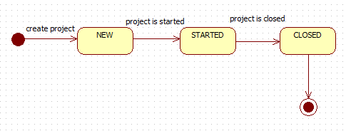

Figure : State Diagram of Project

### Create Function

By clicking the “Create project” button the system will provide the create project screen and user with role Director can create a new project.

Director can assign Manager into a project in this function.

### Update Function

Director can also remove the project if the project not yet started.

Manager and Director can edit the content of the project.

Manager can also assign employees into the project.

Director can close a project after it was finished and assess the project.

### Task Management

Life circle of task:

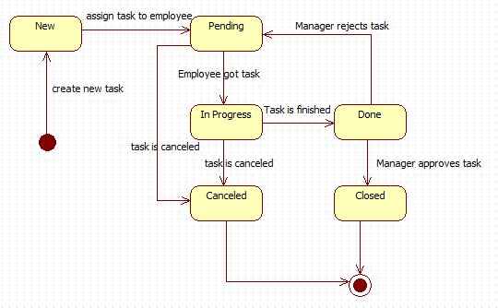

Figure : State Diagram of Task

Only Manager can create new task. If task is assigned to staff in the project, its status become “Pending”, task status become “In Progress” after staff get task, After task is done, Manager will review and reject if any defect was found and the staff will redo task, if task is approved, manager will assess the task and give mark.

Manager can create new task.

Task can be deleted if it not yet assigned to any staff.

Staff and Manager can also discuss about work in task detail view.

Only related staff and Manager can comment in task details.

### Review and Approve task with Files

Manager or Staff can upload files, document about their work. After reviewing, Manager can approve and assess task or reject if anything is wrong. After task is assessed, assessment information will be saved and any related employee can see this information.

### Group discussion

Each project has a forum for discussing issues and exchanging knowledge.

Any employees in the project can use this function and create topic, post comment freely.

#### Create new topic

Any employees in the project can create new topic and upload file and post information, images.

#### Post Comment

Director can also post comment, uploads file freely.

### Report

Director and manager can view reports of their work.

Report of their work will show by using line chart.

### Assessment

User with specific role can assess task/project after task/project is finished

Moreover, a productivity assessment will be started after a period time decided by admin to assess performance of all employees in a specific period time, and employee can feedback to that assessment.

Life circle of assessment:

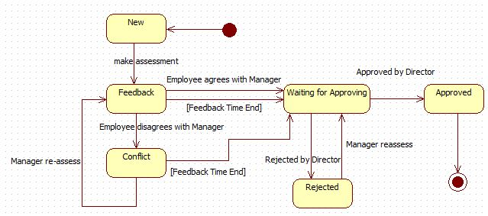

Figure : State Diagram of Assessment

Manager and staff can only see the assessment if the assessment is started.

In the productivity assessment, it have the time for Manager make assessment, after that time ended, it will be the time for Staff feedback and finally will be the time for Director review and approve assessment.

See the timeline below for more details:

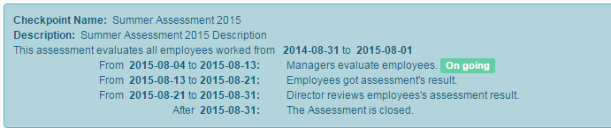

Figure : Assessment Timeline

In the first milestone time will be the time for Manager evaluates employees.

In the second milestone time will be the time for Staff got assessment result and feedback to Manager.

In the third milestone time will be the time for Director review all assessments and even though staff disagrees with Manager, system will get the final result assessed by Manager.

In the final milestone time will be the time for Assessment end.

#### Make assessment

Manager or Director can assessment includes criterion for assessment.

This criterion will be decided by the company needs and can be edited by the user with the admin account.

## Role and Responsibility

|  |  |  |  |  |
| --- | --- | --- | --- | --- |
| No | Full Name | Role | Position | Contact |
| 1 | Lại Đức Hùng | Project Managers | Instructor | [hungld@fpt.edu.vn](mailto:hungld@fpt.edu.vn) |
| 2 | Nguyễn Cự Đạt | Developer | Leader | [datncse601010@fpt.edu.vn](mailto:datncse601010@fpt.edu.vn) |
| 3 | Lư Cẩm Toàn | Developer | Member | [toanlcse60633@fpt.edu.vn](mailto:toanlcse60633@fpt.edu.vn) |
| 4 | Lê Hải Triều | Developer | Member | [trieulhse61146@fpt.edu.vn](mailto:trieulhse61146@fpt.edu.vn) |
| 5 | Trần Thị Kim Anh | Developer | Member | [anhttkse60909@fpt.edu.vn](mailto:anhttkse60909@fpt.edu.vn) |

Table : Role and Responsibility

# Software Project Management Plan

## Problem Definition

### Name of this Capstone project

* + **Office Task Management (OTM)**

### Problem Abstract

Nowadays, there is a large number of routine works in a company or a division, and most of the company works in documents that lead they lose material and manage the assessment difficulty. **Office Task Management** is the system that helps users manage their works, the staffs follow up the works entrusted, the managers watch for their team and project, the director manages the company’s employee and support to evaluate project and employee more specific.

### Project Overview

#### Current Situation

There are many of Office Work Management Systems in recent time.

For example Mantis Bug Tracker, Jira, Trello, CheckAction, etc…

* + Advantages:
    - Having friendly interface with users.
    - Supporting real-time collaboration.
  + Disadvantages:
    - Not supporting forum to the employee of a team to discuss their works.
    - Not supporting tasks and projects assessment to attend to the estimation of an employee in the period of the year.
    - Their system is developed for group working, not for a business organization.
    - Use Bug management system to manage Tasks.

#### The proposed system

To deal this situation, our team suggests the **Office Task Management** system.

##### Web Site

Web application has these main core functions:

* + - Manage project: director and manager can manage the projects in a company.
    - Manage task: manager and staff can manage and follow up tasks in projects.
    - Group discussion: user can discuss in a forum of each project or comment in task.
    - Report tasks and projects: the system collect the supporting user project situation to follow easily.
    - Assess employee in period time: the manager can evaluates the employee in a periodical assessment of a year.

##### Mobile Application

* + - View dashboard and task details: user can follow their tasks and simple interaction.
    - Receive notification: user can receive notification about their tasks.

#### Boundaries of the System

* + Everybody who have basic knowledge about IT and have an Android smartphone could use the system.
  + The language of system is English.
  + The completed product includes:
    - Website version for all roles of user.
    - Mobile version for manager and staff.
    - All of processes document involved.
  + The system cannot support chatting with outside.
  + Mobile version has not yet support for director and it only supports view and some basic features.

#### Development Environment

##### Hardware requirements

**For Server**

|  |  |  |
| --- | --- | --- |
| **Windows** | **Minimum Requirements** | **Recommended** |
| **Internet Connection** | Cable, Wi-Fi (4 Mbps) | Cable, Wi-Fi (12 Mbps) |
| **Operating System** | Window Server 2008 | Window Server 2008 |
| **Computer Processor** | Intel® Xeon ® 1.4GHz | Intel® Xeon ® Quad Core  (12M Cache, 2.50 GHz) |
| **Computer Memory** | 1GB RAM | 2GB or more |

Table : <Hardware Requirements> Server

**For Mobile**

|  |  |  |
| --- | --- | --- |
| **Windows** | **Minimum Requirements** | **Recommended** |
| **Internet Connection** | Cable, Wi-Fi (4 Mbps) | Cable, Wi-Fi (12 Mbps) |
| **Operating System** | Android 4.1.2 | Android 4.4.2 |
| **Hardware** | Intel® Xeon ® 1.4GHz | Intel® Xeon ® Quad Core  (12M Cache, 2.50 GHz) |
| **Computer Memory** | 1GB RAM | 2GB or more |

Table : <Hardware Requirement> Mobile

##### Software requirements

* + - Window Server 2008: operating system and platform for development.
    - SQL Server 2008 Enterprise R2: used to create and manage the database for system.
    - Eclipse Luna 4.4.2: used to implement website and web service.
    - DigitalOcean & TortoiseSVN: used for source control.
    - StarUML, [www.lucidchart.com](http://www.lucidchart.com): used to create models and diagrams.
    - Justinmind: used to create GUI prototypes.
    - Skype: used for communication and meeting.

## Project organization

### Software Process Model

Project is developed under modified waterfall model.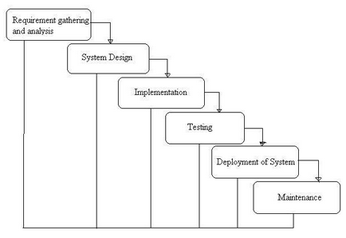

Figure : <Software Process Model> Waterfall

For more information: <http://istqbexamcertification.com/what-is-waterfall-model-advantages-disadvantages-and-when-to-use-it/>

### Roles and responsibilities

|  |  |  |  |
| --- | --- | --- | --- |
| **No** | **Full name** | **Role in Group** | **Responsibilities** |
| **1** | Lại Đức Hùng | Project manager | * Specify user requirement * Control the development process * Give out technique and business analysis |
| **2** | Nguyễn Cự Đạt | Team Leader,  BA, Dev, Tester | * Managing process * Clarifying requirements * Prepare documents * GUI Design * Designing database * Coding * Create test plan * Testing |
| **3** | Lư Cẩm Toàn | Team Member,  BA, Dev, Tester | * Clarifying requirements * Prepare documents * GUI Design * Designing database * Coding * Create test plan * Testing |
| **4** | Lê Hải Triều | Team Member,  BA, Dev, Tester | * Clarifying requirements * Prepare documents * GUI Design * Designing database * Coding * Create test plan * Testing |
| **5** | Trần Thị Kim Anh | Team Member,  BA, Dev, Tester | * Clarifying requirements * Prepare documents * GUI Design * Designing database * Coding * Create test plan * Testing |

Table : <Project Organization> Role and Responsibility

### Tools and Techniques

* Front-end technologies: HTML5, CSS3, JavaScript, jQuery, AJAX.
* Back-end technologies:
  + Website: Java EE
  + Web service: Java + Jersey, Retrofit
  + Third-party libraries: Parse API, Sendgrid API
* Mobile: Android JellyBean 4.1.2 – Java 7
* Web Server: Apache Tomcat 7.0.61
* Database Management System: MSSQL Server 2008 R2 Enterprise

## Project Management Plan

### Software development life cycle

|  |  |  |  |  |  |
| --- | --- | --- | --- | --- | --- |
| **Phase** | **Description** | **Deliverables** | **Resource needed** | **Dependencies and Constrains** | **Risks** |
| **Requirement gathering and Analysis** | - Gather requirement from customers.  - Study business in reality to determine business rules.  - Identify and clarify requirement base on real business. | - Introduction of system.  - Software project management plan.  - Software requirement specification.  - Business rules.  - Prototypes. | 20 man-days | N/A | - Members in team do not identify with the requirement understanding.  -Misunderstanding about business. |
| **System Design** | - Determine architecture style that will be used.  - Design architecture for the system.  - Solve problems and plan solutions. | - Software design document.  - Architectural style for code.  - Technologies for the system. | 50 man-days | Depend on “Requirement gathering and analysis”. | - Lack of knowledge and experience.  - Lack of understanding requirement |
| **Implementation** | - Code GUI.  - Code core functions and other features.  - Unit test and debug. | - Web application.  - Mobile application on Android. | 20 man-days | Depend on “System design”. | - Mistake while implementing |
| **Testing** | - Unit testing.  - Integration testing.  - System testing.  - Fix bugs. | - Test document. | 10 man-days | Depend on “Implementation”. | - Lack of experience.  - Lack of test cases. |
| **Deployment of System** | - Deploy on web server and mobile. | - Installation guide.  - User Manual | 10 man-days | Depend on “Testing”. | - Lack of experience. |
| **Maintenance** | - Maintain and update the system. | N/A | N/A | Depend on “Deployment of system”. | N/A |

Table : Software Development Life Cycle

### Phase Detail

#### Phase 1: Requirement gathering and analysis

|  |  |  |
| --- | --- | --- |
| **Task** | **Description** | **Author** |
| 1. Gather requirement | - Collect requirement from customer.  - Study from current similar system. | DatNC, ToanLC, TrieuLH, AnhTTK |
| 2. Study business | - Define strengths and weakness of current similar system.  - Interview some real PMs about business. | DatNC, ToanLC, TrieuLH, AnhTTK |
| 3. Identify and clarify requirement | - Define main scope of system. | DatNC, ToanLC, TrieuLH, AnhTTK |
| 4. Create system introduction, SRS document | - Complete introduction of system  - Write SRS document | DatNC, TrieuLH |
| 5. Design prototypes | - Design GUI prototypes by tools | ToanLC, AnhTTK |

Table : <Phase Detail> Phase 1

#### Phase 2: System design

|  |  |  |
| --- | --- | --- |
| **Task** | **Description** | **Author** |
| 1. Research technologies | - Research third-party’s APIs support real-time collaboration and push notification.  - Study Android application development.  - Study web services using Jersey | DatNC, ToanLC TrieuLH, AnhTTK |
| 2. Design ERD | - Create ER diagram. | DatNC, ToanLC, TrieuLH, AnhTTK |
| 3. Design database | - Design logical and create physical database | DatNC, TrieuLH |
| 4. Design Class diagram | - Create Class diagram | DatNC, ToanLC, TrieuLH, AnhTTK |
| 5. Detail design and create design document | - Top-down design.  - Create and update software design document | DatNC, ToanLC, TrieuLH, AnhTTK |

Table : <Phase Detail> Phase 2

#### Phase 3: Implementation

|  |  |  |
| --- | --- | --- |
| **Task** | **Description** | **Author** |
| 1. Implement web front-end | - Code GUI for web application | DatNC, ToanLC, TrieuLH, AnhTTK |
| 2. Implement web back-end | - Code functions for web application | DatNC, ToanLC, TrieuLH, AnhTTK |
| 3. Implement mobile front-end | - Code GUI for mobile application | TrieuLH |
| 4. Implement mobile back-end | - Code functions for mobile application | TrieuLH |
| 5. Choose and analysis algorithms | - Code functions for mobile application | DatNC |
| 6. Unit testing | - Unit test  - Fix bugs | DatNC, ToanLC, TrieuLH, AnhTTK |

Table : <Phase Detail> Phase 3

#### Phase 4: Testing

|  |  |  |
| --- | --- | --- |
| **Task** | **Description** | **Author** |
| 1. Unit testing | - Write test cases  - Test and fix bugs. | DatNC, ToanLC, TrieuLH, AnhTTK |
| 2. Integration testing | - Write test cases  - Test and fix bugs. | DatNC, ToanLC, TrieuLH, AnhTTK |
| 3. System testing | - Write test cases  - Test and fix bugs. | DatNC, ToanLC, TrieuLH, AnhTTK |
| 3. Create test document | - Create and update test document | DatNC, ToanLC, TrieuLH, AnhTTK |

Table : <Phase Detail> Phase 4

#### Phase 5: Deployment of System

|  |  |  |
| --- | --- | --- |
| **Task** | **Description** | **Author** |
| 1. Deployment | - Deploy system on server and mobile | TrieuLH |
| 2. Create installation guide | - Write installation guide | TrieuLH, AnhTTK |
| 3. Create user manual | - Write user manual | TrieuLH, AnhTTK |

Table : <Phase Detail> Phase 5

#### Phase 6: Maintenance

|  |  |  |
| --- | --- | --- |
| **Task** | **Description** | **Author** |
| 1. Maintain and update system | - Maintain current system  - Update new features | N/A |

Table : <Phase Detail> Phase 6

### All Meeting Minutes

Place at Meeting Minutes folder.

## Coding Convention

Use Java coding convention to develop website, web service and mobile application.

Convention:

* Naming convention:
  + Use camel case for name of variables and functions.
  + Use Pascal case for class
* Indentation:
  + Avoid lines longer than 80 characters, since they are not handled well by many terminals and tools.
* Declaration:
  + In absolutely no case should variables and functions be declared on the same line.
  + Do not put different types on the same line.

Follow “Code Conventions for the Java TM Programming Language, by Sun Microsystems, rev April 20, 1999”.

<http://www.oracle.com/technetwork/java/codeconventions-150003.pdf>

# Software Requirement Specification

## User Requirement Specification

In this project, users will be divided into roles:

### Guest Requirement

Guest is a person who do not have role in system. “Login” function will help guest login to the system and implement other functions of system. With different roles, functions will be different.

### Admin Requirement

Admin is a person who manages system directly. Admin can use some functions in the system. To use that functions, user must login with Admin Role. There are some functions that admin can use:

* Mange accounts: create, edit, search and deactivate accounts.
* Manage skills: add, update, remove and search skills.
* Add categories of skills.
* Manage period assessments: create, edit, search and remove period assessments.
* Manage criterions: create, edit and search criterions.

### Director Requirement

Director is a person who manages projects in this system. Director has some functions in the system. Beside, director can also use some functions of manager and staff. There are some functions:

* Manage Project: create, update, and remove project
* Add/Change/Remove manager into/from project.
* Manage Employee Assessment: add, edit, and search assessment.
* View Productivity Assessment.
* View report status of task.

### Manager Requirement

Manager is a person who receives projects from director and manages tasks. Manager has some functions in the system. Beside, manager can also use function of staff. There are some functions:

* Manage Task: create, update, remove, assign, and review task.
* Add/Remove staff into/from project.
* View project detail
* Manage Employee Assessment: add, edit, and search assessment.
* View report status of task and project.

### Staff Requirement

Staff is a person who joins in project. Staff has some functions in the system.

* View all tasks
* View task detail
* Manage discussion: add, edit, and search topic
* Edit profile
* View employee assessment
* Update task
* Search tasks, projects.

## System Requirement Specification

### External Interface Requirement

#### User Interface

* General requirement for graphics user interface is the GUI should be simple, clear, intuitive, and reminiscent.
* The interface design is an iterate process includes design, sketching, prototyping, user assessment.
* Some design principles will be taken into consideration:
  + UI for business web applications - Janko Jovanovic [Ref: <http://www.smashingmagazine.com/2010/02/25/designing-user-interfaces-for-business-web-applications/>

#### Hardware Interface

* N/A

#### Software Interface

Run with Chrome (version 43.0.2357.81 m) browser and must support JavaScript and HTML5.

#### Communication Protocol

* Using HTTP/HTTPS protocol

### System Overview Use Case

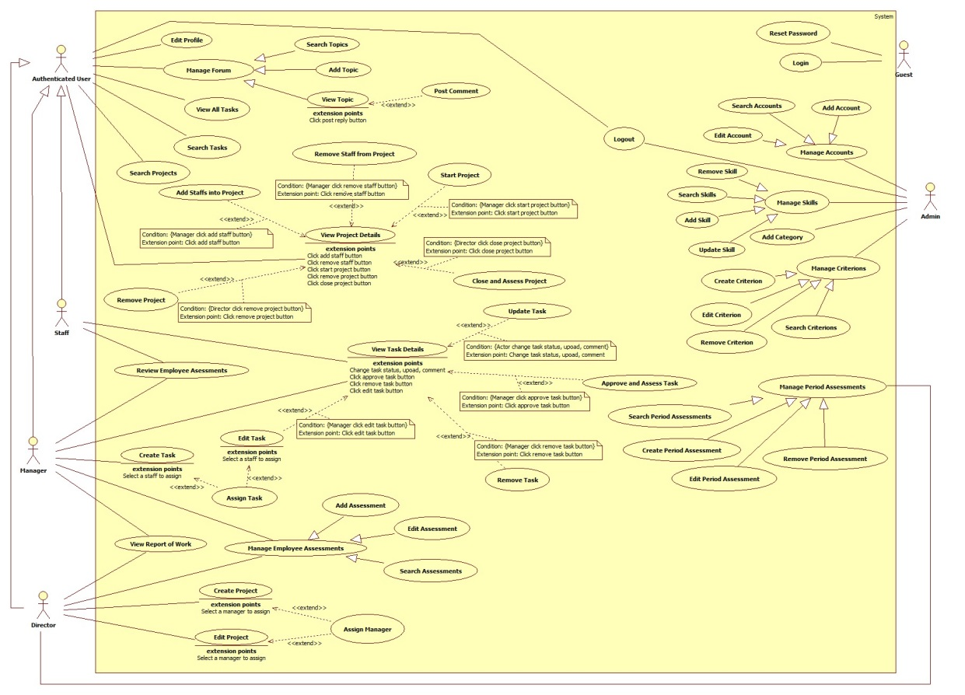

Figure : <Web> System Overview Use Case

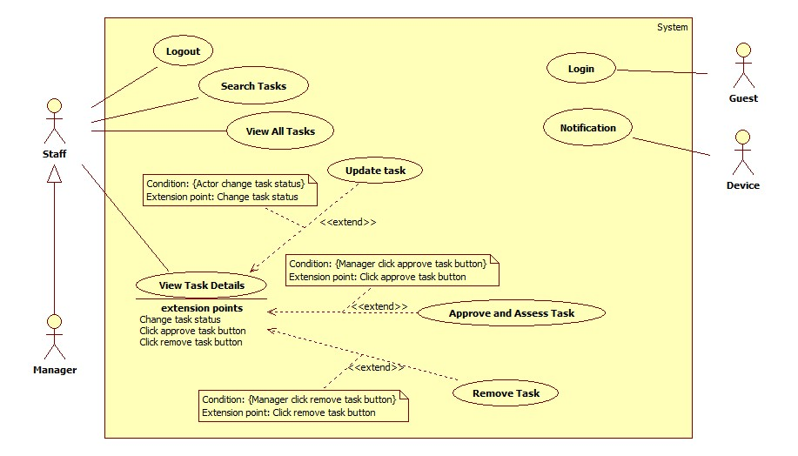

Figure : <Mobile> System Overview Use Case

### List of Use Case

#### <Guest>Overview Use Case

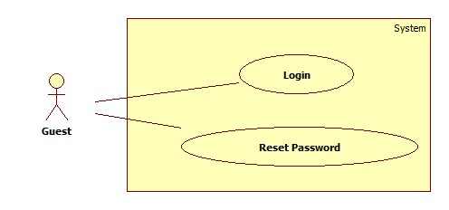

Figure : < Use Case >Overview Use Case

##### <Guest> Login

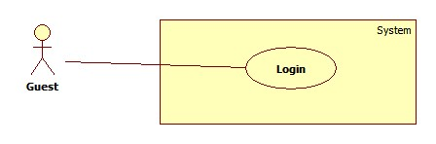

Figure : < Use Case > Login

|  |  |  |  |
| --- | --- | --- | --- |
| **USE CASE – OTM001** | | | |
| **Use Case No.** | OTM001 | **Use Case Version** | 1.0 |
| **Use Case Name** | Login | | |
| **Author** | Tran Thi Kim Anh | | |
| **Date** | 02/06/2015 | **Priority** | High |
| **Actor:**   * Guest.   **Summary:**   * This use case allows guest to login to the system.   **Goal:**   * Guest is logged into the system.   **Triggers:**   * Guest clicks “Login” button on “Login” screen.   **Preconditions**:   * N/A   **Post Conditions:**   * **Success**: Login successfully. * **Fail**: System shows error message.   **Main Success Scenario:**   |  |  |  | | --- | --- | --- | | Step | Actor Action | System Response | | 1 | Guest goes to the website. | System shows Login screen with following contents:   * Username: textbox, max length: 20, not null * Password: textbox, not null * Login: button * Reset Password: link | | 2 | Guest inputs data and clicks “Login” button. | System validates input data then navigates to Dashboard screen.  [Exception 1] |   **Alternative Scenario:**   * N/A   **Exceptions:**   |  |  |  | | --- | --- | --- | | No | Actor Action | System Response | | 1 | “Username” is empty. | System shows error message: “Username is required”. | | 2 | “Password” is empty. | System shows error message: “Password is required”. | | 3 | Input data incorrectly. | System shows error message: “Username or password is incorrect!” |   **Relationships**:   * N/A   **Business Rules:**   * Guest will be navigated to Dashboard screen according to the role. | | | |

Table : <Use Case> Login

##### <Guest> Reset Password

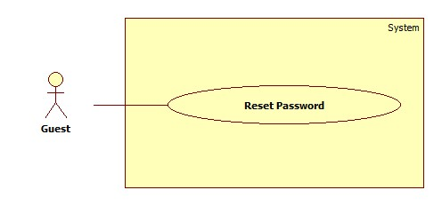

Figure : < Use Case > Reset Password

|  |  |  |  |
| --- | --- | --- | --- |
| **USE CASE – OTM002** | | | |
| **Use Case No.** | OTM002 | **Use Case Version** | 1.0 |
| **Use Case Name** | Reset Password | | |
| **Author** | Tran Thi Kim Anh | | |
| **Date** | 02/06/2015 | **Priority** | Normal |
| **Actor:**   * Guest.   **Summary:**   * This use case allows guest to reset password.   **Goal:**   * Guest can reset password.   **Triggers:**   * Guest clicks “Reset Password” link on “Login” screen.   **Preconditions**:   * N/A   **Post Conditions:**   * **Success**: The new password was sent to guest via mail. * **Fail**: System shows error message.   **Main Success Scenario:**   |  |  |  | | --- | --- | --- | | Step | Actor Action | System Response | | 1 | Click “Reset Password” link. | System opens a popup with following fields:   * “Email”: textbox, max length: 50, not null * “Reset”: button * “Close”: button | | 2 | Guest inputs data then clicks on “Reset” button.  [Alternative 1] | System validates inputted data, creates a random password string and updates to database then sends a new password to guest via mail.  System closes the popup.  [Exception 1] |   **Alternative Scenario:**   |  |  |  | | --- | --- | --- | | No | Actor Action | System Response | | 1 | Guest clicks on “Close” button. | System closes the popup and nothing change |   **Exceptions:**   |  |  |  | | --- | --- | --- | | No | Actor Action | System Response | | 1 | “Email” is empty. | System shows error message “Email cannot empty!” | | 2 | Input data is incorrect. | System shows error message “Email is incorrect”. |   **Relationships**:   * N/A   **Business Rules:**   * Email must be one that registered with company. * Email will have a generate password. | | | |

Table : < Use Case > Reset Password

#### <Admin>Overview Use Case

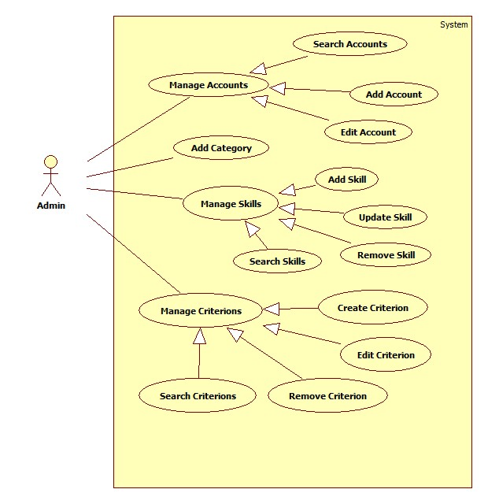

Figure : < Use Case > Admin Overview Use Case

##### <Admin>Search Accounts

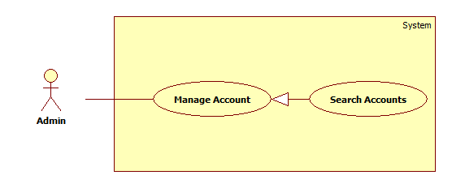

Figure : < Use Case > Search Accounts

|  |  |  |  |
| --- | --- | --- | --- |
| **USE CASE –OTM004** | | | |
| **Use Case No.** | OTM004 | **Use Case Version** | 1.0 |
| **Use Case Name** | Search Accounts | | |
| **Author** | Tran Thi Kim Anh | | |
| **Date** | 02/06/2015 | **Priority** | Normal |
| **Actor:**   * Admin.   **Summary:**   * This use case allows admin to search accounts.   **Goal:**   * The account list is shown.   **Triggers:**   * Admin clicks “Search” button on Account screen.   **Preconditions**:   * User login with Admin Role.   **Post Conditions:**   * **Success**: List of accounts is shown. * **Fail**: Nothing is shown.   **Main Success Scenario:**   |  |  |  | | --- | --- | --- | | Step | Actor Action | System Response | | 1 | Admin inputs an username then clicks “Search” button.  [Alternative 1] | System shows a list of results contains:   * “No”: int * “Username”: textbox. * “Email”: textbox. * “Role”: dropdown list. * “Status”: dropdown list. * “Edit”: button |   **Alternative Scenario:**   |  |  |  | | --- | --- | --- | | No | Actor Action | System Response | | 1 | No account is found | System shows message: “No account is found”. |   **Exceptions:**   * N/A   **Relationships**:   * N/A   **Business Rules:**   * Admin cannot search the admin account. * Admin can search by 2 way:   + Search by input data into textbox search.  + Search by choose role or status in Advance Search.   * After searching, result will sort follow Alphabet. | | | |

Table :< Use Case > Search Account

##### <Admin>Add Account

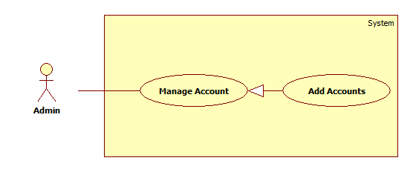

Figure : < Use Case > Add Account

|  |  |  |  |
| --- | --- | --- | --- |
| **USE CASE – OMT005** | | | |
| **Use Case No.** | OMT005 | **Use Case Version** | 1.0 |
| **Use Case Name** | Add Account | | |
| **Author** | Tran Thi Kim Anh | | |
| **Date** | 02/06/2015 | **Priority** | Normal |
| **Actor:**   * Admin.   **Summary:**   * This use case allows admin to add a new account.   **Goal:**   * New account is added.   **Triggers:**   * Admin clicks “Add new” button on Account screen.   **Preconditions**:   * User login with Admin Role.   **Post Conditions:**   * **Success**: A new account is added. * **Fail**: System shows error message.   **Main Success Scenario:**   |  |  |  | | --- | --- | --- | | Step | Actor Action | System Response | | 1 | Admin clicks “Add” button on Account screen. | System opens Add Account popup with following contents:   * “Full name”: textbox, not null, max-length: 50. * “Email”: textbox, not null, max-length: 50. * “Role”: drop down list, not null. * “Add”: button * “Back”: button | | 2 | User inputs data then clicks on “Add” button. [Alternative 1] | System validates inputted data, creates a random password string and updates to database then sends a new password to guest via mail.  System closes the popup and shows message “New account has been created!”  [Exception 1] |   **Alternative Scenario:**   |  |  |  | | --- | --- | --- | | No | Actor Action | System Response | | 1 | Click “Cancel” button. | System closes the popup. |   **Exceptions:**   |  |  |  | | --- | --- | --- | | No | Actor Action | System Response | | 1 | “Full name” is empty. | System shows error message “Full name cannot empty!” | | 2 | “Email” is empty. | System shows error message “Email cannot empty!” | | 3 | “Role” is empty. | System shows error message “Please select Employee role!” | | 4 | “Email” is existed. | System shows error message “The username has already existed!” |   **Relationships**:   * N/A   **Business Rules:**   * Email is used in the system that is user’s email in company. This email was created when user joins into company. * The username is the prefix of email. It was generated by code.   Example: email is “[abc@company.org.vn](mailto:abc@company.org.vn)”, so username is “abc”. | | | |

Table :< Use Case > Add Account

##### <Admin>Edit Account

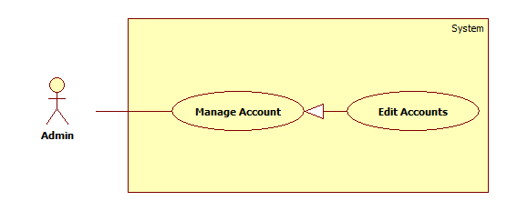

Figure : < Use Case > Edit Account

|  |  |  |  |
| --- | --- | --- | --- |
| **USE CASE – OTM006** | | | |
| **Use Case No.** | OTM006 | **Use Case Version** | 1.0 |
| **Use Case Name** | Edit Account | | |
| **Author** | Tran Thi Kim Anh | | |
| **Date** | 02/06/2015 | **Priority** | Normal |
| **Actor:**   * Admin.   **Summary:**   * This use case allows admin to edit an account.   **Goal:**   * Account is updated.   **Triggers:**   * Admin clicks “Edit” button in Account screen.   **Preconditions**:   * User login with Admin Role.   **Post Conditions:**   * **Success**: Account is updated. * **Fail**: Nothing is shown.   **Main Success Scenario:**   |  |  |  | | --- | --- | --- | | Step | Actor Action | System Response | | 1 | User stays at Account screen. | System shows Account screen with following contents:   * “Username”: textbox, disabled * “Email”: textbox, max length: 50, not null * “Role”: dropdown * “Status”: checkbox * “Edit”: button | | 2 | Admin clicks “Edit” button. | System shows Account screen with following contents:   * “Role”: dropdown * “Status”: checkbox * “Save”: button * “Cancel”: button | | 3 | Admin inputs data and clicks “Save” button.  [Alternative 1] | System reloads Account screen and shows message: “Account has been updated!” |   **Alternative Scenario:**   |  |  |  | | --- | --- | --- | | No | Actor Action | System Response | | 1 | Admin clicks “Cancel” button. | System reloads and shows Account screen. |   **Exceptions:**   * N/A   **Relationships**:   * N/A   **Business Rules:**   * A deactivated account cannot be re-activated. | | | |

Table : < Use Case > Edit Account

##### <Admin> Search Skills

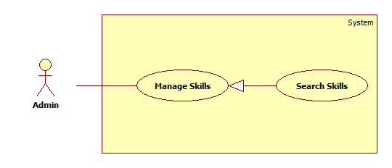

Figure : < Use Case > Search Skills

|  |  |  |  |
| --- | --- | --- | --- |
| **USE CASE – OTM007** | | | |
| **Use Case No.** | OTM007 | **Use Case Version** | 1.0 |
| **Use Case Name** | Search Skills | | |
| **Author** | Tran Thi Kim Anh | | |
| **Date** | 02/06/2015 | **Priority** | Normal |
| **Actor:**   * Admin.   **Summary:**   * This use case allows admin to search skills.   **Goal:**   * The skill list is shown.   **Triggers:**   * Admin clicks “Search” button on Skill List screen.   **Preconditions**:   * User must login with Admin Role.   **Post Conditions:**   * **Success**: List of skills is shown. * **Fail**: Nothing is shown.   **Main Success Scenario:**   |  |  |  | | --- | --- | --- | | Step | Actor Action | System Response | | 1 | Admin inputs a skill name or a category name then clicks “Search” button. | System shows a list of results contains:   * “No”: int * “Skill Name”: text box, not null. * “Category”: drop down list. * “Remove” button * “Edit”: button   [Alternative 1] |   **Alternative Scenario:**   |  |  |  | | --- | --- | --- | | No | Actor Action | System Response | | 1 | No skill is found. | System shows message: “No skill is found”. |   **Exceptions:**   * N/A   **Relationships**:   * N/A   **Business Rules:**   * Admin can search by 2 way:   + Search by input data into textbox search.  + Search by choose category in Advance Search.   * After searching, result will sort follow Alphabet. | | | |

Table : < Use Case > Search Skills

##### <Admin> Add Skill

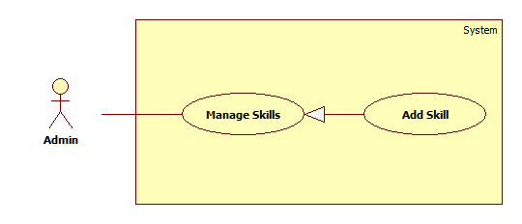

Figure : < Use Case > Add Skill

|  |  |  |  |
| --- | --- | --- | --- |
| **USE CASE – OTM008** | | | |
| **Use Case No.** | OTM008 | **Use Case Version** | 1.0 |
| **Use Case Name** | Add Skill | | |
| **Author** | Tran Thi Kim Anh | | |
| **Date** | 02/06/2015 | **Priority** | Normal |
| **Actor:**   * Admin.   **Summary:**   * This use case allows admin to insert a new skill.   **Goal:**   * Skill is added.   **Triggers:**   * Admin clicks “Add Skill” button on Skill List screen.   **Preconditions**:   * User login with Admin Role.   **Post Conditions:**   * **Success**: A new skill is added. * **Fail**: System shows error message.   **Main Success Scenario:**   |  |  |  | | --- | --- | --- | | Step | Actor Action | System Response | | 1 | Admin clicks “Add Skill” button on Skill List screen. | System opens Add Skill popup with following contents:   * “Category”: dropdown, not null * “Skill Name”: textbox, not null, max-length: 50. * “Add”: button. * “Close”: button. | | 2 | Admin inputs data then clicks on “Add” button. [Alternative 1] | System validates and saves into database.  System closes the popup and shows message “New skill has been created”.  [Exception 1] |   **Alternative Scenario:**   |  |  |  | | --- | --- | --- | | No | Actor Action | System Response | | 1 | Click “Close” button. | System closes the popup. |   **Exceptions:**   |  |  |  | | --- | --- | --- | | No | Actor Action | System Response | | 1 | “Skill Name” is empty. | System shows error message “The Skill Name cannot empty!” | | 2 | “Skill Name” is existed. | System shows error message “The Skill has already existed!” |   **Relationships**:   * N/A   **Business Rules:**   * Each created skill belongs to a category. * Skill Name must be unique. * If a skill does not belong to any categories in the list, it will belong to “Other” category. | | | |

Table : < Use Case > Add Skill

##### <Admin> Edit Skill

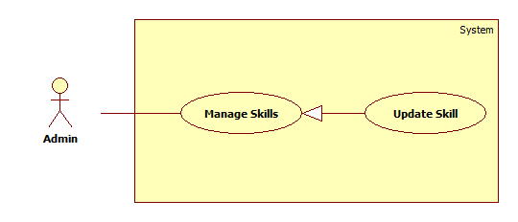

Figure : < Use Case > Update Skill

|  |  |  |  |
| --- | --- | --- | --- |
| **USE CASE –OTM009** | | | |
| **Use Case No.** | OTM009 | **Use Case Version** | 1.0 |
| **Use Case Name** | Update Skill | | |
| **Author** | Tran Thi Kim Anh | | |
| **Date** | 07-06-2015 | **Priority** | Normal |
| **Actor:**   * Admin   **Summary:**   * This use case allows admin to update skill list.   **Goal:**   * Skill is updated.   **Triggers:**   * Admin clicks “Edit” icon on Skill List table on Skill List screen.   **Preconditions**:   * User login with Admin Role.   **Post Conditions:**   * **Success**: Skill has changed. * **Fail**: System shows error message.   **Main Success Scenario:**   |  |  |  | | --- | --- | --- | | Step | Actor Action | System Response | | 1 | Admin stays at Skill List screen. | System shows Skill List screen with following contents:   * “Skill Name”: textbox, not null * “Category”: dropdown, not null * “Edit”: button * “Remove”: button | | 2 | Admin clicks “Edit” button | System shows Account screen with following contents:   * “Skill Name”: textbox, max-length: 50 * “Category”: dropdown * “Save”: button * “Cancel”: button | | 3 | Admin inputs data and then click “Save” button.  [Alternative 1] | System validates input data then updates database.  System reloads Skill List screen and shows message: “Skill has been updated!”  [Exception 1, 2] |   **Alternative Scenario:**   |  |  |  | | --- | --- | --- | | No | Actor Action | System Response | | 1 | Admin clicks “Cancel” button. | System reloads and shows Skill List screen. |   **Exceptions:**   |  |  |  | | --- | --- | --- | | No | Actor Action | System Response | | 1 | “Skill Name” is empty. | System shows error message “The Skill Name cannot empty!” | | 2 | “Skill Name” is existed. | System shows error message “The Skill has already existed!” |   **Relationships**:   * N/A   **Business Rules:**   * N/A | | | |

Table : < Use Case > Update Skill

##### <Admin> Remove Skill

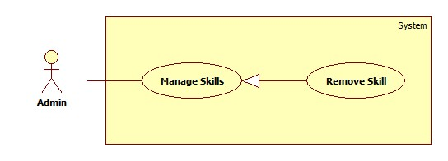

Figure : < Use Case > Remove Skill

|  |  |  |  |
| --- | --- | --- | --- |
| **USE CASE – OTM010** | | | |
| **Use Case No.** | OTM010 | **Use Case Version** | 1.0 |
| **Use Case Name** | Remove Skill | | |
| **Author** | Nguyen Cu Dat | | |
| **Date** | 06-06-2015 | **Priority** | Normal |
| **Actor:**   * Admin   **Summary:**   * This use case is allows Admin to remove the Skill.   **Goal:**   * Remove skills on screen.   **Triggers:**   * Admin clicks on “Remove” button on Skill List screen.   **Preconditions**:   * User login with Admin role.   **Post Conditions:**   * **Success**: Skill is removed from screen. * **Fail**: Nothing is shown.   **Main Success Scenario:**   |  |  |  | | --- | --- | --- | | Step | Actor Action | System Response | | 1 | Admin stays at Skill List screen. | System shows Skill List screen with following contents:   * “Skill Name”: textbox, not null * “Category”: dropdown, not null * “Edit”: button * “Remove”: button | | 2 | Admin clicks “Remove” button. | System opens popup with following contents:   * “Do you want to remove this item?” message. * “Confirm”: button. * “Cancel”: button. | | 3 | Admin clicks “Confirm” button.  [Alternative 1] | System shows message: “Skill has been removed!” |   **Alternative Scenario:**   |  |  |  | | --- | --- | --- | | No | Actor Action | System Response | | 1 | Admin clicks “Cancel” button. | System reloads and shows Skill List screen. |   **Exceptions:**   * N/A   **Relationships**:   * N/A   **Business Rules:**   * N/A | | | |

Table : < Use Case > Update Category

##### <Admin> Add Category

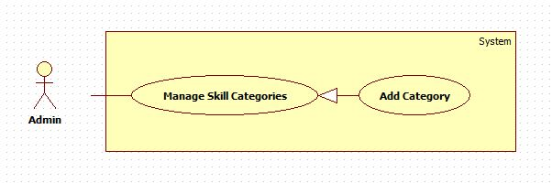

Figure : < Use Case > Add Category

|  |  |  |  |
| --- | --- | --- | --- |
| **USE CASE – OTM011** | | | |
| **Use Case No.** | OTM011 | **Use Case Version** | 1.0 |
| **Use Case Name** | Add Category | | |
| **Author** | Nguyen Cu Dat | | |
| **Date** | 06-06-2015 | **Priority** | Normal |
| **Actor:**   * Admin   **Summary:**   * This use case is allows Admin to add Category.   **Goal:**   * Category is added.   **Triggers:**   * Admin clicks on “Add Category” button in Skill List screen.   **Preconditions**:   * User login with Admin Role.   **Post Conditions:**   * **Success**: New Category is added. * **Fail**: System shows error message.   **Main Success Scenario:**   |  |  |  | | --- | --- | --- | | Step | Actor Action | System Response | | 1 | Admin clicks “Add Category” button on Skill List screen. | System opens Add Category popup with following contents:   * “Category Name”: textbox, not null, max-length: 100. * “Add”: button. * “Close”: button. | | 2 | Admin inputs data then clicks on “Add” button. [Alternative 1] | System validates and saves into database.  System closes the popup and shows message “New category has been created”.  [Exception 1] |   **Alternative Scenario:**   |  |  |  | | --- | --- | --- | | No | Actor Action | System Response | | 1 | Admin clicks “Close” button | System closes popup and shows Skill List screen. |   **Exceptions:**   |  |  |  | | --- | --- | --- | | No | Actor Action | System Response | | 1 | “Category Name” is empty. | System shows error message “Category name cannot empty!” | | 2 | “Category Name” is existed. | System shows error message “This Category has already existed!” |   **Relationships**:   * N/A   **Business Rules:**   * N/A | | | |

Table : < Use Case > Add Category

##### <Admin> Search Criterions

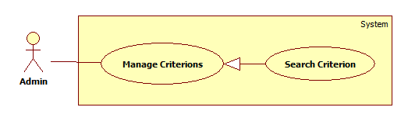

Figure : < Use Case > Search Criterions

|  |  |  |  |
| --- | --- | --- | --- |
| **USE CASE – OTM012** | | | |
| **Use Case No.** | OTM012 | **Use Case Version** | 1.0 |
| **Use Case Name** | Search Criterion | | |
| **Author** | Lu Cam Toan | | |
| **Date** | 08-06-2015 | **Priority** | Normal |
| **Actor:**   * Admin   **Summary:**   * This use case allows admin to search criterions.   **Goal:**   * Search results are shown.   **Triggers:**   * User clicks “Search” icon.   **Preconditions**:   * User login with Admin Role.   **Post Conditions:**   * **Success**: List of results is shown. * **Fail**: Nothing is shown.   **Main Success Scenario:**   |  |  |  | | --- | --- | --- | | Step | Actor Action | System Response | | 1 | Admin inputs a criterion name and clicks on “Search” button. | System searches in database, shows list of results, each result includes:   * “No”: int * “Criterion Name”: textbox * “Criterion Description”: textbox * “Criterion Weight”: int * “Status”: Boolean * “Remove”: button * “Edit”: button   [Alternative 1] |   **Alternative Scenario:**   |  |  |  | | --- | --- | --- | | No | Actor Action | System Response | | 1 | No result is found. | System shows “No result is found” |   **Exceptions:**   * N/A   **Relationships**:   * N/A   **Business Rules:**   * Admin can search by 2 way:   + Search by input data into textbox search.  + Search by choose weight or status in Advance Search.   * After searching, result will sort follow Alphabet. | | | |

Table : < Use Case > Search Criterion

##### <Admin> Create Criterion

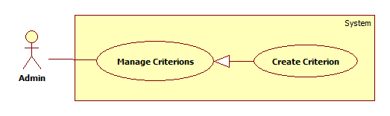

Figure : < Use Case > Create Criterion

|  |  |  |  |
| --- | --- | --- | --- |
| **USE CASE – OTM013** | | | |
| **Use Case No.** | OTM013 | **Use Case Version** | 1.0 |
| **Use Case Name** | Create Criterion | | |
| **Author** | Lu Cam Toan | | |
| **Date** | 08-06-2015 | **Priority** | Normal |
| **Actor:**   * Admin   **Summary:**   * This use case allows admin to create a criterion.   **Goal:**   * A new criterion is created.   **Triggers:**   * User clicks “Add new” button on Criterion screen.   **Preconditions**:   * User login with Admin Role.   **Post Conditions:**   * **Success**: A new Criterion is created. * **Fail**: System shows error message.   **Main Success Scenario:**   |  |  |  | | --- | --- | --- | | Step | Actor Action | System Response | | 1 | Admin clicks “Add new” button. | System navigates to Create Criterion screen:   * “Criterion Name”: textbox, not null, max-length: 50 * “Criterion Description”: text area, max-length: 200 * “Criterion Weight”: drop down * “Create Criterion”: button * “Back”: button | | 2 | Admin inputs data then clicks “Create Criterion” button. | System validates data then updates database.  System shows message: “New criterion has been created!”  [Alternative 1]  [Exceptions 1, 2, 3] |   **Alternative Scenario:**   |  |  |  | | --- | --- | --- | | No | Actor Action | System Response | | 1 | Admin clicks “Back” button. | System navigates to Manage Criterion screen. |   **Exceptions:**   |  |  |  | | --- | --- | --- | | No | Actor Action | System Response | | 1 | Criterion Name is empty. | System shows error message “Criterion name cannot empty”. | | 2 | Criterion Weight is empty. | System shows error message “Criterion weight cannot empty”. | | 3 | Criterion Name is existed. | System shows error message “The criterion has already existed!” |   **Relationships**:   * N/A   **Business Rules:**   * Right after created, status of this criterion is “Activate”. | | | |

Table : < Use Case > Create Criterion

##### <Admin> Edit Criterion

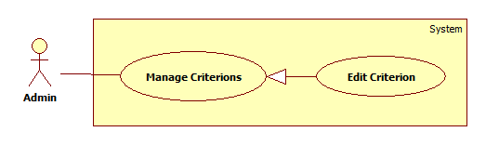

Figure : < Use Case > Edit Criterion

|  |  |  |  |
| --- | --- | --- | --- |
| **USE CASE – OTM014** | | | |
| **Use Case No.** | OTM014 | **Use Case Version** | 1.0 |
| **Use Case Name** | Edit Criterion | | |
| **Author** | Lu Cam Toan | | |
| **Date** | 08-06-2015 | **Priority** | Normal |
| **Actor:**   * Admin.   **Summary:**   * This use case allows the admin to edit a criterion.   **Goal:**   * The criterion details are changed.   **Triggers:**   * User clicks “Edit” icon in the criterions list table.   **Preconditions**:   * User login with Admin Role.   **Post Conditions:**   * **Success**: The criterion details are changed. * **Fail**: System shows error message.   **Main Success Scenario:**   |  |  |  | | --- | --- | --- | | Step | Actor Action | System Response | | 1 | Admin clicks “Edit” icon on the row of the criterion want to edit in the criterion list table. | System show the edit criterion popup includes:   * “Criterion Name”: textbox, not null, max-length: 50 * “Criterion Description”: text area, max-length: 200 * “Criterion Weight”: drop down * “Save”: button * “Cancel”: button | | 2 | Admin clicks “Save change” button.  [Alternative 1] | System validate the enter data, update database and back to the criterion screen.  [Exceptions 1, 2, 3] |   **Alternative Scenario:**   |  |  |  | | --- | --- | --- | | No | Actor Action | System Response | | 1 | Admin clicks “Cancel” button. | System closes the edit criterion popup. |   **Exceptions:**   |  |  |  | | --- | --- | --- | | No | Actor Action | System Response | | 1 | Criterion Name is empty. | System shows error message “Criterion name cannot empty”. | | 2 | Criterion Weight is empty. | System shows error message “Criterion weight cannot empty”. | | 3 | Criterion Name is existed. | System shows error message “The criterion has already existed!” |   **Relationships**:   * N/A   **Business Rules:**   * N/A | | | |

Table : < Use Case > Edit Criterion

##### <Admin> Remove Criterion

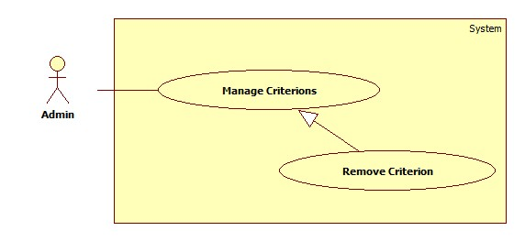

Figure : < Use Case > Remove Criterion

|  |  |  |  |
| --- | --- | --- | --- |
| **USE CASE –OTM015** | | | |
| **Use Case No.** | OTM015 | **Use Case Version** | 1.0 |
| **Use Case Name** | Remove Criterion | | |
| **Author** | Trần Thị Kim Anh | | |
| **Date** | 07/06/2015 | **Priority** | Normal |
| **Actor:**   * Admin   **Summary:**   * This use case allows admin to remove a criterion.   **Goal:**   * A period assessment is updated.   **Triggers:**   * Admin clicks “Remove” button on “Criterion” screen.   **Preconditions**:   * User login with Admin Role.   **Post Conditions:**   * **Success**: The period assessment will be edited. * **Fail**: System shows error message.   **Main Success Scenario:**   |  |  |  | | --- | --- | --- | | Step | Actor Action | System Response | | 1 | Admin stays at Criterion screen. | System shows Criterion screen with following contents:   * “No”: int * “Criterion Name”: textbox * “Criterion Description”: textbox * “Criterion Weight”: int * “Status”: Boolean * “Remove”: button * “Edit”: button | | 2 | Admin clicks “Remove” button. | System opens popup with following contents:   * “Do you want to remove this item?” message. * “Confirm”: button. * “Cancel”: button. | | 3 | Admin clicks “Confirm” button.  [Alternative 1] | System shows message: “Criterion has been removed!” |   **Alternative Scenario:**   |  |  |  | | --- | --- | --- | | No | Actor Action | System Response | | 1 | Admin clicks “Cancel” button. | System reloads and shows Criterion screen. |   **Exceptions:**   * N/A   **Relationships**:   * N/A   **Business Rules:**   * N/A | | | |

Table : < Use Case > Edit Period Assessment

#### <Director>Overview Use Case

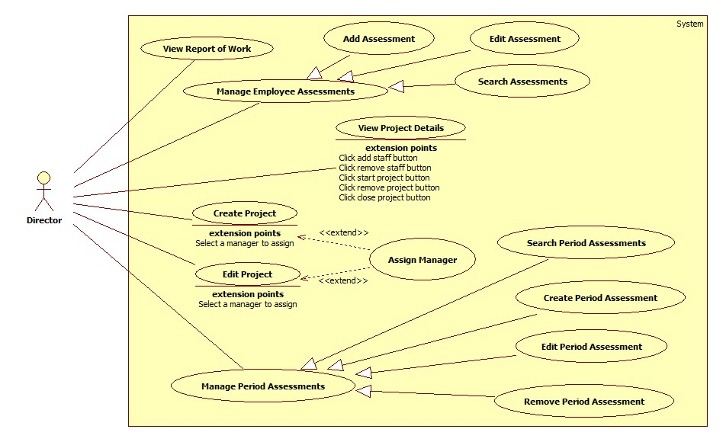

Figure : < Use Case > Director Overview Use Case

##### <Director> Create Project

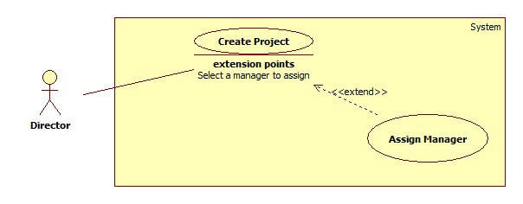

Figure : < Use Case > Create Project

|  |  |  |  |
| --- | --- | --- | --- |
| **USE CASE – OTM016** | | | |
| **Use Case No.** | OTM016 | **Use Case Version** | 1.0 |
| **Use Case Name** | Create Project | | |
| **Author** | Lu Cam Toan | | |
| **Date** | 03-06-2015 | **Priority** | Normal |
| **Actor:**   * Director.   **Summary:**   * This use case allows director to create a new project.   **Goal:**   * New Project is created.   **Triggers:**   * Director clicks “Create Project” button on the list project screen.   **Preconditions**:   * User login with Director Role.   **Post Conditions:**   * **Success**: New project was created. * **Fail**: System shows error message.   **Main Success Scenario:**   |  |  |  | | --- | --- | --- | | Step | Actor Action | System Response | | 1 | Director clicks “Create Project” tab on the header. | System shows a page contains:   * “Project Name”: textbox not null. * “Skills”: “add more” link. * “Project Manager”: dropdown list and Suggest button. * “Start Date”: date picker * “Deadline”: date picker * “Description”: text area. * “Create”: button * “Reset”: button | | 3 | Director inputs data then clicks “Create” button  [Alternative 1] | System validates then navigate to the project detail screen.  [Exception 1, 2, 3] |   **Alternative Scenario:**   |  |  |  | | --- | --- | --- | | No | Actor Action | System Response | | 1 | Director clicks “Reset” button. | System removes the inputted data. |   **Exceptions:**   |  |  |  | | --- | --- | --- | | No | Actor Action | System Response | | 1 | Project name is empty. | System shows error message “Project Name is required.” | | 2 | Start date after Deadline. | System shows error message “Start date should be set before Deadline”. | | 3 | Project name is existed | System shows error message “Project Name is existed.” |   **Relationships**:   * Extended by Assign Manager (Director chooses a manager).   **Business Rules:**   * The status of the project that was created without Project Manager or Start Date is "New". * The status of the project is “NEW”. * User had added skills before clicking “Suggest” button in order to choose Manager. * The start date must before the deadline. | | | |

Table : < Use Case > Create Project

##### <Director> Edit Project

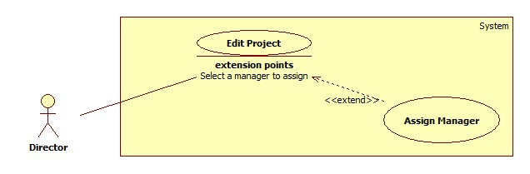

Figure : < Use Case > Edit Project

|  |  |  |  |
| --- | --- | --- | --- |
| **USE CASE –OTM017** | | | |
| **Use Case No.** | OTM017 | **Use Case Version** | 1.0 |
| **Use Case Name** | Edit Project | | |
| **Author** | Tran Thi Kim Anh | | |
| **Date** | 02/06/2015 | **Priority** | Normal |
| **Actor:**   * Director.   **Summary:**   * This use case allows director to edit projects.   **Goal:**   * Director can edit contents of the project.   **Triggers:**   * Director clicks “Edit” button on Project Detail screen.   **Preconditions**:   * User login with Director Role.   **Post Conditions:**   * **Success**: The project details are changed. * **Fail**: System shows error message.   **Main Success Scenario:**   |  |  |  | | --- | --- | --- | | Step | Actor Action | System Response | | 1 | Director clicks “Edit” link on Project Detail screen. | System navigates to “Edit Project” screen with following contents:   * “Project Name”: textbox not null, max-length 100. * “Skills”: “add more” link. * “Project Manager”: dropdown list and Suggest link. * “Start Date”: date picker * “Deadline”: date picker * “Status”: label. * “Description”: text area, max-length 100. * “Create”: button * “Cancel”: button | | 2 | Director inputs data and clicks “Save” button.  [Alternative 1] | System validates data then saves into database.  System shows message “Edited successfully” and back to Project Detail Screen.  [Exception 1, 2] |   **Alternative Scenario:**   |  |  |  | | --- | --- | --- | | No | Actor Action | System Response | | 1 | Director clicks “Cancel” button. | System closes the popup and back to Edit Project screen. |   **Exceptions:**   |  |  |  | | --- | --- | --- | | No | Actor Action | System Response | | 1 | “Project Name” is empty. | System shows error message: “Project Name is required” | | 2 | “Due Date” is set before “Create Date”. | System shows error message: “Due Date must be created after “Create Date”. |   **Relationships**:   * Extended by Assign Manager (Director chooses a manager).   **Business Rules:**   * User had added skills before clicking “Suggest” button in order to choose Manager. * The start date must before the deadline. | | | |

Table : < Use Case > Edit Project

##### <Director> Close and Assess Project

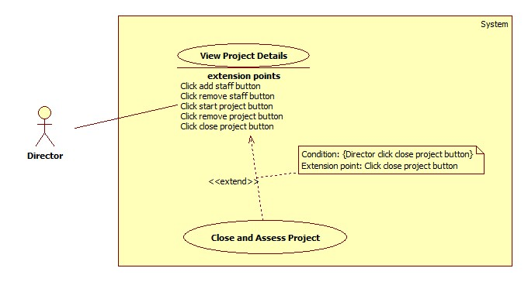

Figure : < Use Case > Close and Assess Project

|  |  |  |  |
| --- | --- | --- | --- |
| **USE CASE – OTM018** | | | |
| **Use Case No.** | OTM018 | **Use Case Version** | 1.0 |
| **Use Case Name** | Close and Assess project | | |
| **Author** | Lu Cam Toan | | |
| **Date** | 03-06-2015 | **Priority** | Normal |
| **Actor:**   * Director.   **Summary:**   * This use case allows director to close a project after review.   **Goal:**   * The project status changed to “Closed”.   **Triggers:**   * Director clicks the “Close” link on Project details screen.   **Preconditions**:   * User login with Director Role.   **Post Conditions:**   * **Success**: The project status changed to “Closed”. * **Fail**: System shows error message   **Main Success Scenario:**   |  |  |  | | --- | --- | --- | | Step | Actor Action | System Response | | 1 | Director chooses “View detail”. | System shows the Project Detail screen. | | 2 | Director clicks “Close” link. | System shows new popup contains:   * “Summary”: text area, max length 200, not null. * “Mark”: dropdown. * “Close Project”: button. * “Cancel”: button. | | 3 | Director inputs data and clicks “Close Project” button.  [Alternative 1, 2] | System validates then navigates to the Project screen.  [Exceptions 1, 2] |   **Alternative Scenario:**   |  |  |  | | --- | --- | --- | | No | Actor Action | System Response | | 1 | Director clicks “Cancel” button. | System closes the popup. | | 2 | Director clicks “Close Project” button. | System navigates to the Project details sceen and show message “Please close all tasks before closing the project!” |   **Exceptions:**   |  |  |  | | --- | --- | --- | | No | Actor Action | System Response | | 1 | “Summary” is empty. | System shows error message “Summary is required”. | | 2 | “Mark” is not number. | System shows error message “Mark must be number”. |   **Relationships**:   * Extend View Project Details (Manager clicks close project button), include Assess Project.   **Business Rules:**   * Member still can view the project when it was closed. * Director will review that all task is done before closing project. * If the tasks in the project still are not closed, the project can not be closed. | | | |

Table : < Use Case > Close and Assess Project

##### <Director> Remove Project

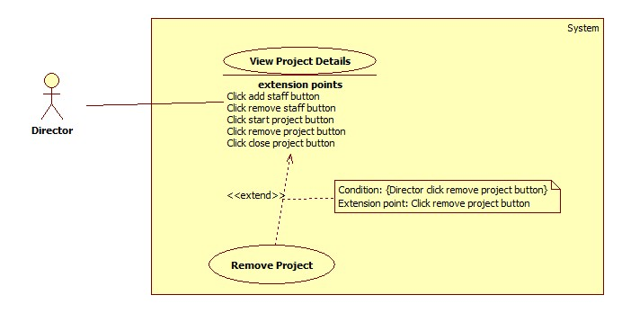

Figure : < Use Case > Remove Project

|  |  |  |  |
| --- | --- | --- | --- |
| **USE CASE – OTM019** | | | |
| **Use Case No.** | OTM019 | **Use Case Version** | 1.0 |
| **Use Case Name** | Remove Project | | |
| **Author** | Lu Cam Toan | | |
| **Date** | 03-06-2015 | **Priority** | Normal |
| **Actor:**   * Director.   **Summary:**   * This use case allows director to remove the project.   **Goal:**   * Project is removed.   **Triggers:**   * Director clicks the Remove button on Project details screen.   **Preconditions**:   * User login with Director Role. * Project is existed.   **Post Conditions:**   * **Success**: Project is removed. * **Fail**: System shows error message.   **Main Success Scenario:**   |  |  |  | | --- | --- | --- | | Step | Actor Action | System Response | | 1 | Director chooses “View detail” on the project, which wants to remove on List Project screen. | System shows the Project Detail screen. | | 2 | Director clicks “Remove” button. | System shows message box “Are you sure you want to delete this project?” with 2 option “Remove” and “Cancel”. | | 3 | Director chooses option “Remove”.  [Alternative 1] | System deletes Project in database. Back to List Project screen and show message “Project was successfully deleted” |   **Alternative Scenario:**   |  |  |  | | --- | --- | --- | | No | Actor Action | System Response | | 1 | Director chooses option “Cancel”. | System closes message box. |   **Exceptions:**   * N/A   **Relationships**:   * Extend View Project Details (Director clicks Remove button).   **Business Rules:**   * The Project can be deleted when this Project’s status is “New”. | | | |

Table : < Use Case > Remove Project

##### <Director> View Report of Work

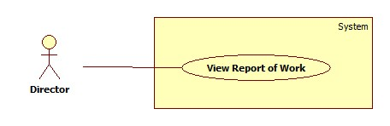

Figure : < Use Case > View Report of Work

|  |  |  |  |
| --- | --- | --- | --- |
| **USE CASE – OTM20** | | | |
| **Use-case No.** | OTM020 | **Use-case Version** | 1.0 |
| **Use-case Name** | View Report of Work | | |
| **Author** | Tran Thi Kim Anh | | |
| **Date** | 06/06/15 | **Priority** | Normal |
| **Actor:**   * Director   **Summary:**   * This use case allows director to view report about projects, which they created and tasks, which have in these projects.   **Goal:**   * Director views report of the project and task and give plan.   **Triggers**   * Director clicks “Report” in navigation bar left.   **Preconditions:**   * User login with Director Role.   **Post Conditions:**   * **Success**: Director will view line chart with information of projects and tasks. * **Fail**: Nothing is shown.   **Main Success Scenario:**   |  |  |  | | --- | --- | --- | | Step | Actor Action | System Response | | 1 | Director clicks “Report” in navigation bar left. | System shows 2 part:   * Part 1: * “Project”: title. * “From”: date time * “To”: date time * “View Report about Project”: button. * Line Chart. * Note: title * Part 2: * “Task”: title. * “From”: date time * “To”: date time * “Project Name”: dropdown * “View Report about Task”: button. * Line Chart. * Note: title   [Alternative 1, 2] |   **Alternative Scenario:**   |  |  |  | | --- | --- | --- | | No | Actor Action | System Response | | 1 | Director chooses from to and then clicks “View Report of Project” button. | System shows chart with statuses of project in period time. | | 2 | Director chooses Project Name and then clicks “View Report about Task” button. | System shows chart with statuses of task in that project. |   **Exceptions:**   * N/A   **Relationships:**   * N/A   **Business Rules:**   * Report will show in period time. * “To” must be larger than “From”. | | | |

Table : < Use Case > View Report of Work

##### <Director> Search Assessments

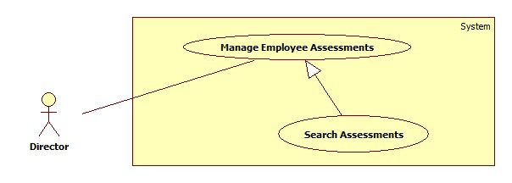

Figure : < Use Case > Search Assessments

|  |  |  |  |
| --- | --- | --- | --- |
| **USE CASE – OTM021** | | | |
| **Use Case No.** | OTM021 | **Use Case Version** | 1.0 |
| **Use Case Name** | Search Assessments | | |
| **Author** | Le Hai Trieu | | |
| **Date** | 06-06-2015 | **Priority** | Normal |
| **Actor:**   * Director   **Summary:**   * This use case allows Director searches assessments.   **Goal:**   * Search results are shown.   **Triggers:**   * Director clicks on “Search” button in Assessment screen.   **Preconditions**:   * User log into the system with role Director.   **Post Conditions:**   * **Success**: List of Employee Assessment is shown. * **Fail:** Nothing is shown.   **Main Success Scenario:**   |  |  |  | | --- | --- | --- | | Step | Actor Action | System Response | | 1 | Director clicks on “View Details” button on Period Assessment screen. | System navigates to Assessment screen with the following:   * “Employee Name”: text box. * “Search”: button. | | 2 | Director input an employee name and clicks on “Search” button. | System shows list of results.   * [Alternative 1] |   **Alternative Scenario:**   |  |  |  | | --- | --- | --- | | No | Actor Action | System Response | | 1 | No result is found. | System shown message “No result was found!” |   **Exceptions:**   * N/A   **Relationships**:   * N/A   **Business Rules:**   * Result will be search following by employee name and status of assessment. * When director clicks an employee name, director can view detail of assessment of each employee. | | | |

Table : < Use Case > Search Assessments

##### <Director> Search Period Assessments

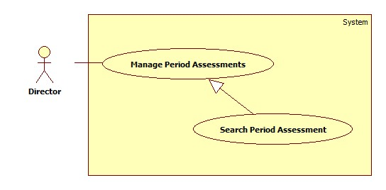

Figure : < Use Case > Search Period Assessment

|  |  |  |  |
| --- | --- | --- | --- |
| **USE CASE –OTM022** | | | |
| **Use Case No.** | OTM022 | **Use Case Version** | 1.0 |
| **Use Case Name** | Search Period Assessments | | |
| **Author** | Le Hai Trieu | | |
| **Date** | 06/06/2015 | **Priority** | Normal |
| **Actor:**   * Director   **Summary:**   * This use case allows director to search period assessments.   **Goal:**   * Director can search period assessments.   **Triggers:**   * Director clicks “Search” button on “Period Assessment” screen.   **Preconditions**:   * User login with Director Role.   **Post Conditions:**   * **Success**: Search period assessments are shown. * **Fail**: Nothing is shown.   **Main Success Scenario:**   |  |  |  | | --- | --- | --- | | Step | Actor Action | System Response | | 1 | Director inputs a period name into search textbox or picks date time then click “Search” button. | System shows a list of results contains:   * “No”: int * “Period Name”: textbox * “Period Description”: textbox * “From”: date time picker * “To”: date time picker * “Start Date”: date time picker * “Feedback Date”: date time picker * “Review Date”: date time picker * “End Date”: date time picker * “Status”: textbox * “Remove”: button * “Edit”: button   [Alternative 1] |   **Alternative Scenario:**   |  |  |  | | --- | --- | --- | | No | Actor Action | System Response | | 1 | No result | Nothing is shown. |   **Exceptions:**   * N/A   **Relationships**:   * N/A   **Business Rules:**   * Director can search by 2 way:   + Search by input data into textbox search.  + Search by choose status in Advance Search.   * After searching, result will sort follow Alphabet. | | | |

Table : < Use Case > Search Period Assessment

##### <Director> Create Period Assessment

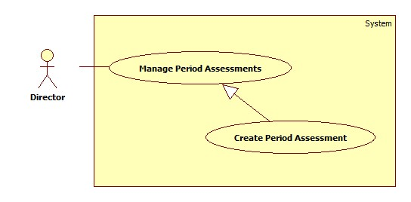

Figure : < Use Case > Create Period Assessment

|  |  |  |  |
| --- | --- | --- | --- |
| **USE CASE –OTM023** | | | |
| **Use Case No.** | OTM023 | **Use Case Version** | 1.0 |
| **Use Case Name** | Create Period Assessment | | |
| **Author** | Le Hai Trieu | | |
| **Date** | 06/06/2015 | **Priority** | Normal |
| **Actor:**   * Director   **Summary:**   * This use case allows director to create a new period assessment.   **Goal:**   * New period assessment is created.   **Triggers:**   * Director clicks on “Add new” button on “Period Assessment” screen.   **Preconditions**:   * User login with Director Role.   **Post Conditions:**   * **Success**: New period assessment is created. * **Fail**: System shows error message.   **Main Success Scenario:**   |  |  |  | | --- | --- | --- | | Step | Actor Action | System Response | | 1 | Director clicks “Add new” button on “Period Assessment” screen. | System opens popup with following contents:   * “Period Name”: textbox, max length: 50, not null * “Period Description”: text area, max length: 200 * “From”: date time-picker, not null * “To”: date time-picker, not null * “Start Date”: date time-picker, not null * “Feedback Date”: date time-picker, not null * “Review Date”: date time-picker, not null * “End Date”: date time-picker, not null * “Create Period Assessment”: button * “Back”: button | | 2 | Director inputs data then clicks “Create” button.  [Alternative 1] | System validates date then updates database.  System closes popup and shows message: “Period assessment was created successfully”.  [Exception 1, 2, 3, 4, 5, 6] |   **Alternative Scenario:**   |  |  |  | | --- | --- | --- | | No | Actor Action | System Response | | 1 | Director clicks “Back” button | System closes popup and nothing change. |   **Exceptions:**   |  |  |  | | --- | --- | --- | | No | Actor Action | System Response | | 1 | “Period Name” is empty. | System shows error message: “Period Name cannot empty” | | 2 | “From” is empty. | System shows error message: “Period start cannot empty”. | | 3 | “To” is empty. | System shows error message: “Period end cannot empty”. | | 4 | “Start Date” is empty. | System shows error message: “Evaluation start date cannot empty”. | | 5 | “Feedback Date” is empty. | System shows error message: “Feedback date cannot empty”. | | 6 | “Review Date” is empty. | System shows error message: “Review date cannot empty”. | | 7 | “End Date” is empty. | System shows error message: “Evaluation end date cannot empty”. | | 8 | “Period Name” is existed” | System shows error message: “This Period Name has been already existed” |   **Relationships**:   * N/A   **Business Rules:**   * If “Start Date” is larger than today, status of this period assessment is “STARTED” otherwise is “NEW”. * Over assessment end date, status of this period assessment is “Deactivate”. * “From” and “To” are a period time to be assessed. * “Start Date” and “End Date” are a period time to assess employee. * “From” is smaller than “To”. * “To” is smaller than “Start Date”. * “Start Date” is smaller than “Feedback Date”. * “Feedback Date” is smaller than “Review Date”. * “Review Date” is smaller than “End Date”. * “Feedback Date” is a period time to employee feedback. * “Review Date” is a period time to director review assessments. * “From” and “To” are unique. * “Start Date” and “End Date” are unique. * Creator can also add criterions needs for assessment in this function | | | |

Table : < Use Case > Create Period Assessment

##### <Director> Edit Period Assessment

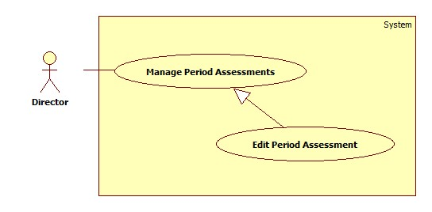

Figure : < Use Case > Edit Period Assessment

|  |  |  |  |
| --- | --- | --- | --- |
| **USE CASE –OTM024** | | | |
| **Use Case No.** | OTM024 | **Use Case Version** | 1.0 |
| **Use Case Name** | Edit Period Assessment | | |
| **Author** | Le Hai Trieu | | |
| **Date** | 07/06/2015 | **Priority** | Normal |
| **Actor:**   * Director   **Summary:**   * This use case allows director to edit a period assessment.   **Goal:**   * A period assessment is updated.   **Triggers:**   * Director clicks “Edit” button on “Period Assessment” screen.   **Preconditions**:   * User login with Director Role.   **Post Conditions:**   * **Success**: The period assessment will be edited. * **Fail**: System shows error message.   **Main Success Scenario:**   |  |  |  | | --- | --- | --- | | Step | Actor Action | System Response | | 1 | Director stays at Period Assessment screen. | System shows a list of results contains:   * “No”: int * “Period Name”: textbox * “Period Description”: textbox * “From”: date time picker * “To”: date time picker * “Start Date”: date time picker * “Feedback Date”: date time picker * “Review Date”: date time picker * “End Date”: date time picker * “Status”: dropdown * “Remove”: button * “Edit”: button | | 2 | Director clicks “Edit” button | System shows Period Assessment screen with following contents:   * “Period Name”: textbox, not null, max-length: 50 * “Period Description”: textbox, not null, max-length: 200 * “From”: date time picker * “To”: date time picker * “Start Date”: date time picker * “Feedback Date”: date time picker * “Review Date”: date time picker * “End Date”: date time picker * “Status”: dropdown * “Save”: button * “Cancel”: button | | 3 | Director inputs data and then click “Save” button.  [Alternative 1] | System validates input data then updates database.  System reloads Period Assessment screen and shows message: “Period Assessment has been updated!”  [Exception 1, 2] |   **Alternative Scenario:**   |  |  |  | | --- | --- | --- | | No | Actor Action | System Response | | 1 | Director clicks “Cancel” button | System closes popup and nothing change. |   **Exceptions:**   |  |  |  | | --- | --- | --- | | No | Actor Action | System Response | | 1 | “Period Name” is empty. | System shows error message: “Period Name cannot empty” | | 2 | “From” is empty. | System shows error message: “Period start cannot empty”. | | 3 | “To” is empty. | System shows error message: “Period end cannot empty”. | | 4 | “Start Date” is empty. | System shows error message: “Evaluation start date cannot empty”. | | 5 | “Feedback Date” is empty. | System shows error message: “Feedback date cannot empty”. | | 6 | “Review Date” is empty. | System shows error message: “Review date cannot empty”. | | 7 | “End Date” is empty. | System shows error message: “Evaluation end date cannot empty”. | | 8 | “Period Name” is existed” | System shows error message: “This Period Name has been already existed” |   **Relationships**:   * N/A   **Business Rules:**   * Editable data are shown as editable fields on “Period Assessment” screen. * Director cannot edit “Start Date” and “Criterion” of the period assessment if the assessment started. * Director cannot edit period assessments, which had closed. | | | |

Table : < Use Case > Edit Period Assessment

##### <Director> Remove Period Assessment

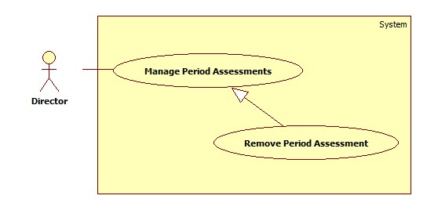

Figure : < Use Case > Remove Period Assessment

|  |  |  |  |
| --- | --- | --- | --- |
| **USE CASE –OTM025** | | | |
| **Use Case No.** | OTM025 | **Use Case Version** | 1.0 |
| **Use Case Name** | Remove Period Assessment | | |
| **Author** | Tran Thi Kim Anh | | |
| **Date** | 07/06/2015 | **Priority** | Normal |
| **Actor:**   * Director   **Summary:**   * This use case allows director to edit a period assessment.   **Goal:**   * A period assessment is removed.   **Triggers:**   * Director clicks “Remove” button on “Period Assessment” screen.   **Preconditions**:   * User login with Director Role.   **Post Conditions:**   * **Success**: The period assessment will be removes. * **Fail**: System shows error message.   **Main Success Scenario:**   |  |  |  | | --- | --- | --- | | Step | Actor Action | System Response | | 1 | Director stays at Period Assessment screen. | System shows Period Assessment screen with following contents:   * “No”: int * “Period Name”: textbox * “Period Description”: textbox * “From”: date time picker * “To”: date time picker * “Start Date”: date time picker * “Feedback Date”: date time picker * “Review Date”: date time picker * “End Date”: date time picker * “Status”: dropdown * “Remove”: button * “Edit”: button | | 2 | Director clicks “Remove” button. | System opens popup with following contents:   * “Do you want to remove this item?” message. * “Confirm”: button. * “Cancel”: button. | | 3 | Director clicks “Confirm” button.  [Alternative 1] | System shows message: “Period Assessment has been removed!” |   **Alternative Scenario:**   |  |  |  | | --- | --- | --- | | No | Actor Action | System Response | | 1 | Director clicks “Cancel” button. | System reloads and shows Period Assessment screen. |   **Exceptions:**   * N/A   **Relationships**:   * N/A   **Business Rules:**   * N/A | | | |

Table : < Use Case > Edit Period Assessment

#### <Manager>Overview Use Case

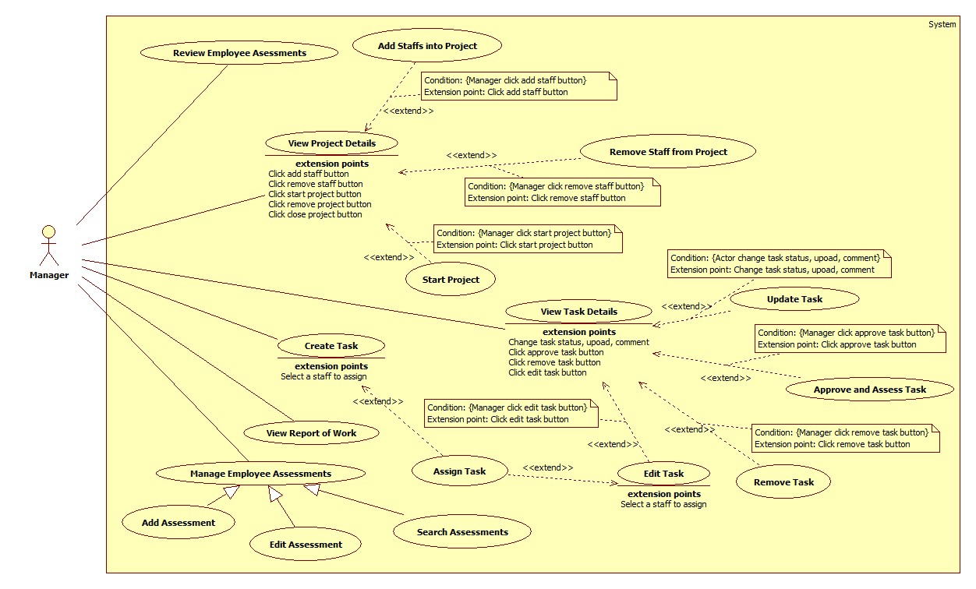

Figure : < Use Case > Manager Overview Use Case

##### <Manager> Add Staffs into Project

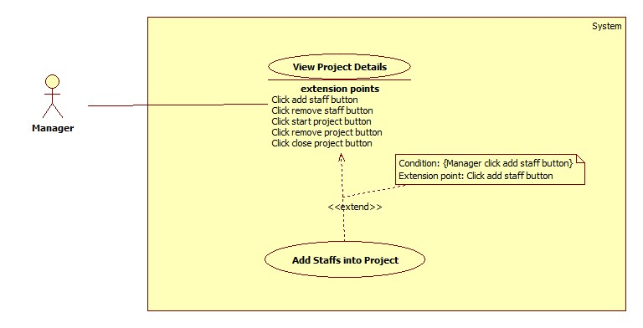

Figure : < Use Case > Add Staffs into Project

|  |  |  |  |
| --- | --- | --- | --- |
| **USE CASE – OTM26** | | | |
| **Use-case No.** | OTM026 | **Use-case Version** | 1.0 |
| **Use-case Name** | Add staffs into Project | | |
| **Author** | Le Hai Trieu | | |
| **Date** | 03/06/15 | **Priority** | High |
| **Actor:**   * Manager   **Summary:**   * This use case allows manager to add more staffs into a project.   **Goal:**   * Staffs are added into a project.   **Triggers**   * Manager clicks “Add member” on Project Detail screen.   **Preconditions:**   * User login with Manager Role.   **Post Conditions:**   * **Success**: Staffs will be added into project. * **Fail**: Nothing is shown.   **Main Success Scenario:**   |  |  |  | | --- | --- | --- | | Step | Actor Action | System Response | | 1 | Manager clicks “Add member” button on Project Detail screen. | System opens “Add member” popup with following contents:   * Tab “Search”: * “Staff’s username”: search box with autocomplete, max length: 20 * Tab “Suggest”: * “Search member…”: search box, max length 50 * “Search”: button * List staffs: data table with checkbox per record. * “Add”: button * “Save”: button * “Cancel”: button | | 2 | Manager inputs staff’s username then presses Enter, or checks in checkbox of staffs then clicks “Add” button. | System will show list of selected staffs. | | 3 | Manager clicks “Save” button.  [Alternative 1] | System closes the popup and updates database.  System shows message: “Added successfully”. |   **Alternative Scenario:**   |  |  |  | | --- | --- | --- | | No | Actor Action | System Response | | 1 | Manager clicks on “Cancel” button | System closes popup and nothing change. |   **Exceptions:**   * N/A   **Relationships:**   * Extend View Project Details (Manager clicks Add staffs button).   **Business Rules:**   * A user can join multi projects at the same time. * Because of project-based system, user can be manager of a project and can be staff of another project. * Suggested staffs in autocomplete search box in tab “Search” are all of users have role “Manager” or “Staff”. * Staffs will be showed in data table in tab “Suggest” are users have skills meet project’s need. | | | |

Table : < Use Case > Add Staffs into Project

##### <Manager> Remove Staffs form Project

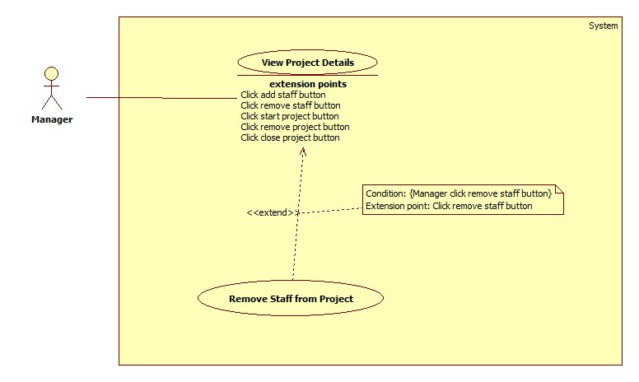

Figure : < Use Case > Remove Staffs from Project

|  |  |  |  |
| --- | --- | --- | --- |
| **USE CASE – OTM027** | | | |
| **Use-case No.** | OTM027 | **Use-case Version** | 1.0 |
| **Use-case Name** | Remove staff from Project | | |
| **Author** | Le Hai Trieu | | |
| **Date** | 03/06/15 | **Priority** | High |
| **Actor:**   * Manager   **Summary:**   * This use case allows manager to remove staff from a project.   **Goal:**   * Staff were removed from a project   **Triggers**   * Manager clicks “Remove” button in tab “Member” on Project Detail screen.   **Preconditions:**   * User login with Manager Role.   **Post Conditions:**   * **Success**: Staff will be removed from the project. * **Fail**: System shows error message.   **Main Success Scenario:**   |  |  |  | | --- | --- | --- | | Step | Actor Action | System Response | | 1 | Manager clicks “Remove” button on staff who manager want to remove from project. | System shows confirm dialog contains:   * “OK”: button * - “Cancel”: button | | 2 | Manager clicks on “OK” button.  [Alternative 1] | System closes popup and updates database.  System shows message: “Removed successfully”  [Exception 1] |   **Alternative Scenario:**   |  |  |  | | --- | --- | --- | | No | Actor Action | System Response | | 1 | Manager clicks on “Cancel” button | System closes the dialog. |   **Exceptions:**   |  |  |  | | --- | --- | --- | | No | Actor Action | System Response | | 1 | This staff is having some tasks in project with status: “Pending”, “In progress”, “Reject”, “Redo”, “Done” | System shows error message: “This member still having task in project.” |   **Relationships:**   * Extend View Project Details (Manager clicks Remove staff button).   **Business Rules:**   * A staff still having task in project cannot be removed. Please close or cancel all tasks of this staff to remove him/her from project. * History of this staff in project will be saved in database. | | | |

Table : < Use Case > Remove Staffs from Project

##### <Manager> Start Project

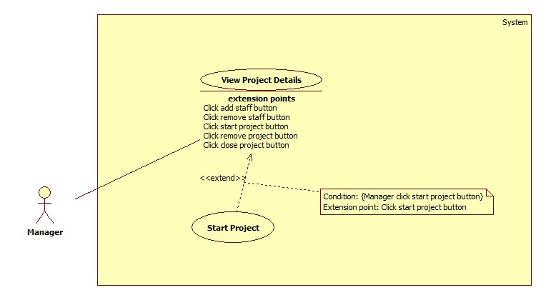

Figure : < Use Case > Start Project

|  |  |  |  |
| --- | --- | --- | --- |
| **USE CASE – OTM028** | | | |
| **Use-case No.** | OTM028 | **Use-case Version** | 1.0 |
| **Use-case Name** | Start Project | | |
| **Author** | Le Hai Trieu | | |
| **Date** | 03/06/15 | **Priority** | High |
| **Actor:**   * Manager.   **Summary:**   * This use case allows manager to start a project.   **Goal:**   * The project status is changed to “STARTED”.   **Triggers**   * Manager clicks “START” link on the project detail screen.   **Preconditions:**   * User login with Manager Role.   **Post Conditions:**   * **Success**: The project status is changed to “STARTED”. * **Fail**: System shows error message.   **Main Success Scenario:**   |  |  |  | | --- | --- | --- | | Step | Actor Action | System Response | | 1 | Manager chooses “View detail” on the project which wants to start on List Project screen. | System navigates to Project Detail screen. | | 2 | Click “START” link. | System changes Project status in database.  System shows message “The project has been started!” |   **Alternative Scenario:**   * N/A   **Exceptions:**   * N/A   **Relationships:**   * Extend View Project Details (Manager clicks Start button).   **Business Rules:**   * The Project can be started when this Project’s status is “NEW”. * If user starts the project when deadline is before system date, deadline will be set to system date. * Started Date will be set to system date. | | | |

Table : < Use Case > Start Project

##### <Manager> Create Task

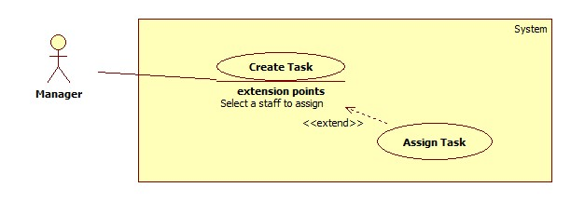

Figure : < Use Case > Create Task

|  |  |  |  |
| --- | --- | --- | --- |
| **USE CASE – OTM029** | | | |
| **Use-case No.** | OTM029 | **Use case Version** | 1.0 |
| **Use-case Name** | Create task | | |
| **Author** | Le Hai Trieu | | |
| **Date** | 03/06/15 | **Priority** | High |
| **Actor:**   * Manager   **Summary:**   * This use case allows manager to create a new task.   **Goal:**   * Task is created.   **Triggers**   * Manager clicks “Create Task” link on navigation bar.   **Preconditions:**   * User login with Manager Role.   **Post Conditions:**   * **Success**: Task will be created. * **Failure**: System shows error message.   **Main Success Scenario:**   |  |  |  | | --- | --- | --- | | Step | Actor Action | System Response | | 1 | Manager clicks “Create Task” link on navigation bar. | System opens “Create task” popup with following contents:   * “Project name”: dropdown-list * “Task name”: textbox, max length: 50 characters, not null. * “Description”: text area, max length: 200 characters * “Assign to”: dropdown-list * “Priority”: radio button * “Level”: dropdown-list, data: “Easy”, “Medium”, “Hard”. Default: “Easy” * “Deadline”: Date time picker, not null * “Create”: button * “Cancel”: button | | 2 | Manager inputs data then clicks “Create” button  [Alternative 1, 2] | System validates input data then updates database.  System shows message: “Created successfully”  [Exception 1, 2, 3] |   **Alternative Scenario:**   |  |  |  | | --- | --- | --- | | No | Actor Action | System Response | | 1 | Manager clicks “Cancel” button | System closes popup and nothing change. | | 2 | Manager clicks in a place out of range of popup. | System closes popup and nothing change. |   **Exceptions:**   |  |  |  | | --- | --- | --- | | No | Actor Action | System Response | | 1 | “Task Name” is empty | System shows error message: “Task name is required.” | | 2 | “Deadline” is empty | System shows error message: “Deadline is required” | | 3 | Deadline was selected before system’s date time | System shows error message: “Deadline must be selected after system’s date time” |   **Relationships:**   * Extended by Assign Task (Manager choose an assignee)   **Business Rules:**   * If “Assign to” is empty, status of task will be “New”. * If “Assign to” is a staff’s username, status of task will be “Pending” and task will be assigned to this staff. The assignee also receives a notification. * Status of task includes “NEW”, “PENDING”, “INPROGRESS”, “DONE”, “CLOSED” and “CANCELED”. * Created Date of task will be system’s date time at the create task time. * Ended Date of task will be system’s date time at the close task time. | | | |

Table : < Use Case > Create Task

##### <Manager> Edit Task

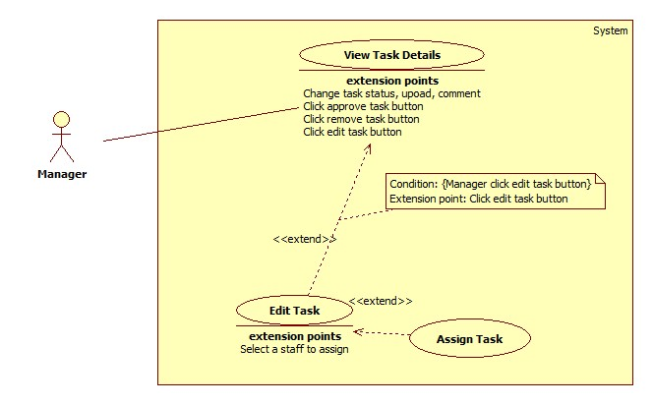

Figure : < Use Case > Edit Task

|  |  |  |  |
| --- | --- | --- | --- |
| **USE CASE – OTM030** | | | |
| **Use Case No.** | OTM030 | **Use Case Version** | 1.0 |
| **Use Case Name** | Edit Task | | |
| **Author** | Nguyen Cu Dat | | |
| **Date** | 03-06-2015 | **Priority** | Normal |
| **Actor:**   * Manager   **Summary:**   * This use case allows the manager to edit the task in his project.   **Goal:**   * Task’s detail is changed.   **Triggers:**   * Manager chooses “Edit” button on Task Detail screen.   **Preconditions**:   * User login with Manager Role. * The task must be in the project which manager manages.   **Post Conditions:**   * **Success**: Task’s detail is changed. * **Fail**: System shows error message.   **Main Success Scenario:**   |  |  |  | | --- | --- | --- | | Step | Actor Action | System Response | | 1 | Manager clicks “Edit” button on Task Detail screen. | System shows a popup with the following fields:   * “Project Name”: textbox, disabled. * “Task Name”: textbox, max length: 50 characters, not null. * “Creator Name”: textbox, disabled. * “Assignee”: drop-down list/disabled textbox. * “Deadline”: date time picker. * “Priority”: radio button. * “Level”: drop-down list. * “Description”: text area, max length 200. * “Save Changes”: button. * “Close”: button | | 2 | Manager edits and clicks “Save Changes” button  [Alternative 1, 2] | System validates all modified information.  System closes current popup and shows Task Detail screen with the content has changed.  [Exception 1] |   **Alternative Scenario:**   |  |  |  | | --- | --- | --- | | No | Actor Action | System Response | | 1 | Manager clicks “Close” button. | System closes popup and nothing change. | | 2 | Manager clicks in a place out of range of popup. | System closes popup and nothing change. |   **Exceptions:**   |  |  |  | | --- | --- | --- | | No | Actor Action | System Response | | 1 | “Task Name” is empty | System shows error message: “Task name is required.” | | 2 | “Deadline” is empty | System shows error message: “Deadline is required” | | 3 | Deadline was selected before system’s date time | System shows error message: “Deadline must be selected after system’s date time” |   **Relationships**:   * Extended by Assign Task (Manager chooses an assignee). * Extend View Task Details (Manager clicks Edit button).   **Business Rules:**   * If “Assign to” is empty, status of task will be “New”. The “Assign to” field will be a drop-down list. * If “Assign to” is a staff’s username, status of task will be “Pending” and task will be assigned to this staff. The assignee also receives a notification. * Task can be re-assign if its status is “CANCELED” or “PENDING”. * Manager cannot edit task with status “CLOSED” and “CANCELED”. | | | |

Table : < Use Case > Edit Task

##### <Manager> Approve and Assess Task

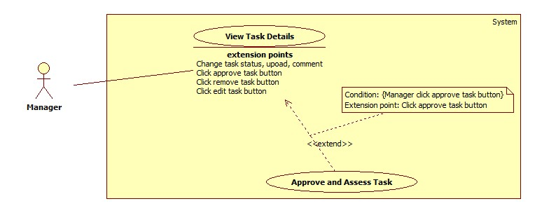

Figure : < Use Case > Approve and Assess Task

|  |  |  |  |
| --- | --- | --- | --- |
| **USE CASE – OTM031** | | | |
| **Use Case No.** | OTM031 | **Use Case Version** | 1.0 |
| **Use Case Name** | Approve and Assess Task | | |
| **Author** | Nguyen Cu Dat | | |
| **Date** | 03-06-2015 | **Priority** | High |
| **Actor:**   * Manager   **Summary:**   * This use case is allows Manager to review the task when task is done.   **Goal:**   * Task status becomes “PENDING” or “CLOSED”.   **Triggers:**   * Manager clicks the Task on Task List screen.   **Preconditions**:   * User login with Manager Role. * The task must be in the project which manager manages. * Task status must be “DONE”.   **Post Conditions:**   * **Success**: Task status becomes “PENDING” or “CLOSED”. * **Fail**: System shows error message.   **Main Success Scenario:**   |  |  |  | | --- | --- | --- | | Step | Actor Action | System Response | | 1 | Manager clicks the Task on Task List screen. | System navigates to Task Detail screen with the following contents:   * “Project Name”: link. * “Created By”: label. * “Assignee”: label. * “Approve By”: label. * “Status”: label. * “Create Date”: label. * “Deadline”: label. * “Close Date”: label. * “Priority”: label. * “Level”: label. * “Description”: label. * “Approve”: button. * “Reject”: button. | | 2 | Manager clicks on “Approve” button. | System shows new popup contains:   * “Summary”: text area, max length 200, not null. * “Mark”: drop-down list. * “Save”: button. * “Close”: button. | | 3 | Manager clicks “Save” button  [Alternative 1, 2, 3] | System closes current popup and return to dashboard.  [Exception 1] |   **Alternative Scenario:**   |  |  |  | | --- | --- | --- | | No | Actor Action | System Response | | 1 | Manager clicks “Reject” button. | Task status will be changed to “PENDING”. | | 2 | Manager clicks “Close” button. | “Summary” popup will be closed. | | 2 | Manager clicks in a place out of range of popup. | System closes popup and nothing change. |   **Exceptions:**   |  |  |  | | --- | --- | --- | | No | Actor Action | System Response | | 1 | “Summary” is empty. | System shows error message “Summary is required.” |   **Relationships**:   * Extend View Task Details(Manager click Approve button). * Include Assess Task.   **Business Rules:**   * A notification will be sent to staff when “Approve” or “Reject” button is clicked. * Task status when approved successfully will be changed to “CLOSED” and when “Reject” button was clicked, it will be changed to “PENDING”. * When manager want to reject a task, the manager must leave a reason. | | | |

Table : < Use Case > Approve and Assess Task

##### <Manager> Remove Task

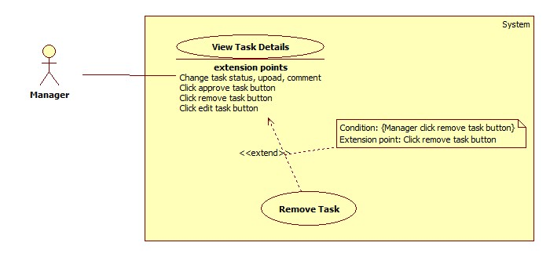

Figure : < Use Case > Remove Task

|  |  |  |  |
| --- | --- | --- | --- |
| **USE CASE –OTM032** | | | |
| **Use Case No.** | OTM032 | **Use Case Version** | 1.0 |
| **Use Case Name** | Remove Task | | |
| **Author** | Tran Thi Kim Anh | | |
| **Date** | 02/06/2015 | **Priority** | Normal |
| **Actor:**   * Manager.   **Summary:**   * This use case allows manager to remove task.   **Goal:**   * Task is removed.   **Triggers:**   * Manager clicks “Remove” button in Task Detail screen.   **Preconditions**:   * User login with Manager Role.   **Post Conditions:**   * **Success**: Task will be removed. * **Fail**: Nothing is shown.   **Main Success Scenario:**   |  |  |  | | --- | --- | --- | | Step | Actor Action | System Response | | 1 | Click a Task. | System navigates to Task Detail screen. After, system shows detail of a task. | | 2 | Click “Remove” button. | System shows popup with following content:   * “Are you sure to remove this task?” * “OK” and “Cancel” button. | | 3 | Click “OK” button.  [Alternative 1, 2] | System shows a pop-up with content: “Task was removed Successfully.” |   **Alternative Scenario:**   |  |  |  | | --- | --- | --- | | No | Actor Action | System Response | | 1 | Click “Cancel” button. | System closes popup and backs to Task Detail Screen. | | 2 | Manager clicks in a place out of range of popup. | System closes popup and nothing change. |   **Exceptions:**   * N/A   **Relationships**:   * Extend View Task Details (Manager clicks Remove task button).   **Business Rules:**   * “Remove” button only shows in screen when task status is “NEW”. * After remove tasks, at list tasks all list tasks are shown except removed tasks. * The removed task still exist in database. | | | |

Table : < Use Case > Remove Task

##### <Manager> Add Assessment

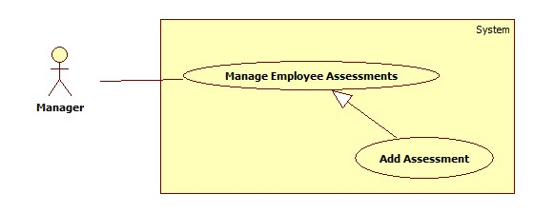

Figure : < Use Case > Add Assessment

|  |  |  |  |
| --- | --- | --- | --- |
| **USE CASE – OTM034** | | | |
| **Use Case No.** | OTM034 | **Use Case Version** | 1.0 |
| **Use Case Name** | Add Assessment | | |
| **Author** | Le Hai Trieu | | |
| **Date** | 03-06-2015 | **Priority** | High |
| **Actor:**   * Manager, Director   **Summary:**   * This use case allows Manager or Director makes a new assessment.   **Goal:**   * New assessment is added.   **Triggers:**   * User clicks “Make Assessment” on “Employee Assessment” screen.   **Preconditions**:   * User login with role “Director”, “Manager”. * User must be in the productivity assessment period.   **Post Conditions:**   * **Success**: New Assessment is added successfully. * **Fail**: System shows error message.   **Main Success Scenario:**   |  |  |  | | --- | --- | --- | | Step | Actor Action | System Response | | 1 | User clicks on “Make Assessment” button on “Employee Assessment” Page. | System shows new popup with the following contains:   * “Criterion”: label. * “Criterion Description”: label. * “Mark”: textbox type number max value 10 min value 0. * “Summary”: text area max length 200 not null. * “Close”: button. * “Done”: button | | 2 | User inputs data and clicks on Done button. | System closes current popup and shows Employee Assessment Page with the content has changed.  [Alternative 1, 2]  [Exception 1, 2, 3] |   **Alternative Scenario:**   |  |  |  | | --- | --- | --- | | No | Actor Action | System Response | | 1 | User clicks “Close” button. | Assessment Popup will be closed. | | 2 | User clicks in a place out of range of popup. | Assessment Popup will be closed. |   **Exceptions:**   |  |  |  | | --- | --- | --- | | No | Actor Action | System Response | | 1 | Mark < 0. | System shows error message “Value must be greater than or equal to 0.” | | 2 | Mark >10. | System shows error message “Value must be less than or equal to 10.” | | 3 | Summary field blank. | System shows error message “Please fill out this field”. |   **Relationships**:   * N/A   **Business Rules:**   * Right after making the assessment, the assessment status is changed to “Feedback”. * New mail will be sent to employee who is assessed to notify. | | | |

Table : < Use Case > Add Assessment

##### <Manager> Edit Assessment

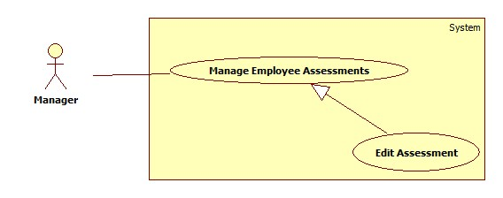

Figure : < Use Case > Edit Assessment

|  |  |  |  |
| --- | --- | --- | --- |
| **USE CASE – OTM035** | | | |
| **Use Case No.** | OTM035 | **Use Case Version** | 1.0 |
| **Use Case Name** | Edit Assessment | | |
| **Author** | Nguyen Cu Dat | | |
| **Date** | 03-06-2015 | **Priority** | High |
| **Actor:**   * Manager, Director   **Summary:**   * This use case is allows Manager or Director to edit an assessment of employee.   **Goal:**   * Employee assessment content is updated.   **Triggers:**   * Manager or Director clicks on Edit Assessment button.   **Preconditions**:   * User login with role Manager or Director. * User must be in the productivity assessment period. * Employee assessment status must be “Feedback”, “Rejected”.   **Post Conditions:**   * **Success**: Employee assessment status becomes “Waiting for Approving”. * **Fail**: System shows error message.   **Main Success Scenario:**   |  |  |  | | --- | --- | --- | | Step | Actor Action | System Response | | 1 | User clicks on “Make Assessment” button on “Employee Assessment” Page. | System shows new popup with the following contains:   * “Criterion”: label. * “Criterion Description”: label. * “Mark”: textbox type number max value 10 min value 0. * “Summary”: text area max length 200 not null. * “Edit Reason”: text area max length 200 not null. * “Close”: button. * “Edit”: button | | 2 | User inputs data and clicks on Done button. | System closes current popup and shows Employee Assessment Page with the content has changed.  [Alternative 1, 2]  [Exception 1, 2, 3, 4] |   **Alternative Scenario:**   |  |  |  | | --- | --- | --- | | No | Actor Action | System Response | | 1 | User clicks “Close” button. | Assessment Popup will be closed. | | 2 | User clicks in a place out of range of popup. | Assessment Popup will be closed. |   **Exceptions:**   |  |  |  | | --- | --- | --- | | No | Actor Action | System Response | | 1 | Mark < 0. | System shows error message “Value must be greater than or equal to 0.” | | 2 | Mark >10. | System shows error message “Value must be less than or equal to 10.” | | 3 | Summary field blank. | System shows error message “Please fill out this field”. | | 4 | Edit Reason field blank. | System shows error message “Please fill out this field”. |   **Relationships**:   * N/A   **Business Rules:**   * Right after making the assessment, the assessment status is changed to “Feedback”. * New mail will be sent to employee who is assessed to notify. * Life circle of assessment:      * Manager and staff can only see the assessment if the assessment is started. * In the productivity assessment, it have the time for Manager make assessment, after that time ended, it will be the time for Staff feedback and finally will be the time for Director review and approve assessment. * See the timeline below for more details:      * In the first milestone time will be the time for Manager evaluates employees. * In the second milestone time will be the time for Staff got assessment result and feedback to Manager. * In the third milestone time will be the time for Director review all assessments and even though staff disagrees with Manager, system will get the final result assessed by Manager. * In the final milestone time will be the time for Assessment end. | | | |

Table : < Use Case > Edit Assessment

##### <Manager> View Report of Work

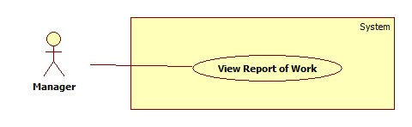

Figure : < Use Case > View Report of Work

|  |  |  |  |
| --- | --- | --- | --- |
| **USE CASE – OTM36** | | | |
| **Use-case No.** | OTM036 | **Use-case Version** | 1.0 |
| **Use-case Name** | View Report of Work | | |
| **Author** | Trần Thị Kim Anh | | |
| **Date** | 06/06/15 | **Priority** | Normal |
| **Actor:**   * Manager   **Summary:**   * This use case allows manager to view report about tasks, which they created.   **Goal:**   * Manager views statistic about task to give plan.   **Triggers**   * Manager clicks “Report” in navigation bar left.   **Preconditions:**   * User login with Manager Role.   **Post Conditions:**   * **Success**: Manager will view line chart with information of tasks. * **Failure**: Nothing is shown.   **Main Success Scenario:**   |  |  |  | | --- | --- | --- | | Step | Actor Action | System Response | | 1 | Manager clicks “Report” in navigation bar left. | System shows:   * “Task”: title. * “From”: date time * “To”: date time * “Project Name”: dropdown * “View Report about Task”: button. * Line Chart. * Note: title   [Alternative 1, 2] |   **Alternative Scenario:**   |  |  |  | | --- | --- | --- | | No | Actor Action | System Response | | 1 | Manager chooses from to and then clicks “View Report of Task” button. | System shows chart with statuses of task in period time. | | 2 | Manager chooses Project Name and then clicks “View Report about Task” button. | System shows chart with statuses of task in that project. |   **Exceptions:**   * N/A   **Relationships:**   * N/A   **Business Rules:**   * N/A | | | |

Table : < Use Case > View Report of Work

#### <Staff>Overview Use Case

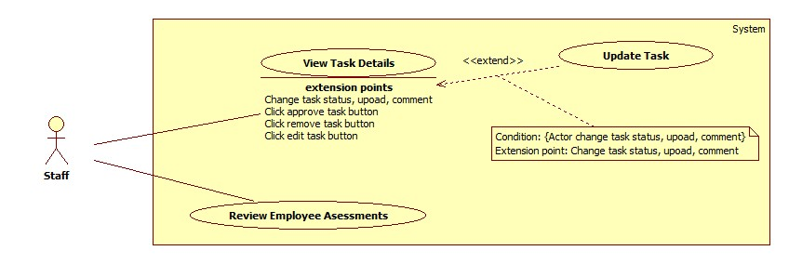

Figure : < Use Case > Staff Overview Use Case

##### <Staff> Review Employee Assessments

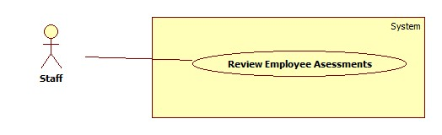

Figure : < Use Case > Review Employee Assessment

|  |  |  |  |
| --- | --- | --- | --- |
| **USE CASE – OTM042** | | | |
| **Use Case No.** | OTM042 | **Use Case Version** | 1.0 |
| **Use Case Name** | Review Employee Assessment | | |
| **Author** | Nguyễn Cự Đạt | | |
| **Date** | 03-06-2015 | **Priority** | High |
| **Actor:**   * Manager, Staff   **Summary:**   * This use case allows staff to review the assessment made by Manager. * This use case allows manager to review the assessment made by Director.   **Goal:**   * Approve or Disagree button is clicked.   **Triggers:**   * Employee chooses “View Assessment” button on Employee Assessment page.   **Preconditions**:   * User log in with role Manager or Staff. * User must be in the productivity assessment period.   **Post Conditions:**   * **Success**: Assessment status is changed. * **Fail**: Nothing is shown.   **Main Success Scenario:**   |  |  |  | | --- | --- | --- | | Step | Actor Action | System Response | | 1 | Staff clicks on “View Assessment” button on Employee Assessment Page. | System shows a popup with the following fields:   * “Criterion Name”: label. * “Criterion Description”: label. * “Mark”: label. * “Summary”: label * “Approve”: button. * “Disagree”: button | | 2 | Staff clicks “Approve” button | System closes current popup and shows Employee Assessment Page with the status has changed to “Waiting for Approving”.  [Alternative 1, 2]  [Exception 1] |   **Alternative Scenario:**   |  |  |  | | --- | --- | --- | | No | Actor Action | System Response | | 1 | Staff clicks “Disagree” button. | System closes current popup and shows Employee Assessment Page with the status has changed to “Conflict”. | | 2 | Staff clicks in a place out of range of popup. | View assessment popup will be closed. |   **Exceptions:**   * N/A   **Relationships**:   * N/A   **Business Rules:**   * Staff or Manager can use this function only when productivity assessment period is started and it must be in “Feedback Time”.      * If Manager click “Approve” button, the status become “Approved By Director”. * If Staff disagrees with their assessment, a mail will be automatic send to the creator of that assessment to notify. * If the feedback time is ended, even though staff disagrees with Manager, system will get the final result assessed by Manager. | | | |

Table : < Use Case > Review Employee Assessment

##### <Staff> View Task Details

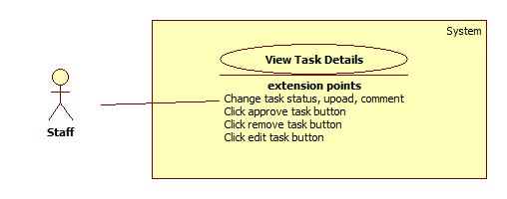

Figure : < Use Case > View Task Detail

|  |  |  |  |
| --- | --- | --- | --- |
| **USE CASE – OTM044** | | | |
| **Use Case No.** | OTM044 | **Use Case Version** | 1.0 |
| **Use Case Name** | View Task Detail | | |
| **Author** | Le Hai Trieu | | |
| **Date** | 07/06/2015 | **Priority** | High |
| **Actor:**   * Staff, manager   **Summary:**   * This use case allows staff and manager to view task detail.   **Goal:**   * Staff and manager can view task detail.   **Triggers:**   * User clicks on task name link on any screen, which contains list of tasks.   **Preconditions**:   * User login with role “Staff” or “Manager”.   **Post Conditions:**   * **Success**: User can view task detail. * **Fail**: Nothing is shown.   **Main Success Scenario:**   |  |  |  | | --- | --- | --- | | Step | Actor Action | System Response | | 1 | On any screen contains list of tasks, user clicks on name of a task. | System navigates to the Task Detail screen with following contents:   * “Task Name”: label * Tab “Overview”: * “Project Name”: label * “Task Description”: label * “Task Creator”: label * “Task Assignee”: label * “Task Approver”: label * “Task Created Date”: label * “Task Ended Date”: label * “Task Due Date”: label * “Task Level”: label * “Task Priority”: label * “Task Status”: label * Tab “Summary”: * “Task Mark”: label * “Task Summary”: label * Tab “Comments”: * “Comment”: label * “Comment Author”: label * “Comment Date”: label * “Write Comment”: text aria * Tab “Files”: * “File name”: label * “File Creator”: label * “File Created Date”: label * “Upload file”: file * Tab “Activities”: * “Activity Time”: label * “Activity Content”: label |   **Alternative Scenario:**   * N/A   **Exceptions:**   * N/A   **Relationships**:   * Extended by Upload Task(Actor change task status, upload, comment), Approve Task(Manager clicks Approve button), Remove Task(Manager clicks Remove button), Edit Task(Manager clicks Edit button).   **Business Rules:**   * “Task Approver”, “Task End Date” and tab “Summary” will be shown when status of task is “CLOSED”. * Depend on task status and roles, action buttons will be showed: * Manager role: * “NEW” status: “Remove” button * “DONE” status: “Approve” button, “Reject” button * “CLOSED” status: no button * Other status: “Cancel” button * Staff role: * “PENDING” status: “Receive” button * “INPROGRESS” status: “Done” button * Other status: no button * On mobile application: task detail screen has only “Overview” tab. | | | |

Table : < Use Case > View Task Detail

##### <Staff> Update Task

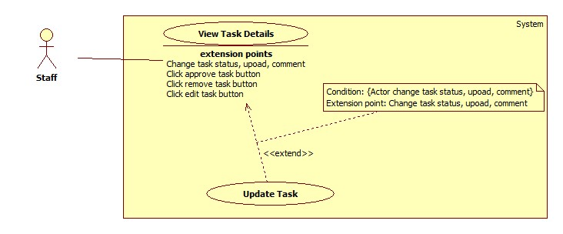

Figure : < Use Case > Update Task

|  |  |  |  |
| --- | --- | --- | --- |
| **USE CASE – OTM046** | | | |
| **Use Case No.** | OTM046 | **Use Case Version** | 1.0 |
| **Use Case Name** | Update Task | | |
| **Author** | Le Hai Trieu | | |
| **Date** | 07/06/2015 | **Priority** | High |
| **Actor:**   * Staff, Manager   **Summary:**   * This use case allows staff and manager to update a task.   **Goal:**   * Task is updated.   **Triggers:**   * The Staff clicks “Receive” or “Done” button on Task Detail screen. * Manager clicks “Approve”, “Reject”, or “Cancel” button on Task Detail screen. * Staff and manager clicks “Comment” or “Upload” button on Task Detail screen.   **Preconditions**:   * User login with role “Staff” or “Manager”.   **Post Conditions:**   * **Success**: Task is updated. * **Fail**: Nothing is shown.   **Main Success Scenario:**   |  |  |  | | --- | --- | --- | | Step | Actor Action | System Response | | 1 | - Staff clicks “Receive” or “Done” button on Task Detail screen.  - Manager clicks “Approve”, “Reject”, or “Cancel” button on Task Detail screen.  [Alternative 1, 2] | System updates status of task in database then reloads “Task Detail” screen.  System shows the task detail with another task’s status. |   **Alternative Scenario:**   |  |  |  | | --- | --- | --- | | No | Actor Action | System Response | | 1 | User inputs data into “Write comment” text area then clicks “Comment” button. | System updates comment in database then reloads “Task Detail” screen.  System shows the task detail with a new comment. | | 2 | User chooses a file in local then click “Upload” button. | System uploads file to server then reloads “Task Detail” screen.  System shows the task detail with a new file. |   **Exceptions:**   * N/A   **Relationships**:   * Extend View Task Details (Actor changes task status, upload, comment).   **Business Rules:**   * “Comment Creator” is current user and “Comment Date” is the system’s date time. * The difference between “Update task” function and “Edit task” function is this function do not change the task’s detail. “Update task” function only do the business flow of a task. * On mobile application: not supporting comment and upload files. | | | |

Table : < Use Case > Update Task

#### <Authenticated> Overview Use case

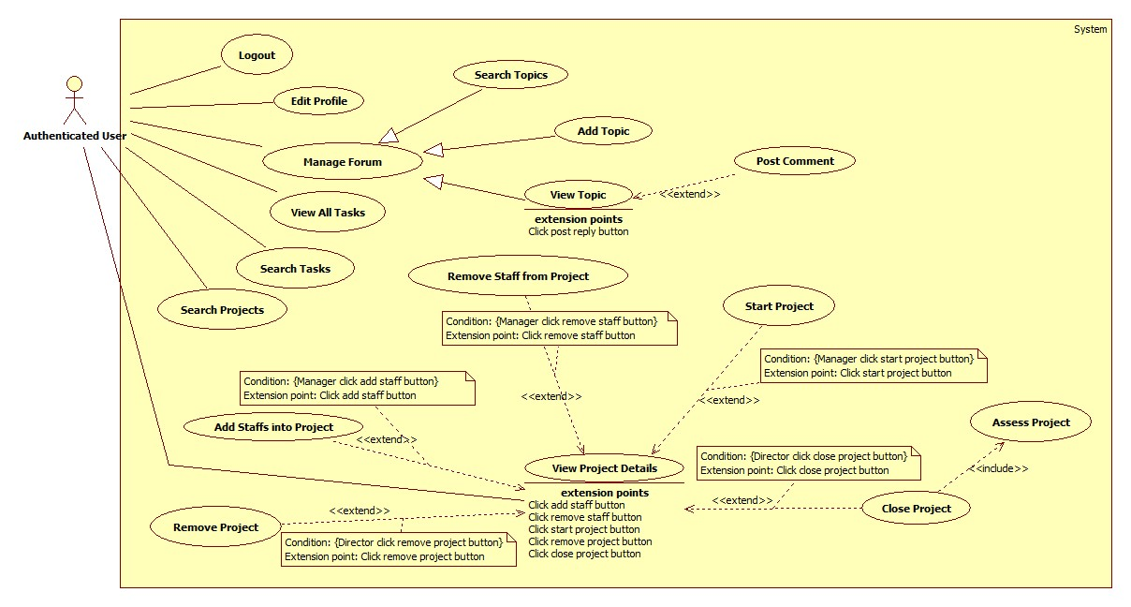

Figure : < Use Case > Authenticated Overview Use Case

##### <Authenticated> Logout

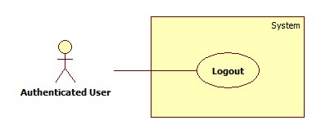

Figure : < Use Case > Logout

|  |  |  |  |
| --- | --- | --- | --- |
| **USE CASE – OTM003** | | | |
| **Use Case No.** | OTM003 | **Use Case Version** | 1.0 |
| **Use Case Name** | Logout | | |
| **Author** | Tran Thi Kim Anh | | |
| **Date** | 02/06/2015 | **Priority** | Normal |
| **Actor:**   * Admin, Staff, Manager, Director.   **Summary:**   * This use case allows user logout from the system.   **Goal:**   * User can logout from the system.   **Triggers:**   * User clicks “Logout” in Navigation bar.   **Preconditions**:   * User is logged in to the system.   **Post Conditions:**   * **Success:** User logout successfully. * **Fail**: Nothing is shown.   **Main Success Scenario:**   |  |  |  | | --- | --- | --- | | Step | Actor Action | System Response | | 1 | User clicks “Logout” link on Navigation bar. | System removes sessions then navigates to log in screen. |   **Alternative Scenario:**   * N/A   **Exceptions:**   * N/A   **Relationships**:   * N/A   **Business Rules:**   * N/A | | | |

Table : < Use Case > Logout

##### <Authenticated> Edit Profile

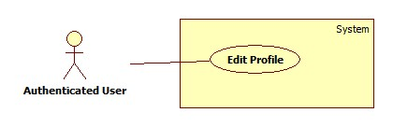

Figure : < Use Case > Edit Profile

|  |  |  |  |
| --- | --- | --- | --- |
| **USE CASE –OTM037** | | | |
| **Use Case No.** | OTM037 | **Use Case Version** | 1.0 |
| **Use Case Name** | Edit Profile | | |
| **Author** | Tran Thi Kim Anh | | |
| **Date** | 02/06/2015 | **Priority** | Normal |
| **Actor:**   * Director, Manager, Staff.   **Summary:**   * This use case allows user to edit profile.   **Goal:**   * Profile is edited.   **Triggers:**   * Admin click “Edit” button on Profile screen.   **Preconditions**:   * User login into system.   **Post Conditions:**   * **Success**: The screen shows information that was edited. * **Fail**: System shows error message.   **Main Success Scenario:**   |  |  |  | | --- | --- | --- | | Step | Actor Action | System Response | | 1 | User clicks “Edit” button. | System shows pop up with the following contents:   * “Username”: label * “Full name”: textbox, max-length 50 * “Password”: textbox, not null, max-length 20 * “Email”: label * “Birthday”: date time picker * “Sex”: radio button * “Phone number”: textbox, max-length 20 * “Address”: textbox, max-length 150 * “Role”: label * “Save”: button * “Reset”: button | | 2 | User inputs data and clicks “Save” button.  [Alternative 1] | System validates and saves into database.  System close popup and reloads Profile screen. |   **Alternative Scenario:**   |  |  |  | | --- | --- | --- | | No | Actor Action | System Response | | 1 | Click “Reset” button. | System reset to the initial values. |   **Exceptions:**   |  |  |  | | --- | --- | --- | | No | Actor Action | System Response | | 1 | “Password” is empty. | System show error message: “Password is required.” |   **Relationships**:   * N/A   **Business Rules:**   * N/A | | | |

Table : < Use Case >Edit Profile

##### <Authenticated> Search Topics

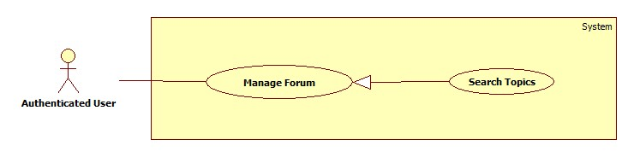

Figure : < Use Case > Search Topics

|  |  |  |  |
| --- | --- | --- | --- |
| **USE CASE – OTM038** | | | |
| **Use Case No.** | OTM038 | **Use Case Version** | 1.0 |
| **Use Case Name** | Search Topic | | |
| **Author** | Lu Cam Toan | | |
| **Date** | 07-06-2015 | **Priority** | Normal |
| **Actor:**   * Staff, Manager, Director   **Summary:**   * This use case allows the user to search a topic.   **Goal:**   * Searched results are shown.   **Triggers:**   * User clicks “Search” icon.   **Preconditions**:   * User login with Staff, Manager, or Director Role.   **Post Conditions:**   * **Success**: List of result is shown. * **Fail**: Nothing is shown.   **Main Success Scenario:**   |  |  |  | | --- | --- | --- | | Step | Actor Action | System Response | | 1 | User goes to the forum screen. | System show the forum screen includes:   * “Create Topic”: button. * “Search”: textbox, search icon and advance search icon. * “List all topics”: panel. | | 2 | User types a title in search textbox and click search icon.  [Alternative 1] | System search in database, show list of results, each result includes:   * Topic Title. * Replies. * Views. * Last post Info. |   **Alternative Scenario:**   |  |  |  | | --- | --- | --- | | No | Actor Action | System Response | | 1 | Click “Advance search” icon. | System show a panel includes:   * Topic Title: textbox. * Author: textbox. * From: date time picker. * To: date time picker. * “Search” icon button. | | 2 | User types in search textboxes and clicks search icon. | System search in database, show list of results, each result includes:   * Topic Title. * Replies. * Views. * Last post Info. |   **Exceptions:**   * N/A   **Relationships**:   * N/A   **Business Rules:**   * N/A | | | |

Table : < Use Case > Search Topic

##### <Authenticated> Add Topic

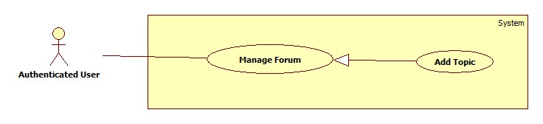

Figure : < Use Case > Add Topic

|  |  |  |  |
| --- | --- | --- | --- |
| **USE CASE – OTM039** | | | |
| **Use Case No.** | OTM039 | **Use Case Version** | 1.0 |
| **Use Case Name** | Add Topic | | |
| **Author** | Lu Cam Toan | | |
| **Date** | 07-06-2015 | **Priority** | Normal |
| **Actor:**   * Staff, Manager, Director.   **Summary:**   * This use case allows the user to add a topic in forum.   **Goal:**   * A new topic is added.   **Triggers:**   * User clicks “Create Topic” button in the forum screen.   **Preconditions**:   * User login with Staff, Manager, or Director Role. * Users go to the forum in their project.   **Post Conditions:**   * **Success**: A new topic is added and show on the topics list in the forum screen. * **Fail**: System shows error message.   **Main Success Scenario:**   |  |  |  | | --- | --- | --- | | Step | Actor Action | System Response | | 1 | User clicks “Create Topic” button in the forum screen. | System show the create topic screen includes:   * “Project Name”: label. * “Title”: textbox not null, max-length 150. * “Message”: text editor, max-length 4000. * “Attachments”: “Choose file” button. * “Submit Post”: button. * “Back”: button. | | 2 | User types in Title textbox and Message text editor, then clicks “Submit Post” button.  [Alternative 1, 2, 3, 4] | System validates the input data, update database then navigate to the forum screen.  [Exceptions 1, 2] |   **Alternative Scenario:**   |  |  |  | | --- | --- | --- | | No | Actor Action | System Response | | 1 | User click “Choose File” button. | System shows a new window. | | 2 | User choose the file want to upload and click “Open” button. | System shows the file name beside the “Upload File” button. | | 3 | User types in Title textbox and Message text editor, then clicks “Submit Post” button. | System validates the input data, update database then navigate to the forum screen.  [Exceptions 1, 2, 3] | | 4 | User click “Back” button. | System backs to the forum screen. |   **Exceptions:**   |  |  |  | | --- | --- | --- | | No | Actor Action | System Response | | 1 | Title is empty. | System shows error message “Title is required”. | | 2 | Message is empty. | System shows error message “Message is required”. | | 3 | File size over 10Mb. | System shows error message “The file is larger than the maximum size allowed.” |   **Relationships**:   * N/A   **Business Rules:**   * N/A | | | |

Use Case : < Use Case > Add Topic

##### <Authenticated> Post Comment

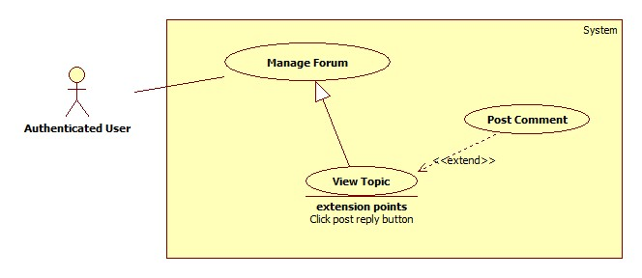

Figure : < Use Case > Post Comment

|  |  |  |  |
| --- | --- | --- | --- |
| **USE CASE – OTM040** | | | |
| **Use Case No.** | OTM040 | **Use Case Version** | 1.0 |
| **Use Case Name** | Post Comment | | |
| **Author** | Lu Cam Toan | | |
| **Date** | 07-06-2015 | **Priority** | Normal |
| **Actor:**   * Staff, Manager, Director.   **Summary:**   * This use case allows the user to post a comment in a topic.   **Goal:**   * The comment is posted in the topic screen.   **Triggers:**   * User clicks “Post Reply” button in the topic screen.   **Preconditions**:   * User login with Staff, Manager, or Director Role.   **Post Conditions:**   * **Success**: The comment is posted. * **Fail**: System shows error message.   **Main Success Scenario:**   |  |  |  | | --- | --- | --- | | Step | Actor Action | System Response | | 1 | User clicks on a Topic Title in the forum screen. | System show the topic screen includes:   * “Topic Title”: label. * “The Comments”: panel. * “Message”: text editor, max-length 4000. * “Attachments”: “Browse…” button. | | 2 | User clicks “Save change” button. | System validate the enter data, update database and back to the forum screen.  [Exceptions 1, 2] |   **Alternative Scenario:**   * N/A   **Exceptions:**   |  |  |  | | --- | --- | --- | | No | Actor Action | System Response | | 1 | Title is empty. | System shows error message “Title is required”. | | 2 | Message is empty. | System shows error message “Message is required”. |   **Relationships**:   * Extend View Topic (User clicks Post Reply button).   **Business Rules:**   * The editor must be the creator. | | | |

Table : < Use Case > Post Comment

##### <Authenticated> Search Tasks

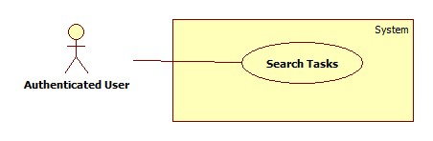

Figure : < Use Case > Search Task

|  |  |  |  |
| --- | --- | --- | --- |
| **USE CASE – OTM041** | | | |
| **Use Case No.** | OTM041 | **Use Case Version** | 1.0 |
| **Use Case Name** | Search Tasks | | |
| **Author** | Nguyen Cu Dat | | |
| **Date** | 07-06-2015 | **Priority** | Normal |
| **Actor:**   * Staff, Manager, Director   **Summary:**   * This use case is allows Staff, Manager to search tasks belong to him in the project.   **Goal:**   * List of task results is shown.   **Triggers:**   * Staff, Manager, Director clicks “Search” button on Task List screen.   **Preconditions**:   * User login with Staff, Manager, Director Role.   **Post Conditions:**   * **Success**: List of results was shown. * **Fail**: System shows error message.   **Main Success Scenario:**   |  |  |  | | --- | --- | --- | | Step | Actor Action | System Response | | 1 | Staff, Manager, Director clicks “Tasks” link on Project Detail screen. | System navigates to Task List screen with the following contents:   * “Search”: Text box * “Advanced Search”: button. * “Search”: button. | | 2 | User inputs a task name and clicks “Search” button.  [Alternative 1, 2, 3] | System validates all modified information.  Task List screen will be reloaded and shows list of results.  [Alternative 2] |   **Alternative Scenario:**   |  |  |  | | --- | --- | --- | | No | Actor Action | System Response | | 1 | User clicks “Advanced Search”. | System shows a collapse with the following contents:   * “Status”: dropdown-list * “Assignee”: dropdown-list | | 2 | User chooses value and clicks “Search” button. | System validates all information.  Task List screen will be reloaded and shows list of results.  [Alternative 2] | | 3 | No result is found. | Nothing is shown. |   **Exceptions:**   * N/A   **Relationships**:   * N/A   **Business Rules:**   * User can click on task name for viewing task details or click on project name for viewing project details. * Director cannot view task details. * Manager and Staff can view details of his/her tasks. * User cannot view task details of other people. * On mobile application: not supporting advanced search. Only support for manager and staff. | | | |

Table : < Use Case > Search Tasks

##### <Authenticated> View All Tasks

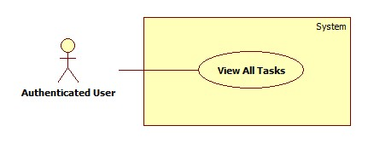

Figure : < Use Case > View All Tasks

|  |  |  |  |
| --- | --- | --- | --- |
| **USE CASE – OTM043** | | | |
| **Use Case No.** | OTM043 | **Use Case Version** | 1.0 |
| **Use Case Name** | View All Tasks | | |
| **Author** | Nguyen Cu Dat | | |
| **Date** | 06-06-2015 | **Priority** | Normal |
| **Actor:**   * Staff, Manager, Director   **Summary:**   * This use case is allows Staff, Manager, Director to view all their tasks in the project.   **Goal:**   * Tasks are shown on all Task screen.   **Triggers:**   * Staff clicks “Tasks” link on Project Detail screen.   **Preconditions**:   * User login with Staff role.   **Post Conditions:**   * **Success**: List of tasks was shown. * **Fail**: Nothing is shown.   **Main Success Scenario:**   |  |  |  | | --- | --- | --- | | Step | Actor Action | System Response | | 1 | User clicks “Tasks” link on Project Detail screen. | System navigates to Task List screen with list of tasks. |   **Alternative Scenario:**   * N/A   **Exceptions:**   * N/A   **Relationships**:   * N/A   **Business Rules:**   * On mobile application: only manager and staff can view their tasks on Dashboard. Manager and staff cannot view all tasks like web version. | | | |

Table : < Use Case > View All Tasks

##### <Authenticated> Search Projects

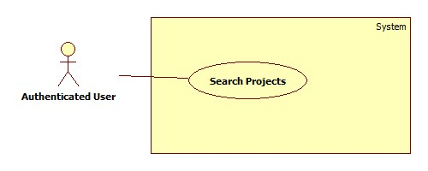

Figure : < Use Case > Search Project

|  |  |  |  |
| --- | --- | --- | --- |
| **USE CASE –OTM045** | | | |
| **Use Case No.** | OTM045 | **Use Case Version** | 1.0 |
| **Use Case Name** | Search Projects | | |
| **Author** | Le Hai Trieu | | |
| **Date** | 07/06/2015 | **Priority** | Normal |
| **Actor:**   * Staff, Manager   **Summary:**   * This use case allows user to search projects.   **Goal:**   * Searched projects are shown.   **Triggers:**   * User clicks “Search” icon on Projects screen.   **Preconditions**:   * User login with role “Staff” or “Manager”.   **Post Conditions:**   * **Success**: List of projects are shown. * **Fail**: Nothing is shown.   **Main Success Scenario:**   |  |  |  | | --- | --- | --- | | Step | Actor Action | System Response | | 1 | User clicks “Projects” tab on left Navigate bar. | System shows a page includes:   * “Search”: textbox and Search icon. * List of projects: panel. | | 2 | User types a project name in search textbox and click search icon.  [Alternative 1, 2, 3] | System search in database, show list of results, each result includes:   * Project Name. * Creator. * Manager. * Start Date. * Deadline. * Status. * View Details link. |   **Alternative Scenario:**   |  |  |  | | --- | --- | --- | | No | Actor Action | System Response | | 1 | No result | Nothing is shown. | | 2 | Click “Advance search” icon. | System show a panel includes:   * Status: dropdown list. * Creator: textbox. * Project Name: textbox. * “Search” icon button. | | 3 | User types in search textboxes and clicks search icon. | System search in database, show list of results, each result includes:   * Project Name. * Creator. * Manager. * Start Date. * Deadline. * Status. * View Details link. |   **Exceptions:**   * N/A   **Relationships**:   * N/A   **Business Rules:**   * Results on Projects screen of the staff role are projects that user had joined as a staff. * Results on Project screen of the manager role are projects that user had managed as a manager. | | | |

Figure : < Use Case > Search Projects

##### <Authenticated> View Project Details

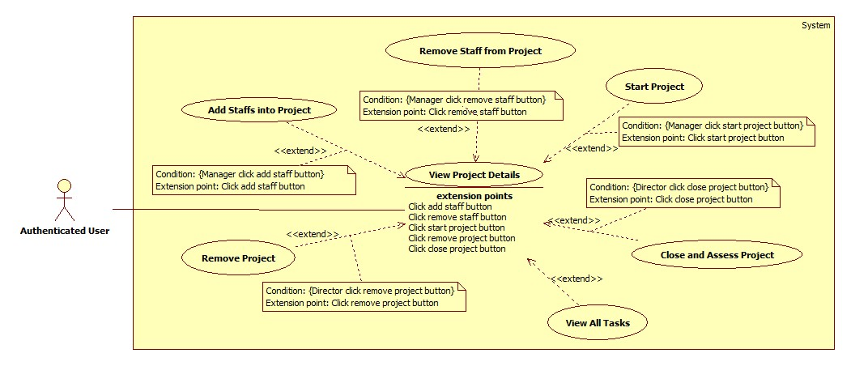

Figure : < Use Case > View Project Details

|  |  |  |  |
| --- | --- | --- | --- |
| **USE CASE – OTM033** | | | |
| **Use Case No.** | OTM033 | **Use Case Version** | 1.0 |
| **Use Case Name** | View Project Details | | |
| **Author** | Lu Cam Toan | | |
| **Date** | 07-06-2015 | **Priority** | Normal |
| **Actor:**   * Staff, Manager, Director.   **Summary:**   * This use case allows the users to view the project detail information.   **Goal:**   * The project detail information is shown.   **Triggers:**   * User clicks “View details” on the panel in the list project screen.   **Preconditions**:   * User go to the list projects screen.   **Post Conditions:**   * **Success**: The project detail screen shows the information of the project. * **Fail**: Nothing is shown.   **Main Success Scenario:**   |  |  |  | | --- | --- | --- | | Step | Actor Action | System Response | | 1 | User clicks “View Details” on the panel in the list project screen. | System show the information of project, include 2 tabs:   * “Overview” tab contains: * “Project Creator”: label. * “Project Manager”: label. * “Skills”: label. * “Start Date”: label. * “Due Date”: label. * “Status”: label. * “Description”: label. * “START”: link * “Edit”: link. * “Remove”: link. * “Close”: link. * “Tasks”: link * “Add member”: link * “Forum”: link * “Members” tab contains: * Every panel shows a member of the project. |   **Alternative Scenario:**   * N/A   **Exceptions:**   * N/A   **Relationships**:   * Extended by Remove Project (Director clicks Remove Project button), extended by Add Staffs into Project (Manager clicks Add staff button), extended by Remove Staff from Project (Manager clicks Remove button), extended by Start Project (Manager clicks Start button), extended by Close Project (Director clicks Close Project button).   **Business Rules:**   * User log in as Staff role can not see the “START”, “Edit”, “Remove”, “Close”, “Add Member” link. * User log in as Manager role can not see the “Close” link. | | | |

Table : < Use Case > View Project Detail

## Software System Attribute

### Usability

* Use simple and understandable words, enabling users manipulate easily in the first time.
* Has a simple User Interface to help user to perform easily.
* Enable users to use the system fluently after 2 days of training.

### Reliability

* + Backup data once a month.

### Availability

* Uptime of the server will be 24/7.
* At the end of the month, website will be unavailable because of backup data.

### Security

* An employee has a unique account with a specific permission.
* Only the owner of account can edit and view their information and password.
* Password will be sent via company-registered email.

### Maintainability

* + In case having any technical error, the problem will be repaired within acceptable time.

### Portability

* + Current system is running on Windows 7 and Android OS 4.1.2 or above.
  + The system is deployed on Windows OS server; because of using Microsoft SQL server.

### Performance

* N/A

## Conceptual Diagram

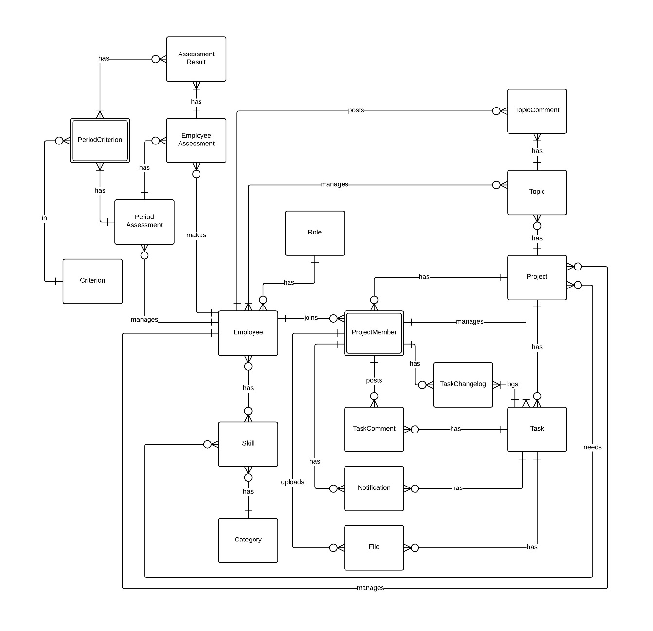

Figure : Conceptual Diagram

**Data Dictionary**

|  |  |
| --- | --- |
| **Conceptual Diagram dictionary: Describe Entity** | |
| **Entity** | **Description** |
| Employee | Describe all employees that are working in the company. |
| Project | Describe all projects in the system. |
| Project Member | Describe all employees that are working in a project. |
| Task | Describe all tasks in the project. |
| Role | Describe all roles in the system. |
| Task Change log | Describe all history of tasks in the system. |
| Topic | Describe all topics in a project. |
| Topic Comment | Describe all comments in a topic |
| Task Comment | Describe all comments in a task. |
| File | Describe all files in tasks. |
| Assessment Result | Describe results of employee assessment. |
| Employee Assessment | Describe employee assessments in period assessment. |
| Period Assessment | Describe period assessments each year. |
| Skill | Describe all skills that belong to categories in the system. |
| Category | Describe all categories that skills belong to in the system. |
| Criterion | Describe criterions in period assessment |
| Notification | Describe notification of a task, which employee will receive when task is assigned to them or changed. |
| PeriodCriterion | Describe all criterions that have in period assessment. |

Table : <Conceptual Diagram> Dictionary

# Software Design Description

## Design Overview

This document describes the technical and user interface design of OTM System. It includes the architectural design, the detailed design of common functions and business functions and the design of database model.

The architectural design describes the overall architecture of the system and the architecture of each main component and subsystem.

The detailed design describes static and dynamic structure for each component and functions. It includes class diagrams, class explanations and sequence diagrams for each use cases.

The database design describes the relationships between entities and details of each entity.

Document overview:

* Section 2: gives an overall description of the system architecture design.
* Section 3: gives component diagrams that describe the connection and integration of the system.
* Section 4: gives the detail design description, which includes class diagram, class explanation, and sequence diagram to details the application functions.
* Section 5: describe screens design.
* Section 6: describe a fully attributed ERD.
* Section 7: describe algorithms

## System Architectural Design

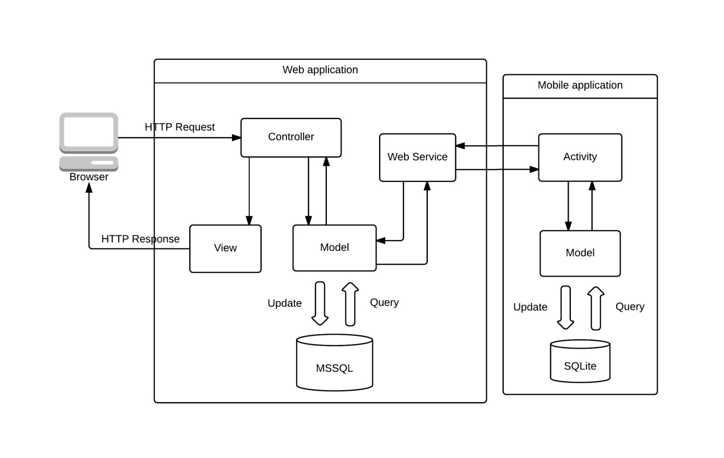

Figure : System Architectural Diagram

### Web application architecture description

* Web application is developed from MVC architectural style and is integrated with RESTful Web Service technology:
  + **Model:** is used to store and represent data in the web application.
  + **View:** is used to visualize data and generate an output representation to the user interface.
  + **Controller**: is used to call model for getting data and redirect data to the suitable view.
  + **Web Service**: is used to provide an interface for mobile application can get and update data in database.

### Mobile application architecture description

* Mobile application is developed as a native application on Android:
  + **Activity:** is used to call web service for interacting with database and provide a user interface that allows user to make actions.
  + **Model:** is similar to model in web application. This model is used to interact with local database on mobile.
  + **SQLite:** is a local database that is used to store user’s personal data

## Component Diagram

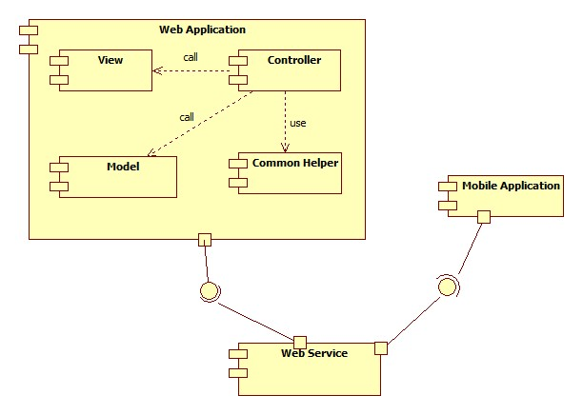

Figure : Component Diagram

|  |  |
| --- | --- |
| **Component dictionary: describe component** | |
| **Component Name** | **Description** |
| View | All views of the system. |
| Controller | All controllers of the system. |
| Component Helper | Some common functions like paging, filters. |
| Mobile Application | Application for mobile user. |
| Model | All models of the system |
| Web Service | Include all web API controller of the system. |

Table : <Component> Description

## Detailed Description

### Class Diagram

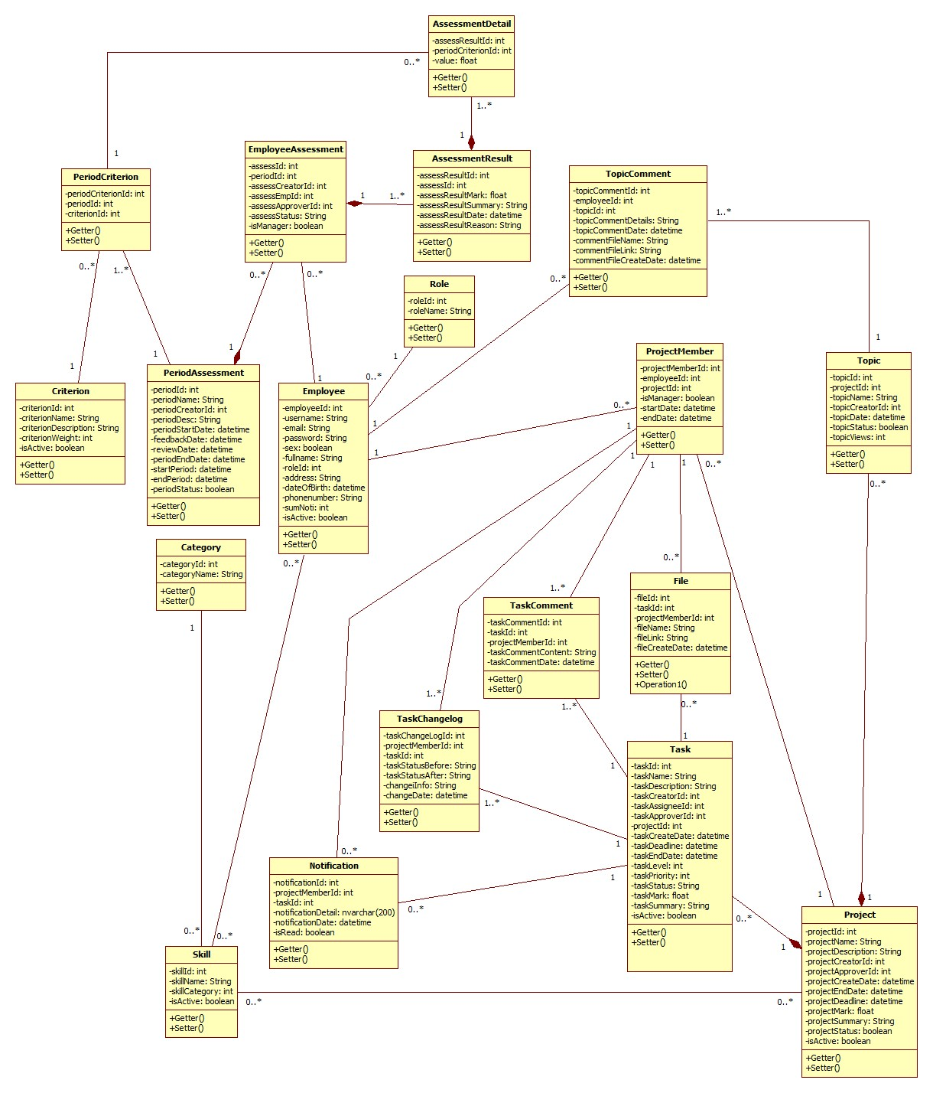

Figure : Class Diagram

|  |  |
| --- | --- |
| **Class Diagram dictionary: Describe Entity** | |
| **Entity** | **Description** |
| Employee | Describe all employees that are working in the company. |
| Project | Describe all projects in the system. |
| ProjectMember | Describe all employees that are working in a project. |
| Task | Describe all tasks in the project. |
| Role | Describe all roles in the system. |
| TaskChangelog | Describe all history of tasks in the system. |
| Topic | Describe all topics in a project. |
| TopicComment | Describe all comments in a topic |
| TaskComment | Describe all comments in a task. |
| File | Describe all files in tasks. |
| AssessmentResult | Describe results of employee assessment. |
| EmployeeAssessment | Describe employee assessments in period assessment. |
| PeriodAssessment | Describe period assessments each year. |
| Skill | Describe all skills that belong to categories in the system. |
| Category | Describe all categories that skills belong to in the system. |
| Criterion | Describe criterions in period assessment |
| Notification | Describe notification of a task, which employee will receive when task is assigned to them or changed. |
| PeriodCriterion | Describe all criterions that have in period assessment. |
| AssessmentDetail | Describe detail of an assessment. |

Table : <Class diagram> Dictionary

### Class Diagram Explanation

#### Employee

Attribute

|  |  |  |  |
| --- | --- | --- | --- |
| **Attribute** | **Type** | **Visibility** | **Description** |
| employeeId | int | Private | Unique identifier of an employee |
| username | String | Private | User name |
| email | String | Private | Email of user |
| password | String | Private | Password of user |
| sex | Boolean | Private | Sex of user |
| fullName | String | Private | Full name of user |
| roleId | int | Private | Role of user in company |
| address | String | Private | Address of user |
| dateOfBirth | datetime | Private | Birthday of user |
| phonenumber | String | Private | Phone number of user |
| sumNoti | int | Private | Sum of notification |
| isActive | Boolean | Private | Status of user |

Table : <Employee> Attribute

Method

|  |  |  |  |
| --- | --- | --- | --- |
| **Method** | **Return type** | **Visibility** | **Description** |
| Getter | Attribute type | Public | Get attribute value |
| Setter | Void | Public | Set value of attribute |

Table : <Employee> Method

#### Project

Attribute

|  |  |  |  |
| --- | --- | --- | --- |
| **Attribute** | **Type** | **Visibility** | **Description** |
| projectId | int | Private | Unique identifier of a project |
| projectName | String | Private | Project name |
| projectDescription | String | Private | Description of a project |
| projectCreatorId | int | Private | Identifier of creator |
| projectApproverId | int | Private | Identifier of approver |
| projectCreateDate | datetime | Private | Date time creates project |
| projectEndDate | datetime | Private | Date time ends project |
| projectDeadline | datetime | Private | Deadline of a project |
| projectMark | float | Private | Mark of project |
| projectSummary | String | Private | Summary of project |
| projectStatus | boolean | Private | Status of project |
| isActive | boolena | Private | Active or Deactivate status of Project |

Table : <Project> Attribute

Method

|  |  |  |  |
| --- | --- | --- | --- |
| **Method** | **Return type** | **Visibility** | **Description** |
| Getter | Attribute type | Public | Get attribute value |
| Setter | Void | Public | Set value of attribute |

Table : <Project> Method

#### Project Member

Attribute

|  |  |  |  |
| --- | --- | --- | --- |
| **Attribute** | **Type** | **Visibility** | **Description** |
| projectMemberId | int | Private | Unique identifier of a project member |
| employeeId | int | Private | Identifier of employee |
| projectId | int | Private | Identifier of project |
| roleInProjectId | int | Private | Identifier of role in project |
| startDate | datetime | Private | Date time that member starts to join into project |
| EndDate | datetime | Private | Date time that member removes from project |

Table : <Project Member> Attribute

Method

|  |  |  |  |
| --- | --- | --- | --- |
| **Method** | **Return type** | **Visibility** | **Description** |
| Getter | Attribute type | Public | Get attribute value |
| Setter | Void | Public | Set value of attribute |

Table : <Project Member> Method

#### Task

Attribute

|  |  |  |  |
| --- | --- | --- | --- |
| **Attribute** | **Type** | **Visibility** | **Description** |
| taskId | int | Private | Unique identifier of a task |
| taskName | String | Private | Task name |
| taskDescription | String | Private | Description of a task |
| taskCreatorId | int | Private | Identifier of creator |
| taskAssigneeId | int | Private | Identifier of assignee |
| taskApproverId | int | Private | Identifier of Approver |
| projectId | int | Private | Identifier of a project |
| taskCreateDate | datetime | Private | Date time creates task |
| taskDeadline | datetime | Private | Date time limits task |
| taskEndDate | datetime | Private | Date time ends task |
| taskLevel | int | Private | Level of task |
| taskPriority | int | Private | Priority of task |
| taskStatus | String | Private | Status of task |
| taskMark | float | Private | Mark of task |
| taskSummary | String | Private | Summary of task |
| isActive | Boolean | Private | Active or Deactivate status of task |

Table : <Task> Attribute

Method

|  |  |  |  |
| --- | --- | --- | --- |
| **Method** | **Return type** | **Visibility** | **Description** |
| Getter | Attribute type | Public | Get attribute value |
| Setter | Void | Public | Set value of attribute |

Table : <Task> Method

#### Role

Attribute

|  |  |  |  |
| --- | --- | --- | --- |
| **Attribute** | **Type** | **Visibility** | **Description** |
| roleId | int | Private | Unique identifier of a role |
| roleName | String | Private | Role name |

Table : <Role> Attribute

Method

|  |  |  |  |
| --- | --- | --- | --- |
| **Method** | **Return type** | **Visibility** | **Description** |
| Getter | Attribute type | Public | Get attribute value |
| Setter | Void | Public | Set value of attribute |

Table : <Role> Method

#### Task Change log

Attribute

|  |  |  |  |
| --- | --- | --- | --- |
| **Attribute** | **Type** | **Visibility** | **Description** |
| taskChangeLogId | int | Private | Unique identifier of a task change log |
| employeeId | int | Private | Identifier of employee |
| taskId | int | Private | Identifier of task |
| taskStatusBefore | String | Private | Status of task before changing |
| taskStatusAfter | String | Private | Status of task after changing |
| changeInfo | String | Private | Information of changing |
| changeDate | datetime | Private | Date time of task is changed |

Table : <Task change log> Attribute

Method

|  |  |  |  |
| --- | --- | --- | --- |
| **Method** | **Return type** | **Visibility** | **Description** |
| Getter | Attribute type | Public | Get attribute value |
| Setter | Void | Public | Set value of attribute |

Table : <Task Changelog> Method

#### Topic

Attribute

|  |  |  |  |
| --- | --- | --- | --- |
| **Attribute** | **Type** | **Visibility** | **Description** |
| topicId | int | Private | Unique identifier of a topic |
| projectId | int | Private | Identifier of project |
| topicName | String | Private | Topic name |
| topicCreatorId | int | Private | Identifier of creator |
| topicDate | datetime | Private | Date time creates topic |
| topicStatus | Boolean | Private | Status of topic |
| topicViews | int | Private | Amount of user view topic |

Table : <Topic> Attribute

Method

|  |  |  |  |
| --- | --- | --- | --- |
| **Method** | **Return type** | **Visibility** | **Description** |
| Getter | Attribute type | Public | Get attribute value |
| Setter | Void | Public | Set value of attribute |

Table : <Topic> Method

#### Topic Comment

Attribute

|  |  |  |  |
| --- | --- | --- | --- |
| **Attribute** | **Type** | **Visibility** | **Description** |
| topicCommentId | int | Private | Unique identifier of a topic comment |
| employeeId | int | Private | Identifier of employee |
| topicId | int | Private | Identifier of topic |
| topicCommentDetail | String | Private | Detail of topic comment |
| topicCommentDate | Date time | Private | Date time of creates topic comment |

Table : <Topic Comment> Attribute

Method

|  |  |  |  |
| --- | --- | --- | --- |
| **Method** | **Return type** | **Visibility** | **Description** |
| Getter | Attribute type | Public | Get attribute value |
| Setter | Void | Public | Set value of attribute |

Table : <Topic Comment> Method

#### Task Comment

Attribute

|  |  |  |  |
| --- | --- | --- | --- |
| **Attribute** | **Type** | **Visibility** | **Description** |
| taskCommentId | int | Private | Unique identifier of a task comment |
| taskId | int | Private | Identifier of task |
| employeeId | int | Private | Identifier os employee |
| taskCommentContent | String | Private | Content of task comment |
| taskComment Date | date time | Private | Date time of task comments |

Table : <Task Comment> Attribute

Method

|  |  |  |  |
| --- | --- | --- | --- |
| **Method** | **Return type** | **Visibility** | **Description** |
| Getter | Attribute type | Public | Get attribute value |
| Setter | Void | Public | Set value of attribute |

Table : <Task Comment> Method

#### File

Attribute

|  |  |  |  |
| --- | --- | --- | --- |
| **Attribute** | **Type** | **Visibility** | **Description** |
| fileId | int | Private | Unique identifier of a file |
| taskId | int | Private | Identifier of task |
| employeeId | int | Private | Identifier of employee |
| fileName | String | Private | File name |
| fileLink | String | Private | File link |
| fileCreateDate | datetime | Private | Date time creates file |

Table : <File> Attribute

Method

|  |  |  |  |
| --- | --- | --- | --- |
| **Method** | **Return type** | **Visibility** | **Description** |
| Getter | Attribute type | Public | Get attribute value |
| Setter | Void | Public | Set value of attribute |

Table : <File> Method

#### Comment File

Attribute

|  |  |  |  |
| --- | --- | --- | --- |
| **Attribute** | **Type** | **Visibility** | **Description** |
| commentFileId | int | Private | Unique identifier of a comment file |
| topicCommentId | int | Private | Identifier of topic comment |
| commentFileName | String | Private | Comment File name |
| commentFileLink | String | Private | Comment File link |
| commentFileCreateDate | datetime | Private | Date time creates comment file |

Table : <Comment File> Attribute

Method

|  |  |  |  |
| --- | --- | --- | --- |
| **Method** | **Return type** | **Visibility** | **Description** |
| Getter | Attribute type | Public | Get attribute value |
| Setter | Void | Public | Set value of attribute |

Table : <Comment File> Method

#### Assessment Result

Attribute

|  |  |  |  |
| --- | --- | --- | --- |
| **Attribute** | **Type** | **Visibility** | **Description** |
| assessResultId | int | Private | Unique identifier of a assessment result |
| assessId | int | Private | Identifier of assessment |
| assessResultMark | float | Private | Mark in assessment result |
| assessResultSummary | String | Private | Summary of assessment result |
| assessResultDate | datetime | Private | Date time creates assessment Result |
| assessResultReason | String | Private | Reason of assessment result |

Table : <Assessment Result> Attribute

Method

|  |  |  |  |
| --- | --- | --- | --- |
| **Method** | **Return type** | **Visibility** | **Description** |
| Getter | Attribute type | Public | Get attribute value |
| Setter | Void | Public | Set value of attribute |

Table : <Assessment Result> Method

#### Employee Assessment

Attribute

|  |  |  |  |
| --- | --- | --- | --- |
| **Attribute** | **Type** | **Visibility** | **Description** |
| assessId | int | Private | Unique identifier of a assessment |
| periodId | int | Private | Identifier of period. |
| assessCreatorId | int | Private | Identifier of creator |
| assessEmpId | int | Private | Identifier of employee |
| assessApproverId | int | Private | Identifier of approver |
| assessStatus | String | Private | Status of assessment |
| isManager | Boolean | Private | Has or not manager |

Table : <Employee Assessment> Attribute

Method

|  |  |  |  |
| --- | --- | --- | --- |
| **Method** | **Return type** | **Visibility** | **Description** |
| Getter | Attribute type | Public | Get attribute value |
| Setter | Void | Public | Set value of attribute |

Table : <Employee Assessment> Method

#### Period Assessment

Attribute

|  |  |  |  |
| --- | --- | --- | --- |
| **Attribute** | **Type** | **Visibility** | **Description** |
| periodId | int | Private | Unique identifier of a period |
| periodName | String | Private | Period name |
| periodDescription | String | Private | Period description |
| periodStartDate | datetime | Private | Date time that period starts |
| feedbackDate | datetime | Private | Date time to feedback |
| reviewDate | datetime | Private | Date time to review |
| periodEndDate | datetime | Private | Date time that period ends |
| startPeriod | datetime | Private | Date time creates period |
| endPeriod | datetime | Private | Date time ends period |
| periodStatus | boolean | Private | Status of period |

Table : <Period Assessment> Attribute

Method

|  |  |  |  |
| --- | --- | --- | --- |
| **Method** | **Return type** | **Visibility** | **Description** |
| Getter | Attribute type | Public | Get attribute value |
| Setter | Void | Public | Set value of attribute |

Table : <Period Assessment> Method

#### Skill

Attribute

|  |  |  |  |
| --- | --- | --- | --- |
| **Attribute** | **Type** | **Visibility** | **Description** |
| skillId | int | Private | Unique identifier of a skill |
| skillName | String | Private | Skill name |
| skillCategory | int | Private | Unique identifier of a category |
| isActive | Boolean | Private | Status of skill |

Table : <Skill> Attribute

Method

|  |  |  |  |
| --- | --- | --- | --- |
| **Method** | **Return type** | **Visibility** | **Description** |
| Getter | Attribute type | Public | Get attribute value |
| Setter | Void | Public | Set value of attribute |

Table : <Skill> Method

#### Category

Attribute

|  |  |  |  |
| --- | --- | --- | --- |
| **Attribute** | **Type** | **Visibility** | **Description** |
| categoryId | int | Private | Unique identifier of a category |
| categoryName | String | Private | Category name |

Table : <Category> Attribute

Method

|  |  |  |  |
| --- | --- | --- | --- |
| **Method** | **Return type** | **Visibility** | **Description** |
| Getter | Attribute type | Public | Get attribute value |
| Setter | Void | Public | Set value of attribute |

Table : <Category> Method

#### Criterion

Attribute

|  |  |  |  |
| --- | --- | --- | --- |
| **Attribute** | **Type** | **Visibility** | **Description** |
| criterionId | int | Private | Unique identifier of a criterion |
| criterionName | String | Private | Criterion name |
| criterionDescription | String | Private | Criterion description |
| criterionWeight | int | Private | Criterion weight |
| isActive | boolean | Private |  |

Table : <Criterion> Attribute

Method

|  |  |  |  |
| --- | --- | --- | --- |
| **Method** | **Return type** | **Visibility** | **Description** |
| Getter | Attribute type | Public | Get attribute value |
| Setter | Void | Public | Set value of attribute |

Table : <Criterion> Method

#### Notification

Attribute

|  |  |  |  |
| --- | --- | --- | --- |
| **Attribute** | **Type** | **Visibility** | **Description** |
| notificationId | int | Private | Unique identifier of a notification |
| employeeId | int | Private | Unique identifier of an employee |
| taskId | int | Private | Unique identifier of a task |
| notificationDetail | int | Private | Detail of notification |
| isRead | boolean | Private | Read or not read status of Notification |

Table : <Criterion> Attribute

Method

|  |  |  |  |
| --- | --- | --- | --- |
| **Method** | **Return type** | **Visibility** | **Description** |
| Getter | Attribute type | Public | Get attribute value |
| Setter | Void | Public | Set value of attribute |

Table : <Criterion> Method

#### PeriodCriterion

Attribute

|  |  |  |  |
| --- | --- | --- | --- |
| **Attribute** | **Type** | **Visibility** | **Description** |
| periodCriterionId | int | Private | Unique identifier of a PeriodCriterion |
| periodId | int | Private | Unique identifier of a period |
| criterionId | int | Private | Unique identifier of a criterion |

Table : <PeriodCriterion> Attribute

Method

|  |  |  |  |
| --- | --- | --- | --- |
| **Method** | **Return type** | **Visibility** | **Description** |
| Getter | Attribute type | Public | Get attribute value |
| Setter | Void | Public | Set value of attribute |

Table : <PeriodCriterion> Method

#### AssessmentDetail

Attribute

|  |  |  |  |
| --- | --- | --- | --- |
| **Attribute** | **Type** | **Visibility** | **Description** |
| assessResultId | int | Private | Unique identifier of a AssessResult |
| periodCriterionId | int | Private | Unique identifier of a PeriodCriterion |
| value | float | Private | Mark of a criterion |

Table : <AssessmentDetail> Attribute

Method

|  |  |  |  |
| --- | --- | --- | --- |
| **Method** | **Return type** | **Visibility** | **Description** |
| Getter | Attribute type | Public | Get attribute value |
| Setter | Void | Public | Set value of attribute |

Table : <AssessmentDetail> Method

### Interaction Diagram

#### Sequence Diagram

##### <Guest> Login

**Summary:** This diagram shows how guests log into the system.

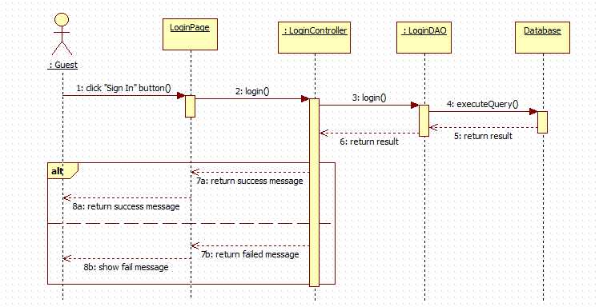

Figure : <Guest> Login

##### <Guest> Reset Password

**Summary:** This diagram shows how reset password guest.

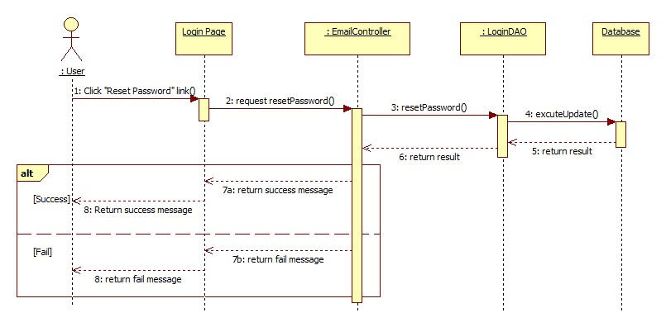

Figure : <Sequence Diagram> Reset Password

##### <Admin> Logout

**Summary:** This diagram shows how member logout of the system.

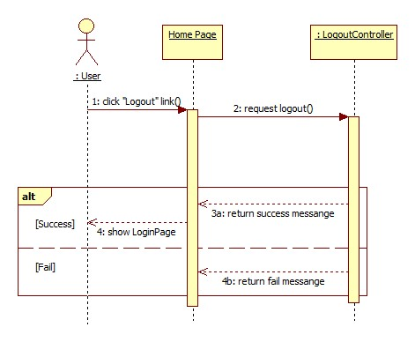

Figure : <Sequence Diagram> Logout

##### <Admin> Search Accounts

**Summary:** This diagram shows how admin search accounts.

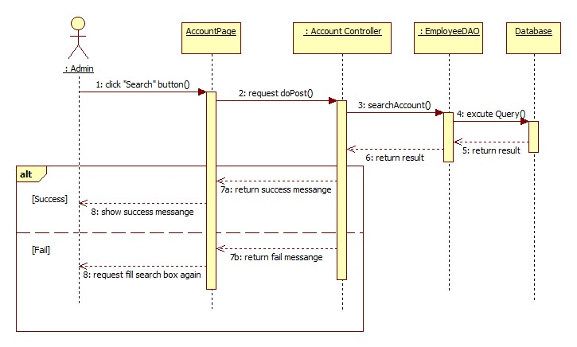

Figure : <Sequence Diagram> Search Accounts

##### <Admin> Add Account

**Summary:** This diagram shows how admin adds account.

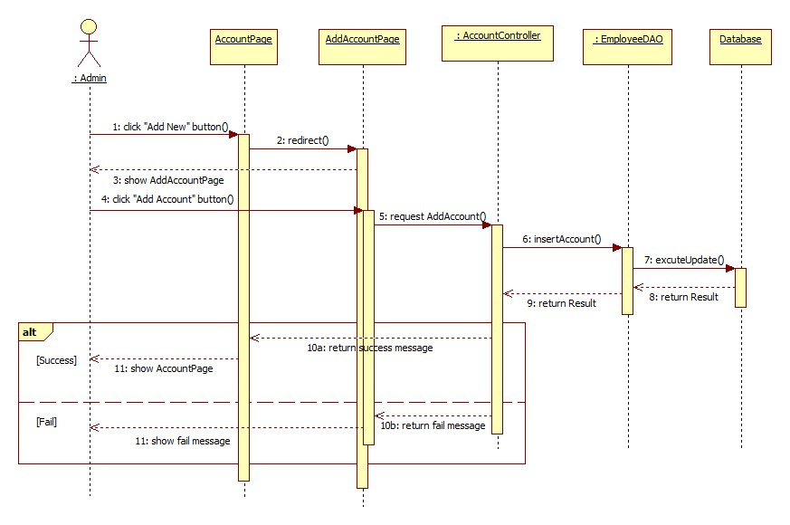

Figure : <Sequence Diagram> Add Account

##### <Admin> Edit Account

**Summary:** This diagram shows how admin edits account.

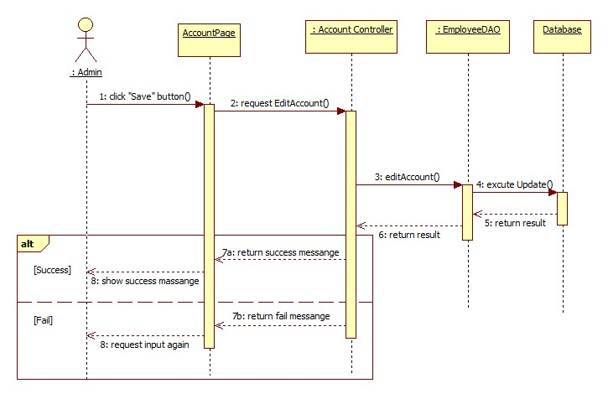

Figure : <Sequence Diagram> Edit Account

##### <Admin> Search Skills

**Summary:** This diagram shows how admin search skills.

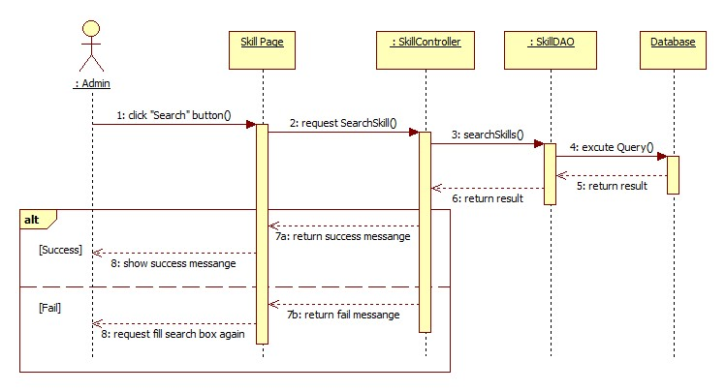

Figure : <Sequence Diagram> Search Skills

##### <Admin> Add Skill

**Summary:** This diagram shows how admin adds skill.

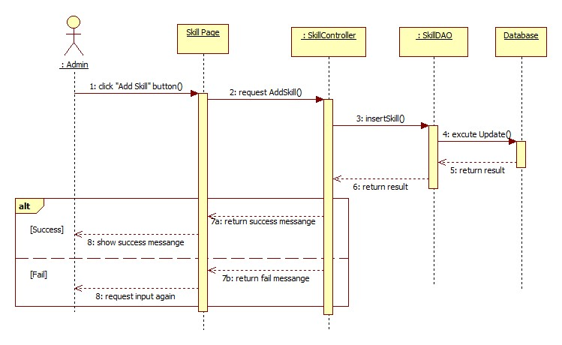

Figure : <Sequence Diagram> Add Skill

##### <Admin> Edit Skill

**Summary:** This diagram shows how admin updates skill.

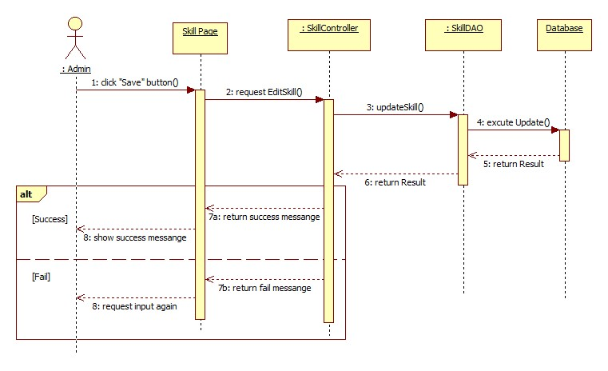

Figure : <Sequence Diagram> Edit Skill

##### <Admin> Add Category

**Summary:** This diagram shows how admin adds a new category.

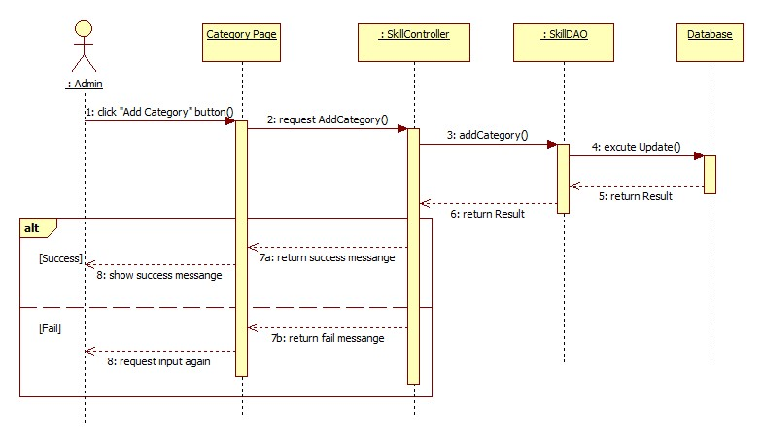

Figure : <Sequence Diagram> Add Category

##### <Admin> Search Criterion

**Summary:** This diagram shows how admin search criterion.

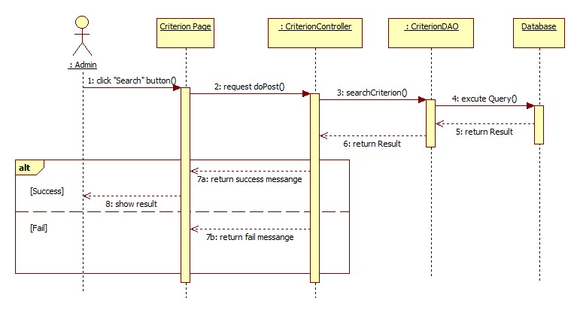

Figure : <Sequence Diagram> Search Criterions

##### <Admin> Create Criterion

**Summary:** This diagram shows how admin creates criterion.

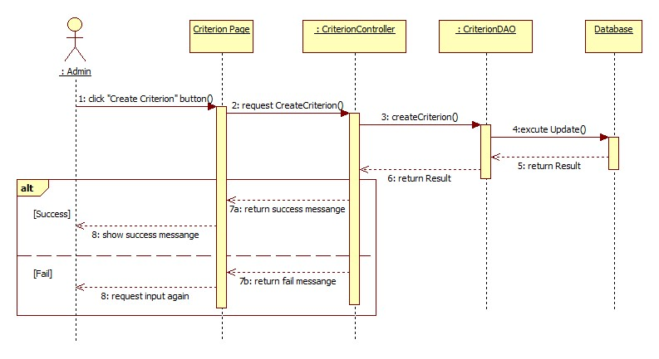

Figure : <Sequence Diagram> Create Criterion

##### <Admin> Edit Criterion

**Summary:** This diagram shows how admin edit criterion.

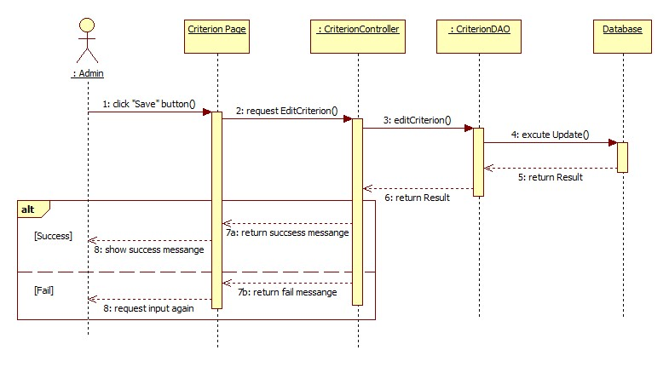

Figure : <Sequence Diagram> Edit Criterion

##### <Director> Create Project

**Summary:** This diagram shows how director creates project.

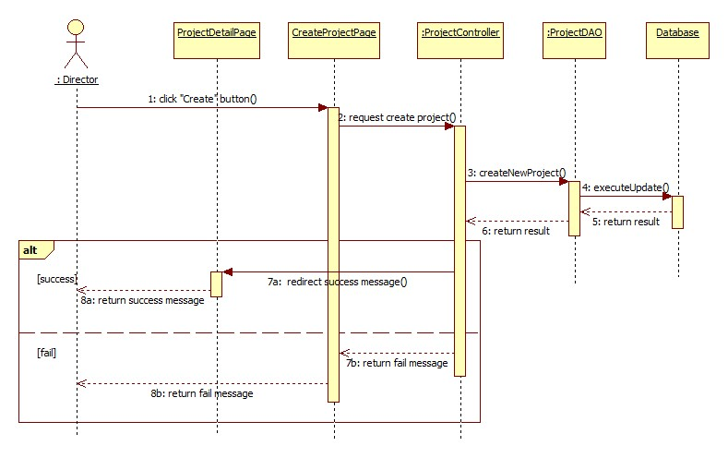

Figure : <Sequence Diagram> Create Project

##### <Director> Edit Project

**Summary:** This diagram shows how director updates project.

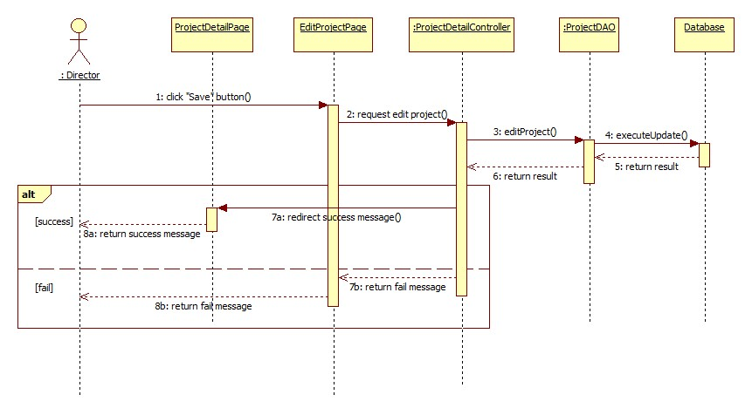

Figure : <Sequence Diagram> Edit Project

##### <Director> Start Project

**Summary:** This diagram shows how director closes project.

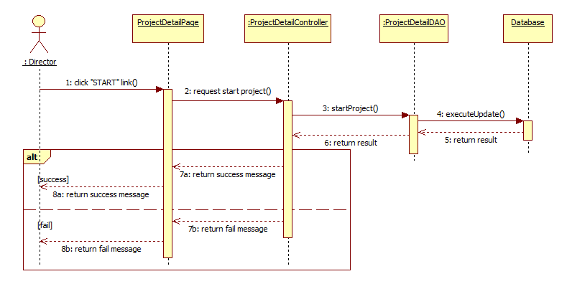

Figure : <Sequence Diagram> Start Project

##### <Director> Close and Assess Project

**Summary:** This diagram shows how director closes project.

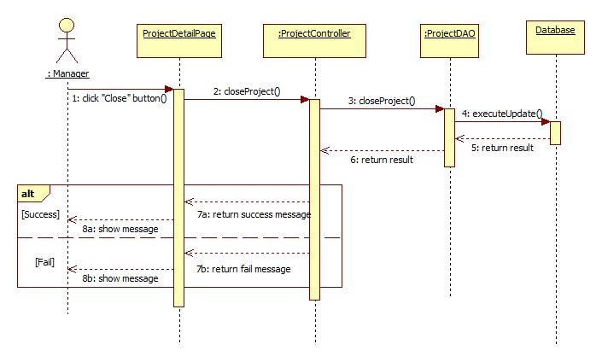

Figure : <Sequence Diagram> Close and Assess Project

##### <Director> Remove Project

**Summary:** This diagram shows how director removes project.

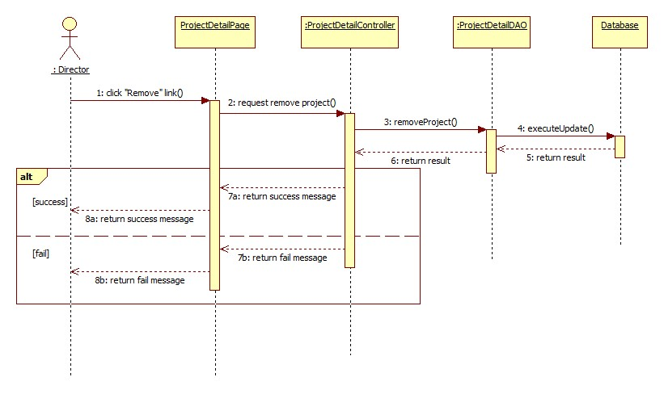

Figure : <Sequence Diagram> Remove Project

##### <Director> View Report of Project

**Summary:** This diagram shows how director view report of work.

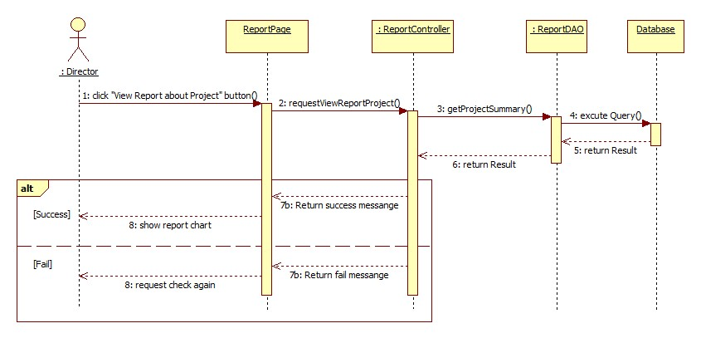

Figure : <Sequence Diagram> View Report of Project

##### <Director> Search Period Assessments

**Summary:** This diagram shows how admin search period assessments.

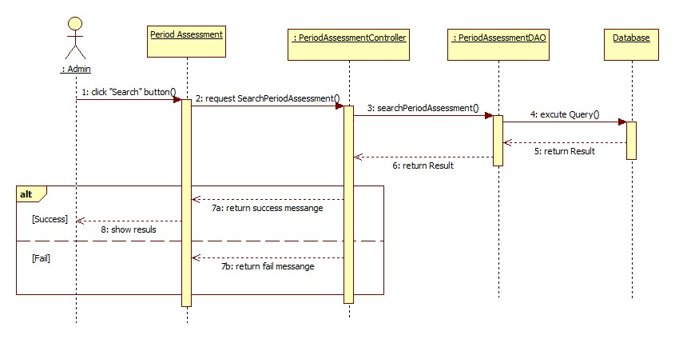

Figure : <Sequence Diagram> Search Period Assessments

##### <Director> Create Period Assessment

**Summary:** This diagram shows how admin creates period assessment.

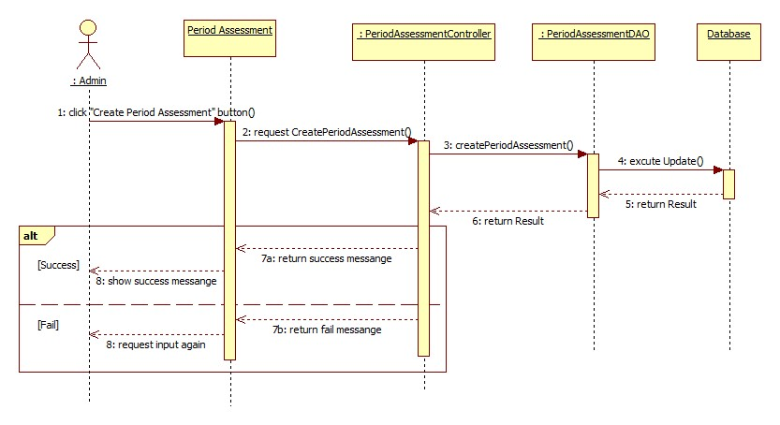

Figure : <Sequence Diagram> Create Period Assessment

##### <Director> Edit Period Assessment

**Summary:** This diagram shows how admin edits period assessment.

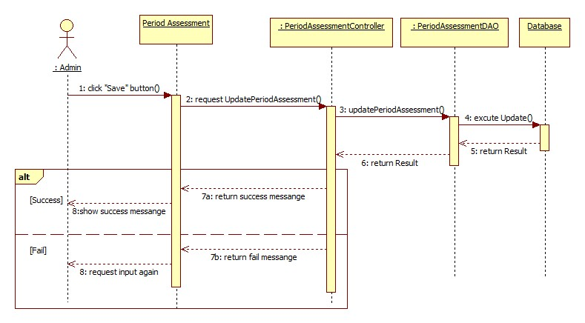

Figure : <Sequence Diagram> Edit Period Assessment

##### <Manager> Add Staffs into Project

**Summary:** This diagram shows how manager add staffs into the project.

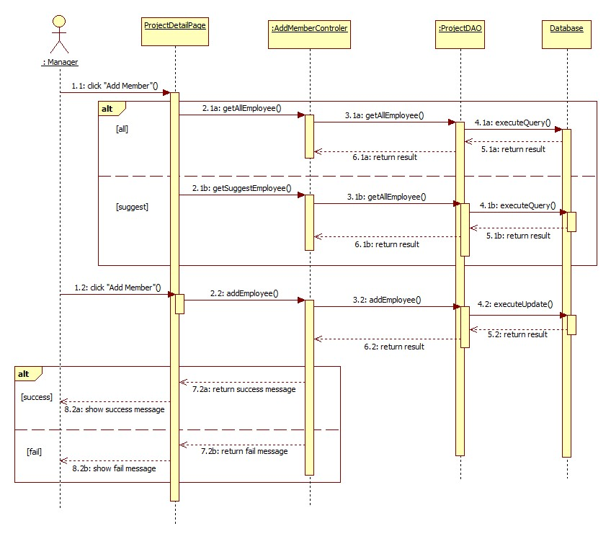

Figure : <Sequence Diagram> Add Staff into Project

##### <Manager> Remove Staffs from Project

**Summary:** This diagram shows how manager removes staffs from the project.

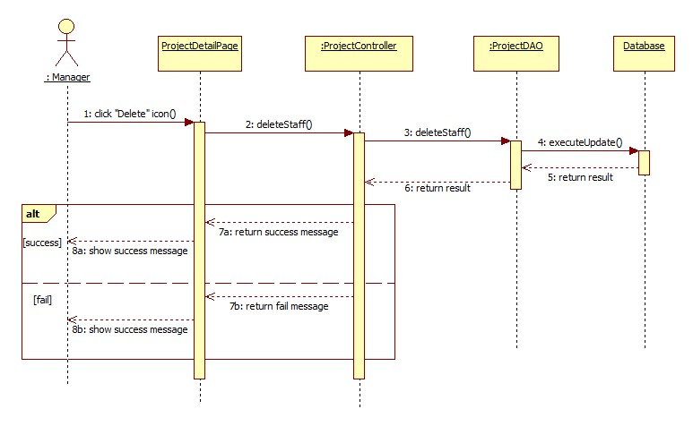

Figure : <Sequence Diagram> Remove Staff from Project

##### <Manager> Create Task

**Summary:** This diagram shows how manager creates task of project.

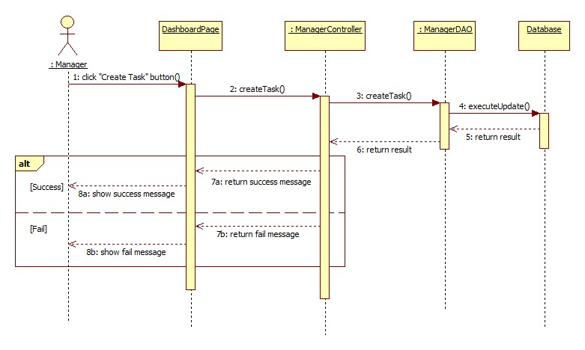

Figure : <Sequence Diagram> Create Task

##### <Manager> Edit Task

**Summary:** This diagram shows how manager edits task of project.

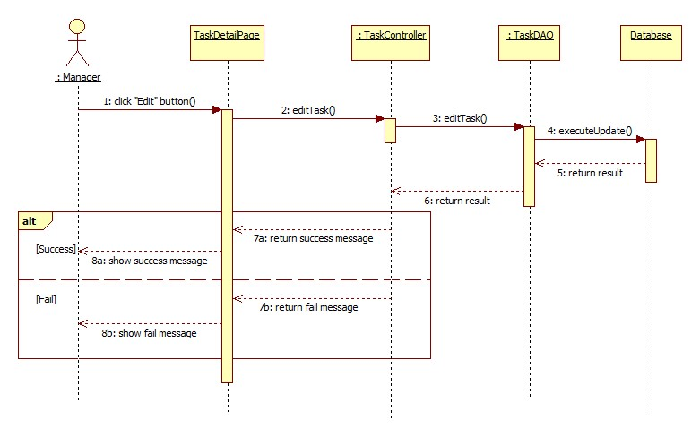

Figure : <Sequence Diagram> Edit Task

##### <Manager> Approve and Assess Task

**Summary:** This diagram shows how manager assigns task to staff.

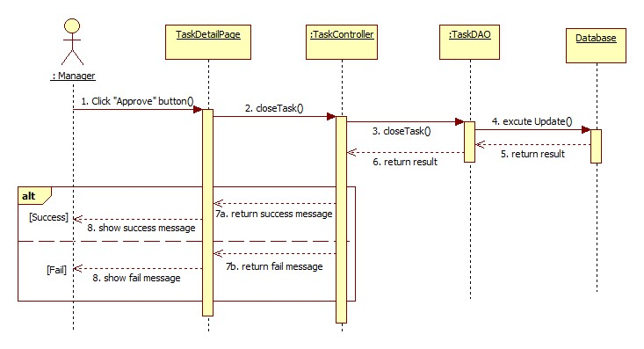

Figure : <Sequence Diagram> Approve and Assess Task

##### <Manager> Remove Task

**Summary:** This diagram shows how manager removes task.

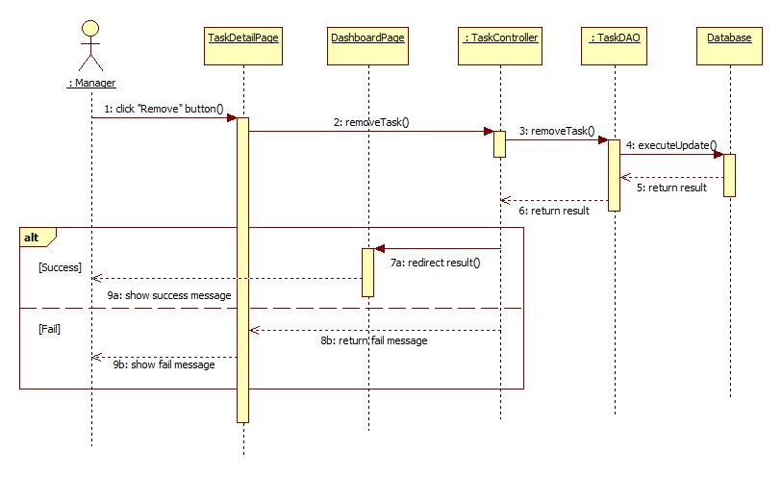

Figure : <Sequence Diagram> Remove Task

##### <Manager> View Project Details

**Summary:** This diagram shows how manager view project details.

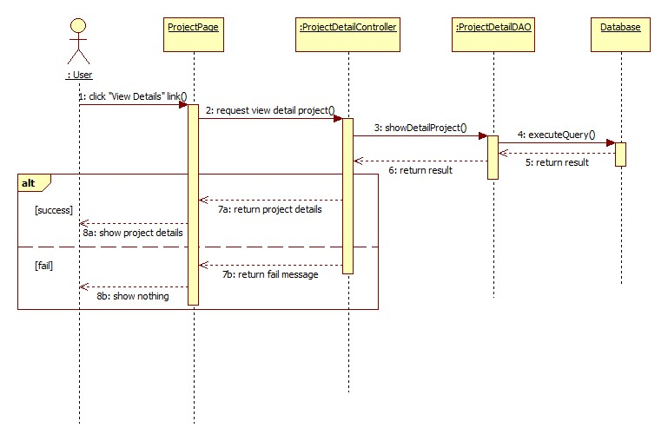

Figure : <Sequence Diagram> View Product Details

##### <Manager> Add Assessment

**Summary:** This diagram shows how manager adds assessment.

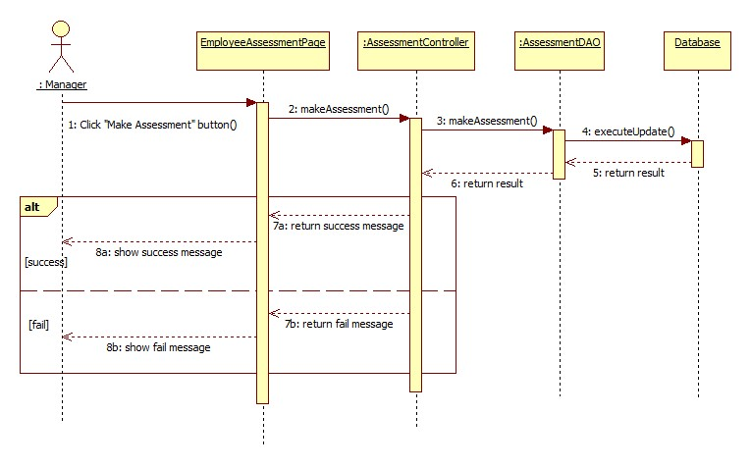

Figure : <Sequence Diagram> Add Assessment

##### <Manager> Edit Assessment

**Summary:** This diagram shows how manager edits assessment.

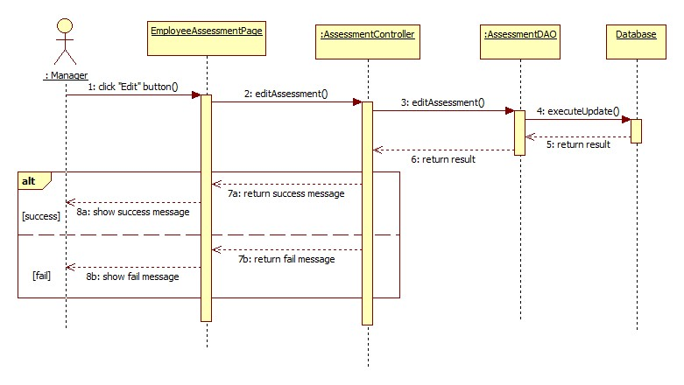

Figure : <Sequence Diagram> Edit Assessment

##### <Manager> View Report of Task

**Summary:** This diagram shows how manager views report of work.

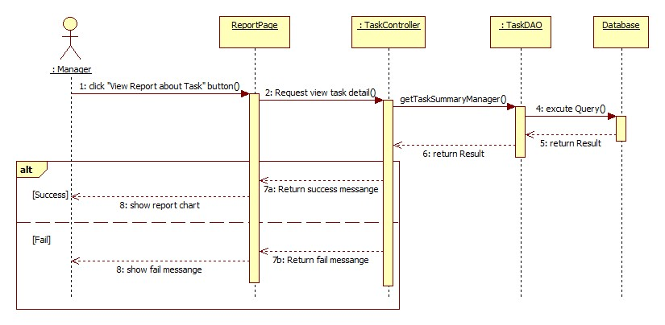

Figure : <Sequence Diagram> View Report of Task

##### <Staff> Edit Profile

**Summary:** This diagram shows how staff edits her/his profile.

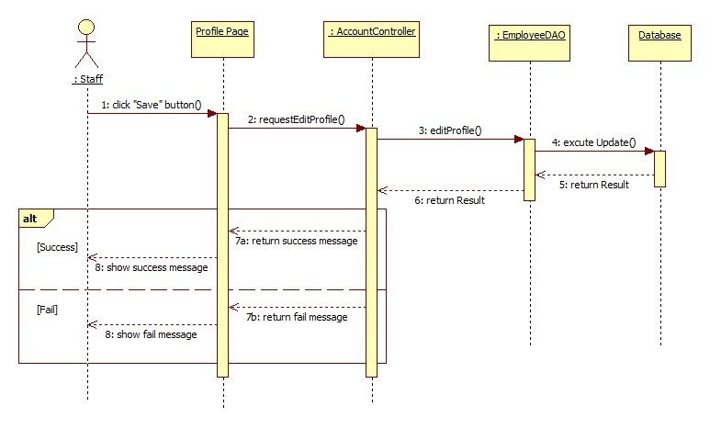

Figure : <Sequence Diagram> Edit Profile

##### <Staff> Search Topics

**Summary:** This diagram shows how staff search their topics.

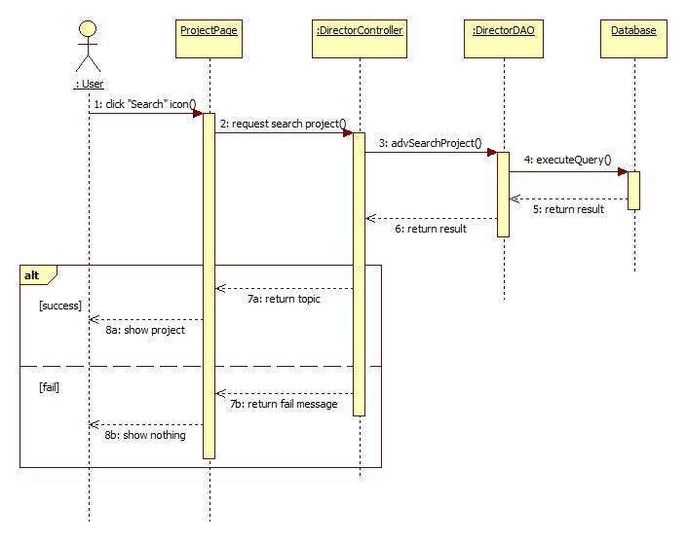

Figure : <Sequence Diagram> Search Topics

##### <Staff> Add Topic

**Summary:** This diagram shows how staff/manager creates new topic in the project.

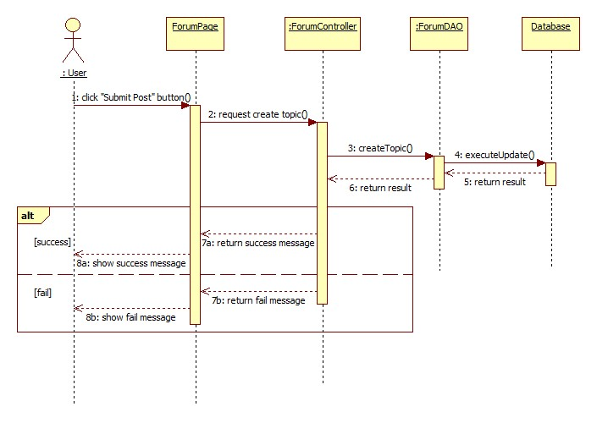

Figure : <Sequence Diagram> Add Topic

##### <Staff> Post Comment

**Summary:** This diagram shows how staff/manager edits their topic in the project.

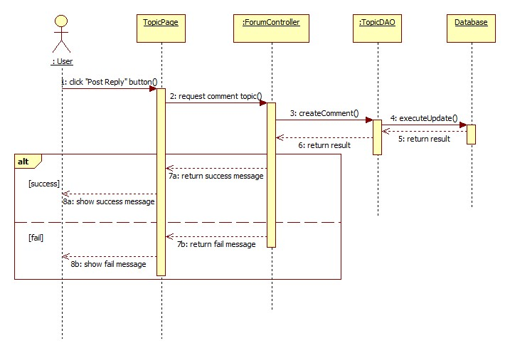

Figure : <Sequence Diagram> Post Comment

##### <Staff> Search Tasks

**Summary:** This diagram shows how staff search tasks.

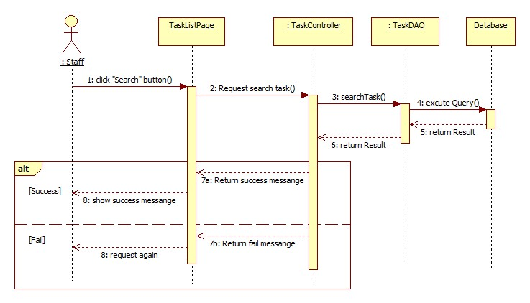

Figure : <Sequence Diagram> Search Task

##### <Staff> Review Employee Assessment

**Summary:** This diagram shows how staff/manager reviews their assessment in a period assessed by manager/director.

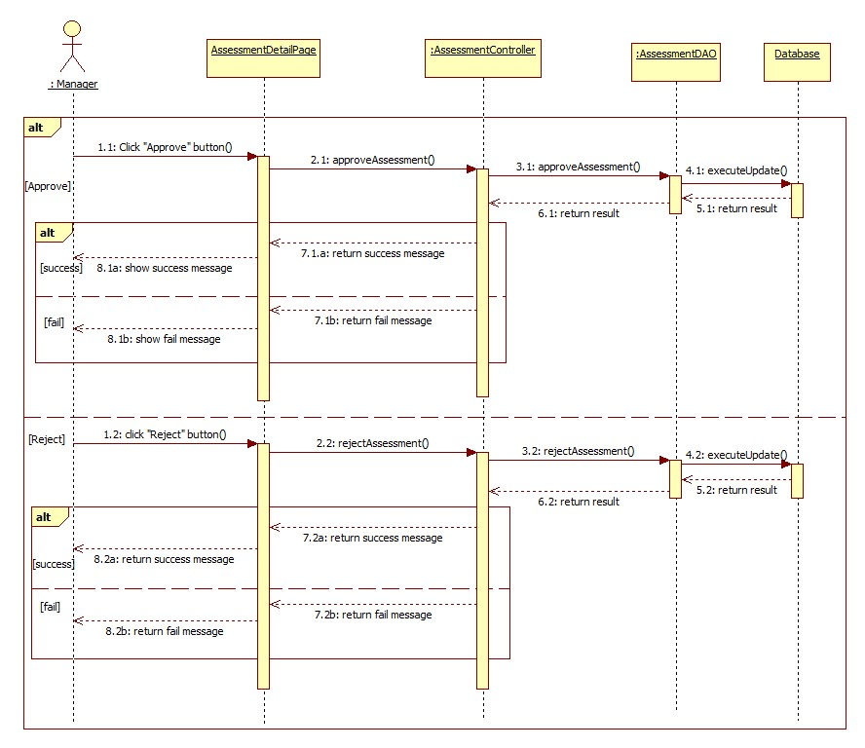

Figure : <Sequence Diagram> Review Employee Assessment

##### <Staff> View All Tasks

**Summary:** This diagram shows how staff views all their related tasks.

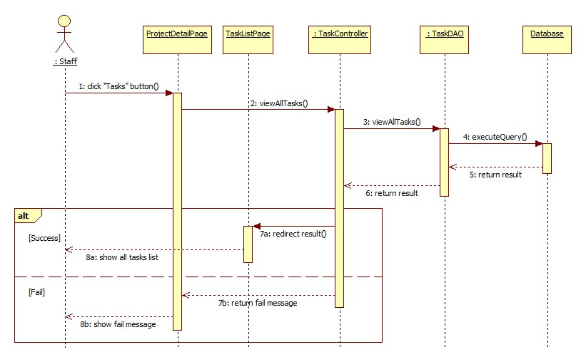

Figure : <Sequence Diagram>View All Tasks

##### <Staff> View Task Details

**Summary:** This diagram shows how staff views their task details.

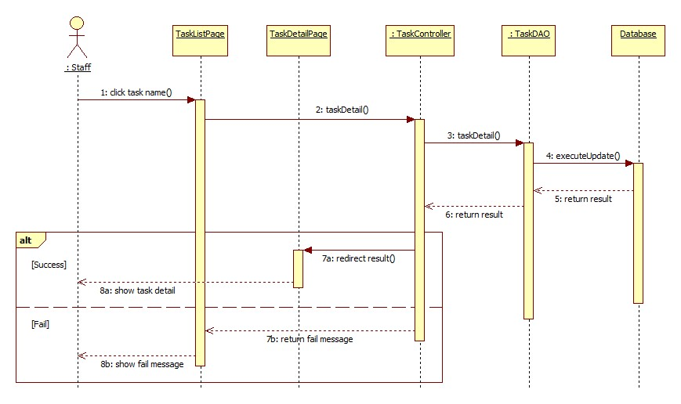

Figure : <Sequence Diagram> View Task Detail

##### <Staff> Search Projects

**Summary:** This diagram shows how staff searches projects.

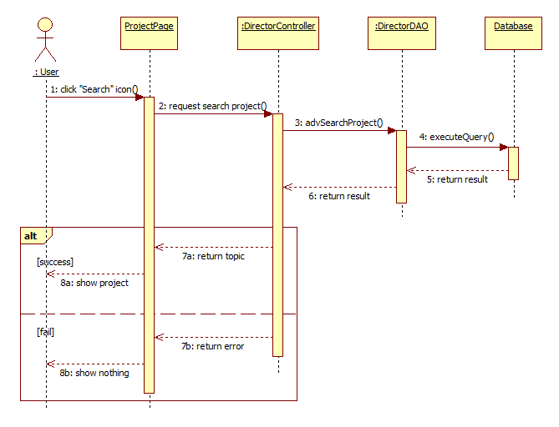

Figure : <Sequence Diagram> Search Project

##### <Staff> Update Task

**Summary:** This diagram shows how staff changes task status.

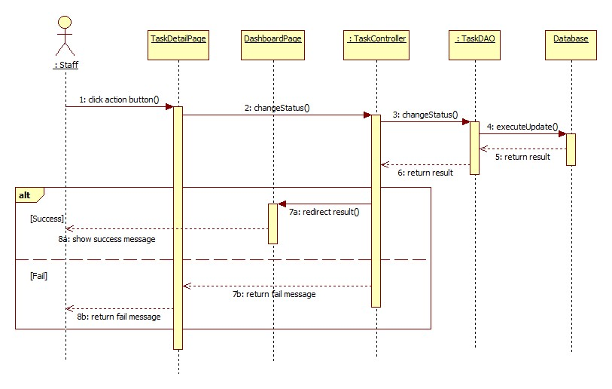

Figure : <Sequence Diagram> Update Task

#### Activity Diagram

##### Notification

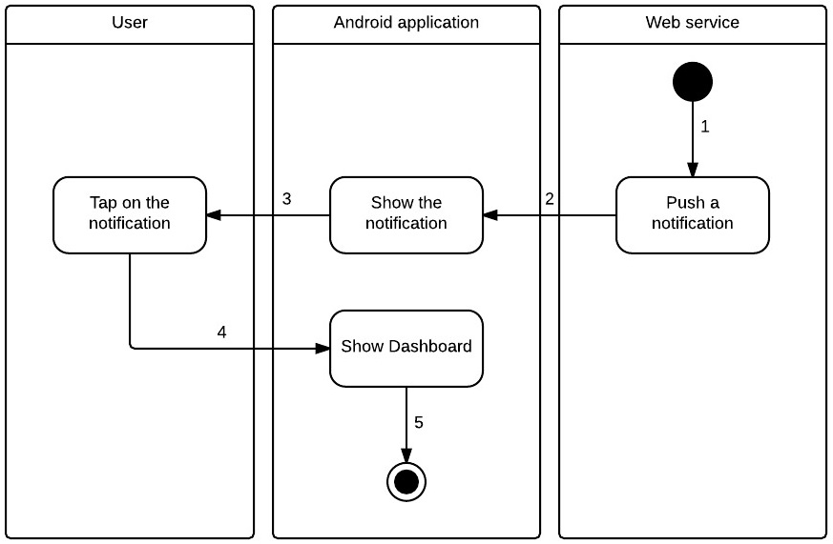

Figure : <Notification> Activity Diagram

|  |  |
| --- | --- |
| **Step** | **Description** |
| 1 | Start |
| 2 | Web service calls parse.com API for pushing notification to mobile. |
| 3 | Mobile notifies and shows notification for user. |
| 4 | User taps on notification for opening OTM application to show Dashboard. |
| 5 | Finish |

Table : <Notification> Activity Diagram Description

## User Interface Design

### Guest Interface Design

#### Login

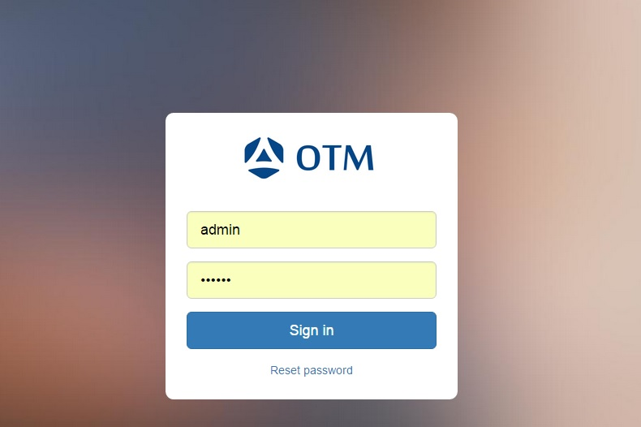

Figure : <Interface> Login

**Fields**

|  |  |  |  |  |  |  |  |
| --- | --- | --- | --- | --- | --- | --- | --- |
| **No** | **Field**  **Name** | **Description** | **Read only** | **Mandatory** | **Control**  **Type** | **Data**  **Type** | **Length** |
| 1 | Username | Fill user name | No | Yes | Textbox | String | N/A |
| 2 | Password | Fill password | No | Yes | Password | String | N/A |

Table : <Interface-Fields> Login

**Buttons/Hyperlinks**

|  |  |  |  |  |
| --- | --- | --- | --- | --- |
| **No** | **Function** | **Description** | **Validation** | **Outcome** |
| 3 | Signin | Log-in into the system | N/A | Transfer to home screen |

Table : <Interface-Buttons/Hyperlinks> Login

#### Reset Password

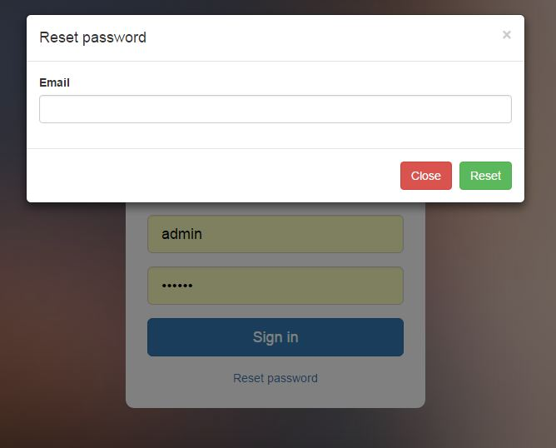

Figure : <Interface> Reset Password

**Fields**

|  |  |  |  |  |  |  |  |
| --- | --- | --- | --- | --- | --- | --- | --- |
| **No** | **Field**  **Name** | **Description** | **Read only** | **Mandatory** | **Control**  **Type** | **Data**  **Type** | **Length** |
| 1 | Email | Fill user name | No | Yes | Textbox | String | N/A |

Table : < Interface-Fields > Reset Password

**Buttons/Hyperlinks**

|  |  |  |  |  |
| --- | --- | --- | --- | --- |
| **No** | **Function** | **Description** | **Validation** | **Outcome** |
| 2 | Reset | Reset password | Email required. | Close popup and back Login screen. |
| 3 | Close | Close popup |  |  |

Table : <Interface-Buttons/Hyperlinks> Reset Password

### Admin Interface Design

#### Add Account

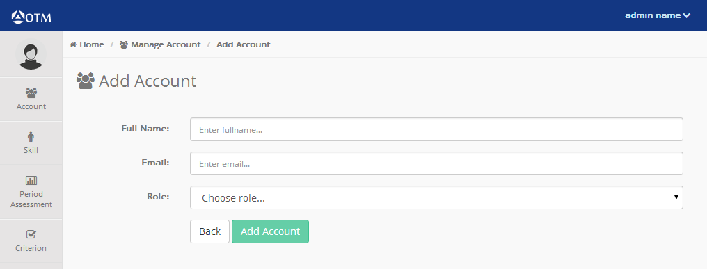

Figure : <Interface> Add Accounts

**Fields**

|  |  |  |  |  |  |  |  |
| --- | --- | --- | --- | --- | --- | --- | --- |
| **No** | **Field**  **Name** | **Description** | **Read only** | **Mandatory** | **Control**  **Type** | **Data**  **Type** | **Length** |
| 1 | Full name | Fill full name | No | Yes | Textbox | String | N/A |
| 2 | Email | Fill email | No | Yes | Textbox | String | N/A |
| 3 | Role | Choose role | No | Yes | Dropdown list | String | N/A |

Table : < Interface-Fields > Add Account

**Buttons/Hyperlinks**

|  |  |  |  |  |
| --- | --- | --- | --- | --- |
| **No** | **Function** | **Description** | **Validation** | **Outcome** |
| 4 | Add Account | Add Account | N/A | Transfer to home screen |
| 5 | Back | Back to Home screen | N/A | Transfer to home screen |

Table : <Interface-Buttons/Hyperlinks> Add Account

#### Add Skill

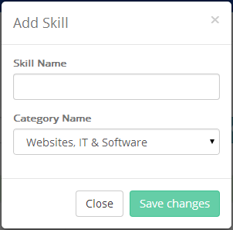

Figure : <Interface> Add Skill

**Fields**

|  |  |  |  |  |  |  |  |
| --- | --- | --- | --- | --- | --- | --- | --- |
| **No** | **Field**  **Name** | **Description** | **Read only** | **Mandatory** | **Control**  **Type** | **Data**  **Type** | **Length** |
| 1 | Skill Name | Fill skill name | No | Yes | Textbox | String | N/A |
| 2 | Category Name | Choose category name | No | Yes | Dropdown list | String | N/A |

Table : < Interface-Fields > Add Skill

**Buttons/Hyperlinks**

|  |  |  |  |  |
| --- | --- | --- | --- | --- |
| **No** | **Function** | **Description** | **Validation** | **Outcome** |
| 3 | Save changes | Save skill into database. | N/A | Transfer to home screen |
| 4 | Close | Close popup | N/A | Transfer to home screen |

Table : <Interface-Buttons/Hyperlinks> Add Skill

#### Add Category

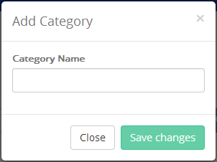

Figure : <Interface> Add Category

**Fields**

|  |  |  |  |  |  |  |  |
| --- | --- | --- | --- | --- | --- | --- | --- |
| **No** | **Field**  **Name** | **Description** | **Read only** | **Mandatory** | **Control**  **Type** | **Data**  **Type** | **Length** |
| 1 | Category Name | Fill category name | No | Yes | Textbox | String | N/A |

Table : < Interface-Fields > Add Category

**Buttons/Hyperlinks**

|  |  |  |  |  |
| --- | --- | --- | --- | --- |
| **No** | **Function** | **Description** | **Validation** | **Outcome** |
| 2 | Save Changes | Save category into database | N/A | Transfer to home screen |
| 3 | Close | Close popup. | N/A | Transfer to home screen |

Table : <Interface-Buttons/Hyperlinks> Add Category

#### Add Period Assessment

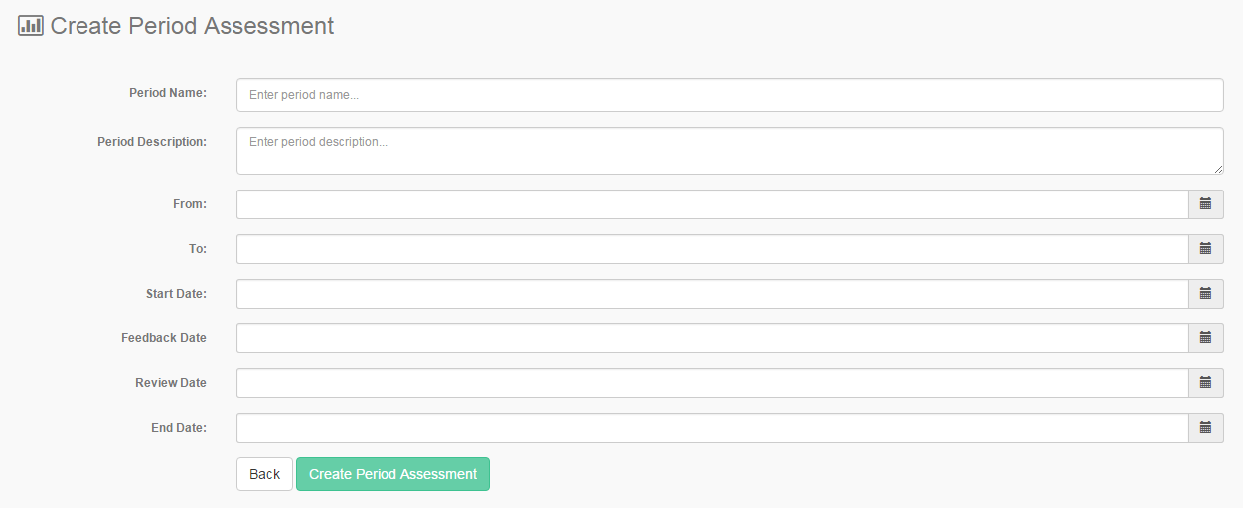

Figure : <Interface> Add Period Assessment

**Fields**

|  |  |  |  |  |  |  |  |
| --- | --- | --- | --- | --- | --- | --- | --- |
| **No** | **Field**  **Name** | **Description** | **Read only** | **Mandatory** | **Control**  **Type** | **Data**  **Type** | **Length** |
| 1 | Period Name | Fill period name | No | Yes | Textbox | String | N/A |
| 2 | Period Description | Fill period description | No | Yes | Text area | String | N/A |
| 3 | From | Choose date that will start to be assess | No | Yes | Date time picker | Date | N/A |
| 4 | To | Choose date that will end to be assess | No | Yes | Date time picker | Date | N/A |
| 5 | Start Date | Choose date that start assessment | No | Yes | Date time picker | Date | N/A |
| 6 | Feedback Date | Choose date that feedback assessment | No | Yes | Date time picker | Date | N/A |
| 7 | Review Date | Choose date that review assessment | No | Yes | Date time picker | Date | N/A |
| 8 | End Date | Choose date that start assessment | No | Yes | Date time picker | Date | N/A |

Table : < Interface-Fields > Add Period Assessment

**Buttons/Hyperlinks**

|  |  |  |  |  |
| --- | --- | --- | --- | --- |
| **No** | **Function** | **Description** | **Validation** | **Outcome** |
| 2 | Create Period Assessment | Save period assessment into database | N/A | Transfer to Manage Period Assessment |
| 3 | Back | Navigate to Manage Period Assessment screen | N/A | Transfer to Manage Period Assessment |

Table : <Interface-Buttons/Hyperlinks> Add Period Assessment

#### Add Criterion

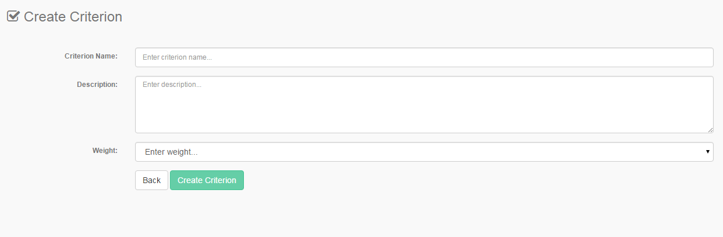

Figure : <Interface> Add Criterion

**Fields**

|  |  |  |  |  |  |  |  |
| --- | --- | --- | --- | --- | --- | --- | --- |
| **No** | **Field**  **Name** | **Description** | **Read only** | **Mandatory** | **Control**  **Type** | **Data**  **Type** | **Length** |
| 1 | Criterion Name | Fill criterion name | No | Yes | Textbox | String | N/A |
| 2 | Criterion Description | Fill criterion description | No | Yes | Text area | String | N/A |
| 3 | Criterion Weight | Choose criterion weight | No | Yes | Dropdown list | String | N/A |

Table : < Interface-Fields > Add Criterion

**Buttons/Hyperlinks**

|  |  |  |  |  |
| --- | --- | --- | --- | --- |
| **No** | **Function** | **Description** | **Validation** | **Outcome** |
| 2 | Create Criterion | Save criterion into database | N/A | Transfer to Manage Criterion screen |
| 3 | Back | Navigate to Manage Criterion screen | N/A | Transfer to Manage Criterion screen |

Table : <Interface-Buttons/Hyperlinks> Add Criterion

### Director Interface Design

#### List All Projects

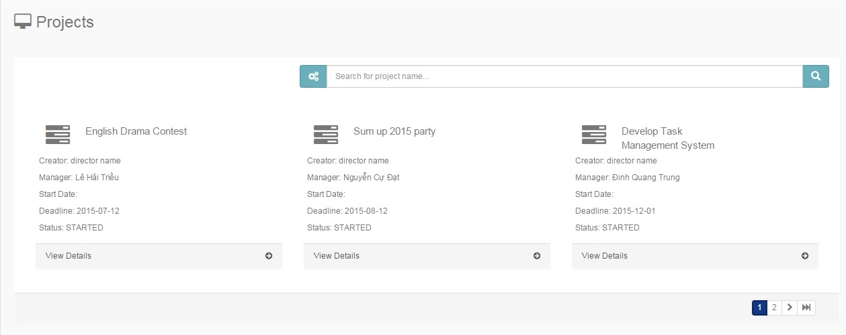

Figure : <Interface> List All Project

**Fields**

|  |  |  |  |  |  |  |  |
| --- | --- | --- | --- | --- | --- | --- | --- |
| **No** | **Field**  **Name** | **Description** | **Read only** | **Mandatory** | **Control**  **Type** | **Data**  **Type** | **Length** |
| 1 | Search | Fill project name to search | No | Yes | Textbox | String | N/A |

Table : < Interface-Fields > Project

**Buttons/Hyperlinks**

|  |  |  |  |  |
| --- | --- | --- | --- | --- |
| **No** | **Function** | **Description** | **Validation** | **Outcome** |
| 2 |  | Advance search | N/A | Open fields with contents: status, creator, project name, manager, from, to. |
| 3 |  | Search | N/A | Transfer to result of search. |

Table : <Interface-Buttons/Hyperlinks> Project

#### Project Detail

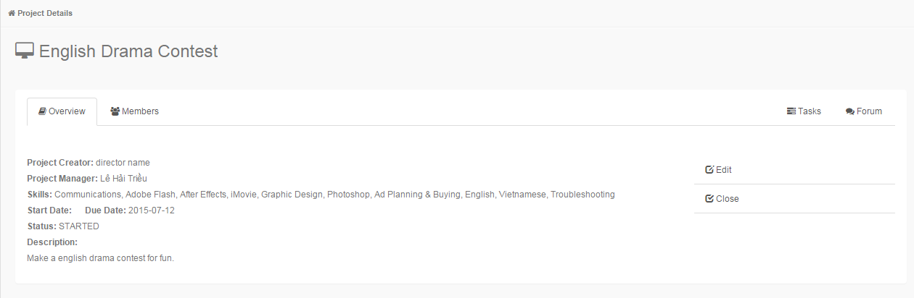

Figure : <Interface> Project Detail

**Buttons/Hyperlinks**

|  |  |  |  |  |
| --- | --- | --- | --- | --- |
| **No** | **Function** | **Description** | **Validation** | **Outcome** |
| 1 | Edit | Edit project | N/A | Transfer to Edit Project screen |
| 2 | Close | Project is closed. | N/A | Open popup to assess employee. |
| 3 | Members | List members are joining in project | N/A | Transfer to Members Tab |
| 4 | Tasks | List tasks has in project | N/A | Navigate to Task in Project screen |
| 5 | Forum | Forum of project | N/A | Navigate to Forum screen |

Table : <Interface-Buttons/Hyperlinks>

#### Create Project

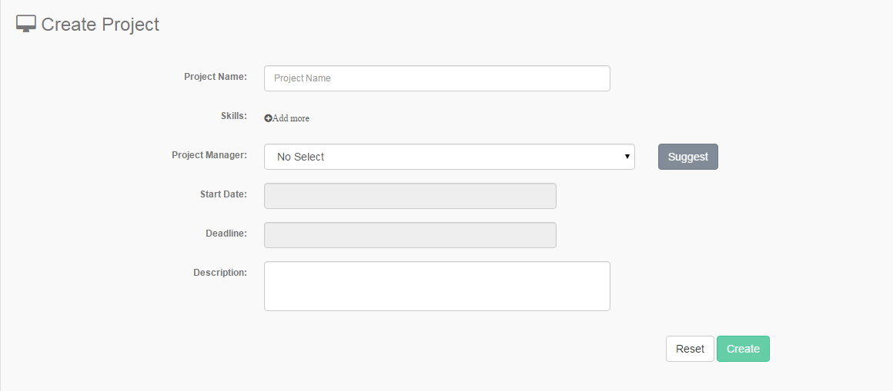

Figure : <Interface> Create Project

**Fields**

|  |  |  |  |  |  |  |  |
| --- | --- | --- | --- | --- | --- | --- | --- |
| **No** | **Field**  **Name** | **Description** | **Read only** | **Mandatory** | **Control**  **Type** | **Data**  **Type** | **Length** |
| 1 | Project Name | Fill project name | No | Yes | Textbox | String | N/A |
| 2 | Skills | Show skills in project | Yes | Yes | Password | String | N/A |
| 3 | Project Manager | Manager of project | No | Yes | Dropdown list | String | N/A |
| 4 | Start Date | Choose date to start project | No | Yes | Date time picker | date | N/A |
| 5 | Deadline | Choose date to deadline project | No | Yes | Date time picker | Date | N/A |
| 6 | Description | Choose date to end project | No | Yes | Text area | String | N/A |

Table : < Interface-Fields > Create Project

**Buttons/Hyperlinks**

|  |  |  |  |  |
| --- | --- | --- | --- | --- |
| **No** | **Function** | **Description** | **Validation** | **Outcome** |
| 3 | Add skill | Add skill into project | N/A | Open popup. |
| 4 | Suggest | Help to choose manager into project | N/A | Open popup |
| 5 | Create | Create a new project | N/A | Transfer to list all project screen |
| 6 | Reset | Delete data that was filled | N/A | Load page again with all fields is empty |

Table : <Interface-Buttons/Hyperlinks> Create Project

#### Edit Project

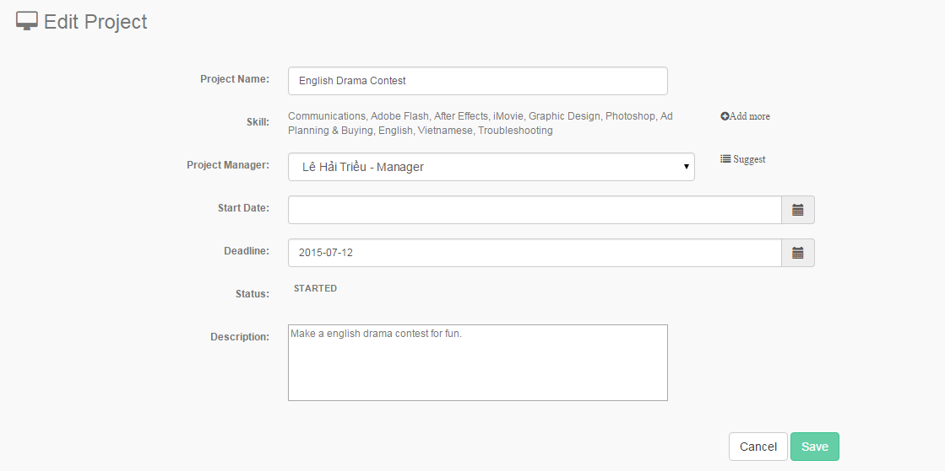

Figure : <Interface> Edit Project

**Fields**

|  |  |  |  |  |  |  |  |
| --- | --- | --- | --- | --- | --- | --- | --- |
| **No** | **Field**  **Name** | **Description** | **Read only** | **Mandatory** | **Control**  **Type** | **Data**  **Type** | **Length** |
| 1 | Project Name | Fill project name | No | Yes | Textbox | String | N/A |
| 2 | Skill | Show skills in project | Yes | Yes |  | String | N/A |
| 3 | Project Manager | Choose project manager | No | Yes | Dropdown list | String | N/A |
| 4 | Start Date | Choose date to start project | No | Yes | Date time picker | Date | N/A |
| 5 | Deadline | Choose date to deadline project | No | Yes | Date time picker | Date | N/A |
| 6 | Status | Show status of project | Yes | Yes |  | String | N/A |
| 7 | Description | Fill description of project | No | Yes | Text area | String | N/A |

Table : < Interface-Fields > Edit Project

**Buttons/Hyperlinks**

|  |  |  |  |  |
| --- | --- | --- | --- | --- |
| **No** | **Function** | **Description** | **Validation** | **Outcome** |
| 8 | Add more | Add more skills into project | N/A | Open popup |
| 9 | Suggest | Help to choose manager into project | N/A | Open popup |
| 10 | Save | Save data into database | N/A | Transfer to Project Detail screen |
| 11 | Cancel | Back to Project Detail screen | N/A | Transfer to Project Detail screen |

Table : <Interface-Buttons/Hyperlinks> Edit Project

#### View Report of Project

**Fields**

|  |  |  |  |  |  |  |  |
| --- | --- | --- | --- | --- | --- | --- | --- |
| **No** | **Field**  **Name** | **Description** | **Read only** | **Mandatory** | **Control**  **Type** | **Data**  **Type** | **Length** |
| 1 | Username | Fill user name | No | Yes | Textbox | String | N/A |
| 2 | Password | Fill password | No | Yes | Password | String | N/A |

Table : < Interface-Fields > View Report of Project

**Buttons/Hyperlinks**

|  |  |  |  |  |
| --- | --- | --- | --- | --- |
| **No** | **Function** | **Description** | **Validation** | **Outcome** |
| 3 | Signin | Log-in into the system | N/A | Transfer to home screen |

Table : <Interface-Buttons/Hyperlinks> View Report of Project

#### Close and Assess Project

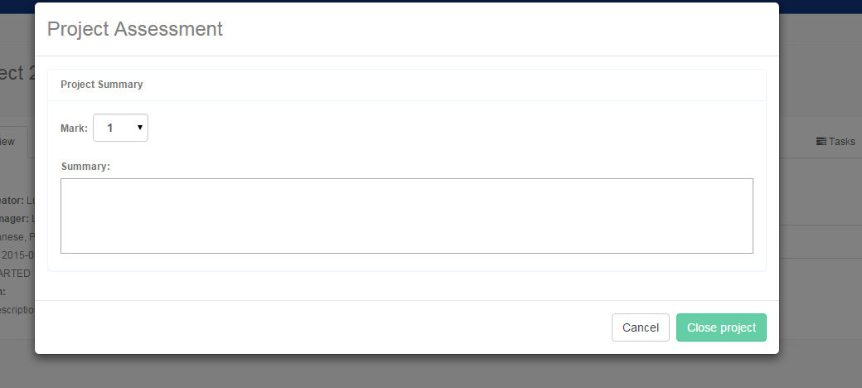

Figure : <Interface> Close and Assess Project

**Fields**

|  |  |  |  |  |  |  |  |
| --- | --- | --- | --- | --- | --- | --- | --- |
| **No** | **Field**  **Name** | **Description** | **Read only** | **Mandatory** | **Control**  **Type** | **Data**  **Type** | **Length** |
| 1 | Mark | Choose mark for project | No | Yes | Dropdown list | String | N/A |
| 2 | Summary | Fill summary for project | No | Yes | Textbox | String | N/A |

Table : < Interface-Fields > Close and Assess Project

**Buttons/Hyperlinks**

|  |  |  |  |  |
| --- | --- | --- | --- | --- |
| **No** | **Function** | **Description** | **Validation** | **Outcome** |
| 3 | Close Project | Finish project | N/A | Close popup and show Project Detail |
| 4 | Cancel | Back to project detail | N/A | Close popup and show Project Detail |

Table : <Interface-Buttons/Hyperlinks> Close and Assess Project

### Manager Interface Design

#### Manager Dashboard

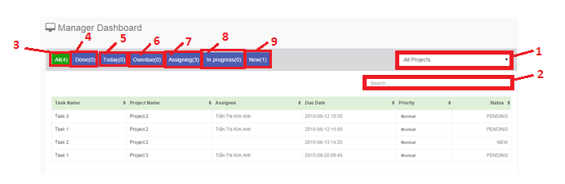

Figure : <Interface> Dashboard Manager

**Fields**

|  |  |  |  |  |  |  |  |
| --- | --- | --- | --- | --- | --- | --- | --- |
| **No** | **Field**  **Name** | **Description** | **Read only** | **Mandatory** | **Control**  **Type** | **Data**  **Type** | **Length** |
| 1 | Search | Fill task name | No | Yes | Textbox | String | N/A |
| 2 | All Project | Choose project | No | Yes | Dropdown list | String | N/A |

Table : < Interface-Fields > Dashboard Manager

**Buttons/Hyperlinks**

|  |  |  |  |  |
| --- | --- | --- | --- | --- |
| **No** | **Function** | **Description** | **Validation** | **Outcome** |
| 3 | All | Show all tasks | N/A | Transfer to home screen |
| 4 | Done | Show tasks with “Done” status | N/A | Transfer to home screen |
| 5 | Today | Show tasks with “Today” status | N/A | Transfer to home screen |
| 6 | Overdue | Show tasks with “Overdue” status | N/A | Transfer to home screen |
| 7 | Assigning | Show tasks with “Assigning” status | N/A | Transfer to home screen |
| 8 | In-progress | Show tasks with “In-progress” status | N/A | Transfer to home screen |
| 9 | New | Show tasks with “New” status | N/A | Transfer to home screen |

Table : <Interface-Buttons/Hyperlinks> Dashboard Manager

#### Create Task

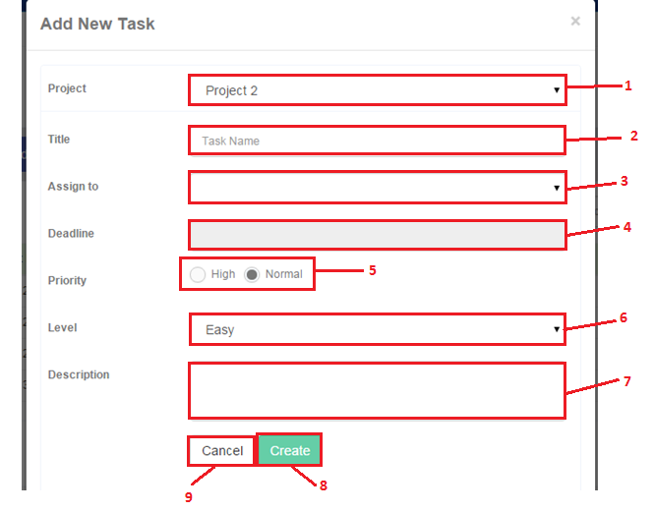

Figure : <Interface> Create Task

**Fields**

|  |  |  |  |  |  |  |  |
| --- | --- | --- | --- | --- | --- | --- | --- |
| **No** | **Field**  **Name** | **Description** | **Read only** | **Mandatory** | **Control**  **Type** | **Data**  **Type** | **Length** |
| 1 | Project | Choose project name | No | Yes | Dropdown list | String | N/A |
| 2 | Title | Fill task name | No | Yes | Textbox | String | N/A |
| 3 | Assign to | Choose member that will make task | No | Yes | Dropdown list | String | N/A |
| 4 | Deadline | Choose time to deadline task | No | Yes | Date time picker | Date | N/A |
| 5 | Priority | Choose priority of task | No | Yes | Radio button | Boolean | N/A |
| 6 | Level | Choose level of task | No | Yes | Dropdown list | String | N/A |
| 7 | Description | Fill description of task | No | Yes | Textbox | String | N/A |

Table : < Interface-Fields > Create Task

**Buttons/Hyperlinks**

|  |  |  |  |  |
| --- | --- | --- | --- | --- |
| **No** | **Function** | **Description** | **Validation** | **Outcome** |
| 8 | Create | Create a new task | N/A | Show new task in list of task on Manager Dashboard |
| 9 | Cancel | Close popup | N/A | Close popup |

Table : <Interface-Buttons/Hyperlinks> Create Task

#### Edit Task

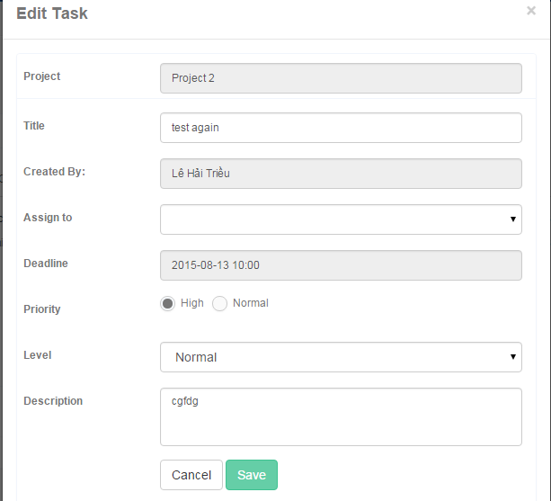

Figure : <Interface> Edit Task

**Fields**

|  |  |  |  |  |  |  |  |
| --- | --- | --- | --- | --- | --- | --- | --- |
| **No** | **Field**  **Name** | **Description** | **Read only** | **Mandatory** | **Control**  **Type** | **Data**  **Type** | **Length** |
| 1 | Project | Project name | Yes | Yes | Textbox | String | N/A |
| 2 | Title | Fill task name | No | Yes | Textbox | String | N/A |
| 3 | Created By | Creator Name | Yes | Yes | Textbox | String | N/A |
| 4 | Assign to | Choose member that will make the task | No | Yes | Dropdown list | String | N/A |
| 5 | Deadline | Choose time to deadline of task | No | Yes | Date time picker | Date | N/A |
| 6 | Priority | Choose priority of task | No | Yes | Radio button | Boolean | N/A |
| 7 | Level | Choose level of task | No | Yes | Dropdown list | String | N/A |
| 8 | Description | Fill description of task | No | Yes | Textbox | String | N/A |

Table : < Interface-Fields > Edit Task

**Buttons/Hyperlinks**

|  |  |  |  |  |
| --- | --- | --- | --- | --- |
| **No** | **Function** | **Description** | **Validation** | **Outcome** |
| 9 | Save | Save task | N/A | Show Task Detail screen |
| 10 | Cancel | Close popup | N/A | Close popup |

Table : <Interface-Buttons/Hyperlinks> Edit Task

#### Task Detail

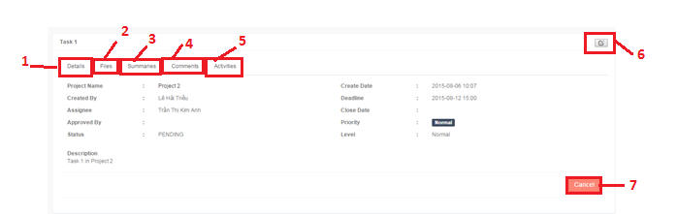

Figure : <Interface> Task Detail

**Buttons/Hyperlinks**

|  |  |  |  |  |
| --- | --- | --- | --- | --- |
| **No** | **Function** | **Description** | **Validation** | **Outcome** |
| 1 | Detail | Show detail of task | N/A | Transfer to Detail tab |
| 2 | Files | Show files that have in task | N/A | Transfer to Files tab |
| 3 | Summaries | Show result of assessment | N/A | Transfer to Summaries tab |
| 4 | Comments | Show comments that have in forum | N/A | Transfer to Comments tab |
| 5 | Activities | Show activities of task | N/A | Transfer to Activities tab |
| 6 |  | Open edit popup | N/A | Open Edit popup |
| 7 | Cancel | Button describe to change status of task | N/A | Transfer to Manager Dashboard |

Table : <Interface-Buttons/Hyperlinks> Task Detail

#### View Report of Task

**Fields**

|  |  |  |  |  |  |  |  |
| --- | --- | --- | --- | --- | --- | --- | --- |
| **No** | **Field**  **Name** | **Description** | **Read only** | **Mandatory** | **Control**  **Type** | **Data**  **Type** | **Length** |
| 1 | Username | Fill user name | No | Yes | Textbox | String | N/A |
| 2 | Password | Fill password | No | Yes | Password | String | N/A |

Table : < Interface-Fields > View Report of Task

**Buttons/Hyperlinks**

|  |  |  |  |  |
| --- | --- | --- | --- | --- |
| **No** | **Function** | **Description** | **Validation** | **Outcome** |
| 3 | Signin | Log-in into the system | N/A | Transfer to home screen |

Table : <Interface-Buttons/Hyperlinks> View Report of Task

#### Approve and Assess Task

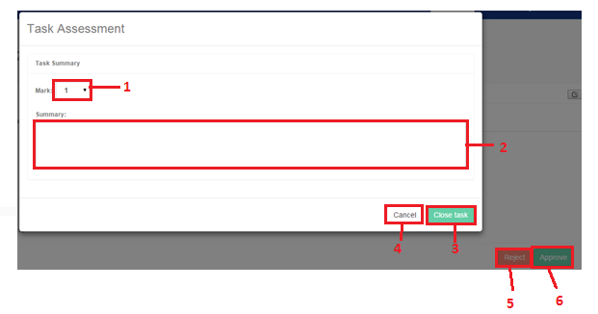

Figure : <Interface> Approve and Assess Task

**Fields**

|  |  |  |  |  |  |  |  |
| --- | --- | --- | --- | --- | --- | --- | --- |
| **No** | **Field**  **Name** | **Description** | **Read only** | **Mandatory** | **Control**  **Type** | **Data**  **Type** | **Length** |
| 1 | Mark | Choose mark for task | No | Yes | Dropdown list | String | N/A |
| 2 | Summary | Fill summary about task | No | Yes | Textbox | String | N/A |

Table : < Interface-Fields > Approve and Assess Task

**Buttons/Hyperlinks**

|  |  |  |  |  |
| --- | --- | --- | --- | --- |
| **No** | **Function** | **Description** | **Validation** | **Outcome** |
| 3 | Close Task | Finish assessment and close task | N/A | Transfer to home screen |
| 4 | Cancel | Close popup | N/A | Transfer to home screen |
| 5 | Reject | Reject task | N/A | Transfer to Manager Dashboard screen, change status of task |
| 6 | Approve | Approve task and begin assessment | N/A | Transfer to Manager Dashboard screen, change status of task |

Table : <Interface-Buttons/Hyperlinks> Approve and Assess Task

#### Add Assessment

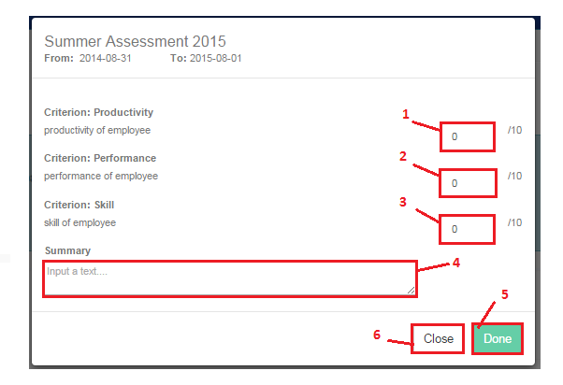

Figure : <Interface> Add Assessment

**Fields**

|  |  |  |  |  |  |  |  |
| --- | --- | --- | --- | --- | --- | --- | --- |
| **No** | **Field**  **Name** | **Description** | **Read only** | **Mandatory** | **Control**  **Type** | **Data**  **Type** | **Length** |
| 1 | Productivity | Fill mark for productivity of criterion | No | Yes | Textbox | int | N/A |
| 2 | Performance | Fill mark for Performance of criterion | No | Yes | Textbox | int | N/A |
| 3 | Skill | Fill mark for Skill of criterion | No | Yes | Textbox | int | N/A |
| 4 | Summary | Fill summary of criterion | No | Yes | Textbox | String | N/A |

Table : < Interface-Fields > Add Assessment

**Buttons/Hyperlinks**

|  |  |  |  |  |
| --- | --- | --- | --- | --- |
| **No** | **Function** | **Description** | **Validation** | **Outcome** |
| 5 | Done | Finish to add assessment | N/A | Close popup and show Assessment Detail screen |
| 6 | Close | Close popup | N/A | Close popup and show Assessment Detail screen |

Table : <Interface-Buttons/Hyperlinks> Add Assessment

#### Edit Assessment

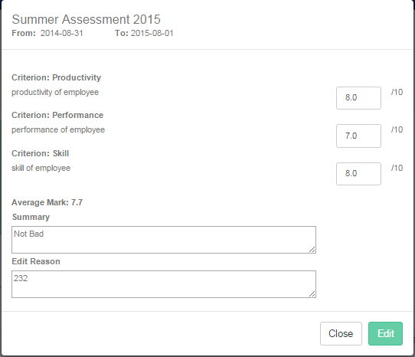

Figure : <Interface> Edit Assessment

**Fields**

|  |  |  |  |  |  |  |  |
| --- | --- | --- | --- | --- | --- | --- | --- |
| **No** | **Field**  **Name** | **Description** | **Read only** | **Mandatory** | **Control**  **Type** | **Data**  **Type** | **Length** |
| 1 | Productivity | Fill mark for productivity of criterion | No | Yes | Textbox | int | N/A |
| 2 | Performance | Fill mark for Performance of criterion | No | Yes | Textbox | int | N/A |
| 3 | Skill | Fill mark for Skill of criterion | No | Yes | Textbox | int | N/A |
| 4 | Summary | Fill summary of criterion | No | Yes | Textbox | String | N/A |

Table : < Interface-Fields > Edit Assessment

**Buttons/Hyperlinks**

|  |  |  |  |  |
| --- | --- | --- | --- | --- |
| **No** | **Function** | **Description** | **Validation** | **Outcome** |
| 5 | Done | Finish to add assessment | N/A | Close popup and show Assessment Detail screen |
| 6 | Close | Close popup | N/A | Close popup and show Assessment Detail screen |

Table : <Interface-Buttons/Hyperlinks> Edit Assessment

### Staff Interface Design

#### Staff Dashboard

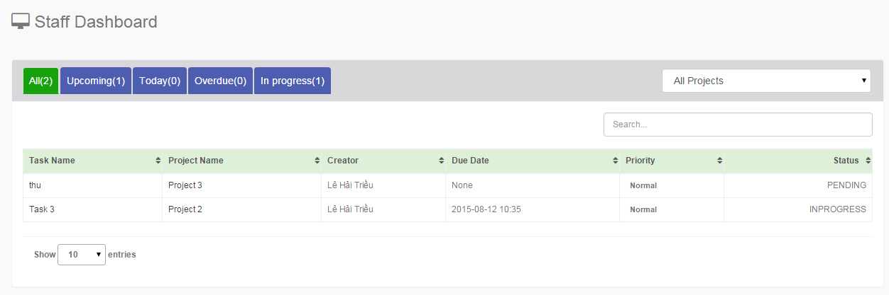

Figure : <Interface> Staff Dashboard

**Fields**

|  |  |  |  |  |  |  |  |
| --- | --- | --- | --- | --- | --- | --- | --- |
| **No** | **Field**  **Name** | **Description** | **Read only** | **Mandatory** | **Control**  **Type** | **Data**  **Type** | **Length** |
| 1 | Search | Fill task name | No | Yes | Textbox | String | N/A |
| 2 | All Project | Choose project | No | Yes | Dropdown list | String | N/A |

Table : < Interface-Fields > Staff Dashboard

**Buttons/Hyperlinks**

|  |  |  |  |  |
| --- | --- | --- | --- | --- |
| **No** | **Function** | **Description** | **Validation** | **Outcome** |
| 3 | All | Show all tasks | N/A | Transfer to home screen |
| 4 | Upcoming | Show tasks with “Upcoming” status | N/A | Transfer to home screen |
| 5 | Today | Show tasks with “Today” status | N/A | Transfer to home screen |
| 6 | Overdue | Show tasks with “Overdue” status | N/A | Transfer to home screen |

Table : <Interface-Buttons/Hyperlinks> Staff Dashboard

#### Forum

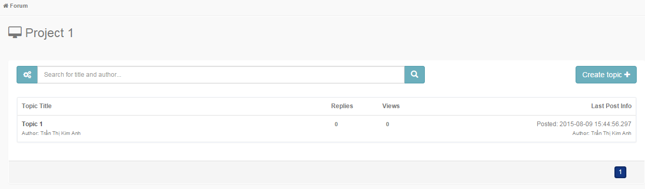

Figure : <Interface> Forum

**Fields**

|  |  |  |  |  |  |  |  |
| --- | --- | --- | --- | --- | --- | --- | --- |
| **No** | **Field**  **Name** | **Description** | **Read only** | **Mandatory** | **Control**  **Type** | **Data**  **Type** | **Length** |
| 1 | Search | Fill title or author | No | Yes | Textbox | String | N/A |

Table : < Interface-Fields > Forum

**Buttons/Hyperlinks**

|  |  |  |  |  |
| --- | --- | --- | --- | --- |
| **No** | **Function** | **Description** | **Validation** | **Outcome** |
| 2 | Create Topic | Create a new topic | N/A | Transfer to Create Topic screen |

Table : <Interface-Buttons/Hyperlinks> Forum

#### Create Topic

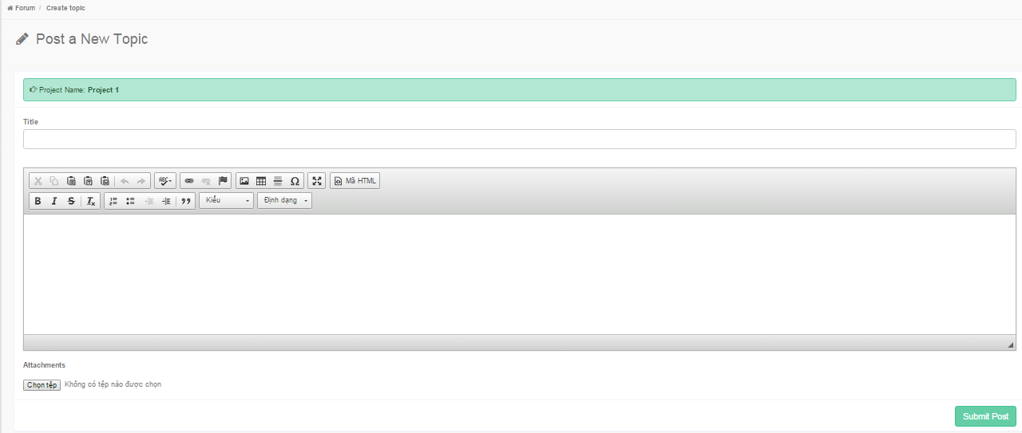

Figure : <Interface> Create Topic

**Fields**

|  |  |  |  |  |  |  |  |
| --- | --- | --- | --- | --- | --- | --- | --- |
| **No** | **Field**  **Name** | **Description** | **Read only** | **Mandatory** | **Control**  **Type** | **Data**  **Type** | **Length** |
| 1 | Title | Fill title of topic | No | Yes | Textbox | String | N/A |
| 2 | Content | Fill content of topic | No | Yes | Textbox | String | N/A |
| 3 | **Attachments** | Choose file to attach | No | Yes |  |  | N/A |

Table : < Interface-Fields > Create Topic

**Buttons/Hyperlinks**

|  |  |  |  |  |
| --- | --- | --- | --- | --- |
| **No** | **Function** | **Description** | **Validation** | **Outcome** |
| 4 | Chọn tệp | Choose file to attach | N/A | Sample: “abc.docx” |
| 5 | Submit Post | Post on forum | N/A | Transfer to Forum screen |

Table : <Interface-Buttons/Hyperlinks> Create Topic

#### Review Employee Assessment

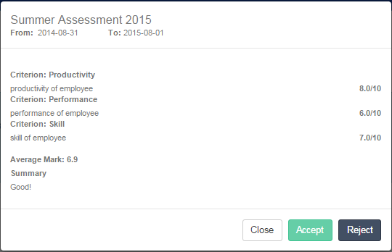

Figure : <Interface> Review Employee Assessment

**Buttons/Hyperlinks**

|  |  |  |  |  |
| --- | --- | --- | --- | --- |
| **No** | **Function** | **Description** | **Validation** | **Outcome** |
| 1 | Accept | Employee accepts assessment from manager. | N/A | Close popup. |
| 2 | Reject | Employee rejects assessment from manager. | N/A | Close popup. |
| 3 | Close | Close popup | N/A | Close popup. |

Table : <Interface-Buttons/Hyperlinks> Review Employee Assessment

#### Error

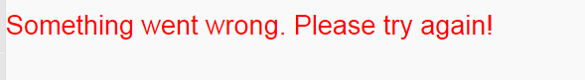

Figure : <Interface> Error

## Database Design

### Logical Diagram

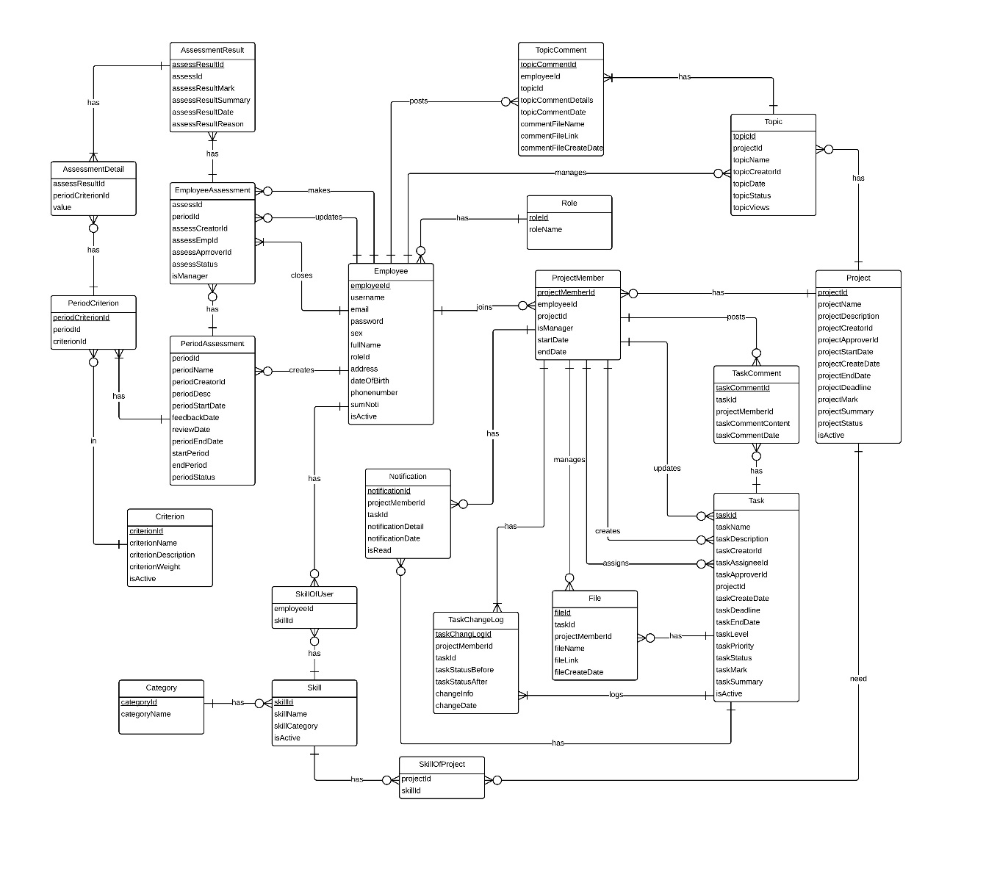

Figure : Logical Diagram

### Data Dictionary

|  |  |
| --- | --- |
| **Logical Diagram dictionary: Describe Entity** | |
| **Entity** | **Description** |
| Employee | Describe all employees that are working in the company. |
| Project | Describe all projects in the system. |
| Project Member | Describe all employees that are working in a project. |
| Task | Describe all tasks in the project. |
| Role | Describe all roles in the system. |
| Task Change log | Describe all history of tasks in the system. |
| Topic | Describe all topics in a project. |
| Topic Comment | Describe all comments in a topic |
| Task Comment | Describe all comments in a task. |
| File | Describe all files in tasks. |
| Assessment Result | Describe results of employee assessment. |
| Employee Assessment | Describe employee assessments in period assessment. |
| Period Assessment | Describe period assessments each year. |
| Skill | Describe all skills that belong to categories in the system. |
| Category | Describe all categories that skills belong to in the system. |
| Criterion | Describe criterions in period assessment |
| Notification | Describe notification of a task, which employee will receive when task is assigned to them or changed. |
| PeriodCriterion | Describe all criterions that have in period assessment. |
| AssessmentDetail | Describe detail of an assessment. |

Table : <Logical Diagram> Dictionary 1

|  |  |  |  |  |
| --- | --- | --- | --- | --- |
| **Entity name** | **Attributes** | **Description** | **Domain** | **Null** |
| Employee | employeeId {PK} | Unique identifier of employee, auto increment. | Int | No |
| Username | Name of user. | nvarchar(20) | No |
| Email | Email of user. | nvarchar(20) | No |
| password | Key to login into system. | nvarchar(20) | No |
| Sex | Sex of user. | Bit | Yes |
| fullName | Full name of user. | nvarchar(50) | Yes |
| roleId {FK} | Unique identifier of role. | Int | Yes |
| address | Address of user. | nvarchar(150) | Yes |
| dateOfBirth | Birthday of user. | Date | Yes |
| phonenumber | Phone number of user. | nvarchar(20) | Yes |
| sumNoti | Sum of Notification | int | Yes |
| isActive | Activate status or deactivate status of user. | Bit | No |
| Project | projectId {PK} | Unique identifier of project, auto increment. | Int | No |
| projectName | Name of a project. | nvarchar(100) | Yes |
| projectDescription | Description of a project | nvarchar(200) | Yes |
| projectCreatorId {FK} | Unique identifier of project creator. | Int | Yes |
| projectApproverId {FK} | Unique identifier of project approver. | Int | Yes |
| projectStartDate | Date start a project. | datetime | Yes |
| projectCreateDate | Date creates a project. | datetime | Yes |
| projectEndate | Date ends a project. | datetime | Yes |
| projectDeadline | Deadline of project. | datetime | Yes |
| projectMark | Mark of a project. | float | Yes |
| projectSummary | Summary of project | nvarchar(200) | Yes |
| projectStatus | Status of a project | nvarchar(10) | Yes |
| isActive | Activate status or deactivate status of project. | bit | Yes |
| ProjectMember | projectMemberId {PK} | Unique identifier of project member, auto increment. | int | No |
| employeeId {FK} | Unique identifier of employee. | int | Yes |
| projectId {FK} | Unique identifier of project. | int | Yes |
| roleInProjectId {FK} | Unique identifier of role in a project. | int | Yes |
| startDate | Date that a member join in a project. | datetime | Yes |
| endDate | Date that a member move out a project. | datetime | Yes |
| Task | taskId {PK} | Unique identifier of task, auto increment. | int | No |
| taskName | Name of a task. | nvarchar(50) | Yes |
| taskDescription | Description of a task. | nvarchar(200) | Yes |
| taskCreatorId {FK} | Unique identifier of task creator. | int | Yes |
| taskAssigneeId {FK} | Unique identifier of task assignee. | int | Yes |
| taskApproverId {FK} | Unique identifier of task approver. | int | Yes |
| projectId {FK} | Unique identifier of project. | int | Yes |
| taskCreateDate | Date creates task. | datetime | Yes |
| taskDeadline | Deadline of a task. | datetime | Yes |
| taskEndDate | Date ends task. | datetime | Yes |
| taskLevel | Level of a task | int | Yes |
| taskPriority | Priority of a task. | Bit | Yes |
| taskStatus | Status of a task. | nvarchar() | Yes |
| taskMark | Mark of a task. | float | Yes |
| taskSummary | Summary of a task. | nvarchar(200) | Yes |
| isActive | Activate or Deactivate status of task | bit | No |
| RoleInSystem | roleId {PK} | Unique identifier of role, auto increment. | int | No |
| roleName | Name of a role. | nvarchar(50) | Yes |
| RoleInProject | roleId {PK} | Unique identifier of role, auto increment. | int | No |
| roleName | Name of a role. | nvarchar(50) | Yes |
| TaskChangeLog | taskChangeLogId {PK} | Unique identifier of task change log, auto increment. | int | No |
| employeeId {FK} | Unique identifier of employee. | int | Yes |
| taskId {FK} | Unique identifier of task. | int | Yes |
| taskStatusBefore | Status of task before changing | nvarchar(20) | Yes |
| taskStatusAfter | Status of task after changing | nvarchar(20) | Yes |
| changeInfo | Information was changed in period time. | nvarchar(20) | Yes |
| changeDate | Date that information was changed. | datetime | Yes |
| Topic | topicId {PK} | Unique identifier of topic. | int | No |
| projectId {FK} | Unique identifier of project. | int | Yes |
| topicName | Name of topic | nvarchar(150) | Yes |
| topicCreatorId {FK} | Unique identifier of topic creator. | int | Yes |
| topicDate | Date creates topic. | Datetime | Yes |
| topicStatus | Status of a topic. | Bit | Yes |
| topicViews | Number view of a topic | int | Yes |
| TopicComment | topicCommentId {PK} | Unique identifier of topic comment. | int | No |
| employeeId {FK} | Unique identifier of employee. | int | Yes |
| topicId {FK} | Unique identifier of topic. | int | Yes |
| topicCommentDetails | Detail of a topic comment. | nvarchar(4000) | Yes |
| topicCommentDate | Date creates of topic comment. | datetime | Yes |
| TaskComment | taskCommentId {PK} | Unique identifier of task comment. | int | No |
| taskId {FK} | Unique identifier of task. | int | Yes |
| employeeId {FK} | Unique identifier of employee. | int | Yes |
| taskCommentContent | Show content of task comment | nvarchar(4000) | Yes |
| taskCommentDate | Show date of task comment | datetime | Yes |
| File | fileId {PK} | Unique identifier of file. | int | No |
| taskId {FK} | Unique identifier of task. | int | Yes |
| employeeId {FK} | Unique identifier of employee. | int | Yes |
| fileName | Name of file | nvarchar(50) | Yes |
| fileLink | Link of file | nvarchar(MAX) | Yes |
| fileCreateDate | Date creates the file. | datetime | Yes |
| AssessmentResult | assessResultId {PK} | Unique identifier of result assessment. | int | No |
| assessId {FK} | Unique identifier of assessment. | int | Yes |
| assessResultMark | Mark of result assessment. | float | Yes |
| assessResultSummary | Summary of result assessment. | nvarchar(200) | Yes |
| assessResultDate | Date of result assessment. | datetime | Yes |
| assessResultReason | Reason of result assessment. | nvarchar(200) | Yes |
| AssessmentDetail | assessmentResultId {PK} | Unique identifier of result assessment. | int | No |
| criterionId {FK} | Unique identifier of criterion. | int | No |
| Value | Mark of each assessment. | float | Yes |
| EmployeeAssessment | assessId {PK} | Unique identifier of assessment. | int | No |
| periodId {FK} | Unique identifier of period. | int | Yes |
| assessCreatorId {FK} | Unique identifier of creator who creates assessment. | int | Yes |
| assessEmpId {FK} | Unique identifier of employee, who assesses. | int | Yes |
| assessApproverId {FK} | Unique identifier of approver, who accepts assessment. | int | Yes |
| assessStatus | Status of assessment. | nvachar(10) | Yes |
| isManager | Check employee to be manager or not. | bit | Yes |
| PeriodAssessment | periodId{PK} | Unique identifier of period assessment. | int | No |
| periodName | Name of period assessment | nvarchar(50) | Yes |
| periodDesc | Description of period assessment. | nvarchar(200) | Yes |
| periodStartDate | Date starts implement assessment. | datetime | Yes |
| feedbackDate | Date feedbacks. | datetime | Yes |
| reviewDate | Date reviews. | datetime | Yes |
| periodEndDate | Date ends implement assessment. | datetime | Yes |
| startPeriod | Date starts assessment. | datetime | Yes |
| endPeriod | Date ends assessment. | datetime | Yes |
| periodStatus | Status of Period Assessment. | bit | Yes |
| Skill | skillId {PK} | Unique identifier of skill. | int | No |
| skillName | Name of skill. | nvarchar(50) | Yes |
| skillCategory | Unique identifier of category. | int | Yes |
| isActive | Activate or Deactivate status of skill. | bit | No |
| SkillOfUser | employeeId{FK} | Unique identifier of employee. | int | No |
| skillId{FK} | Unique identifier of skill. | int | No |
| SkillOfProject | projectId{FK} | Unique identifier of project.  . | Int | No |
| skillId{FK} | Unique identifier of skill. | int | No |
| Category | categoryId{PK} | Unique identifier of category. | int | No |
| categoryName | Name of category. | nvarchar(100) | Yes |
| Criterion | criterionId {PK} | Unique identifier of criterion. | int | No |
| criterionName | Name of criterion. | nvarchar(50) | Yes |
| criterionDescription | Description of criterion. | nvarchar(200) | Yes |
| criterionWeight | Weight of criterion. | int | Yes |
| isActive | Status of criterion. | bit | Yes |
| Notification | notificationId{PK} | Unique identifier of notification. | int | No |
|  | employeeId{FK} | Unique identifier of employee. | int | Yes |
|  | taskId{FK} | Unique identifier of task. | int | Yes |
|  | notificationDetail | Detail of notification. | nvarchar(200) | Yes |
|  | notificationDate | Date of notification. | datetime | Yes |
|  | isRead | Show status “read” or “not read” of notification. | bit | Yes |
| PeriodCriterion | periodCriterionId{PK} | Unique identifier of periodCriterion. | int | No |
| periodId{FK} | Unique identifier of period. | int | Yes |
| criterionId{FK} | Unique identifier of criterion. | int | Yes |
| AssessmentDetail | assessResultId{FK} | Unique identifier of assessResult. | Int | No |
| periodCriterionId{FK} | Unique identifier of periodCriterion. | Int | No |
| Value | Mark of criterion. | float | Yes |

Table : <Logical Diagram> Dictionary 2

## Algorithms

### Alternating Decision Tree

ADTrees were introduced by [Yoav Freund](https://en.wikipedia.org/wiki/Yoav_Freund) and Llew Mason.

Bernhard Pfahringer, Geoffrey Holmes and Richard Kirkby later presented clarifications and optimizations.

Implementations are available in [Weka](https://en.wikipedia.org/wiki/Weka_(machine_learning)) and JBoost.

#### Definition

Director creates new project and want to add experienced manager into his/her project.

Director creates new project and want to add suitable manager with suitable skills into his/her project.

Manager wants to add suitable staff with suitable skills into his/her project.

#### Define Problem

How does director/manager choose suitable employees?

#### Solution

To solve this problem, a suggest function is need.

We should follow these steps:

**Step 1:** Prepare list of employees.

**Step 2:** Define three attributes of each employee need to suggest.

+ availableRate: represent is employee is working or free.

+skillMatching: represent the number of employee skills match with project skills.

+empAvrMark: represent the average mark of an employee in a period time.

**Step 3:** set **potential value/point** based on three attributes into each row of list of employees using alternating decision tree**.**

**Step 4:** sort list of employees based on potential value.

#### Complexity

- In total, the complexity of this algorithm is:

At step 3:

C1 = n * k

n: number of employees

k: number of conditions(k=3)

At step 4 (Merge sort):

C2 = n * log(n)

n: number of employees

* Total: C = C1 + C2 = *k*n + n*log(n) = **n*(k + log(n)) = n*(1 + log(n))**

#### Flowchart

_ Suggest Manager:

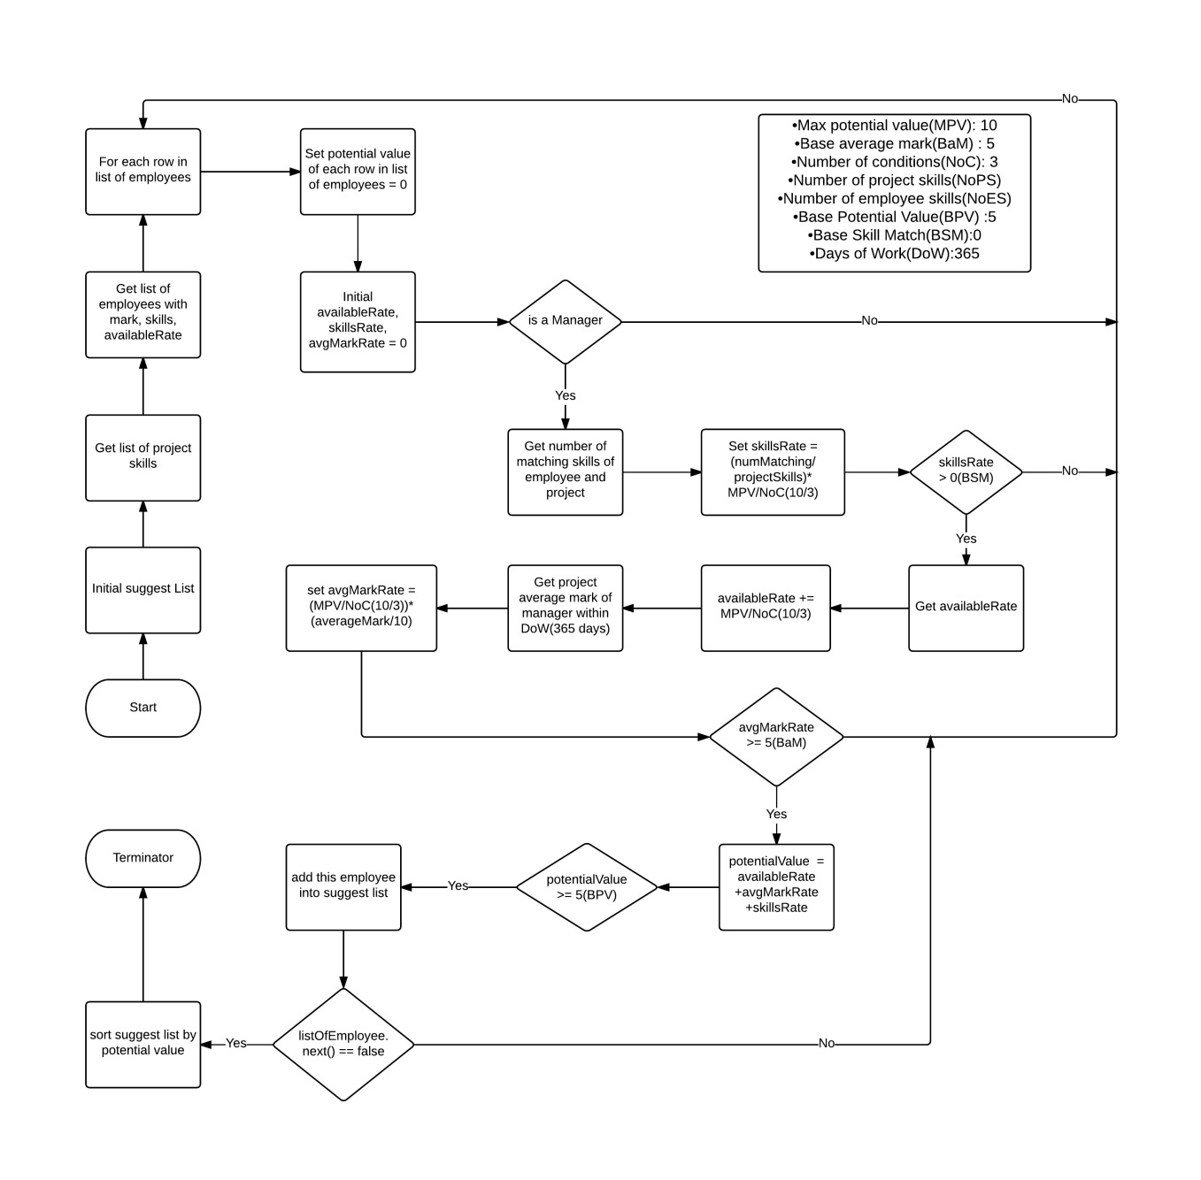

Figure : <Algorithms> Suggest Manager

_ Suggest Staff

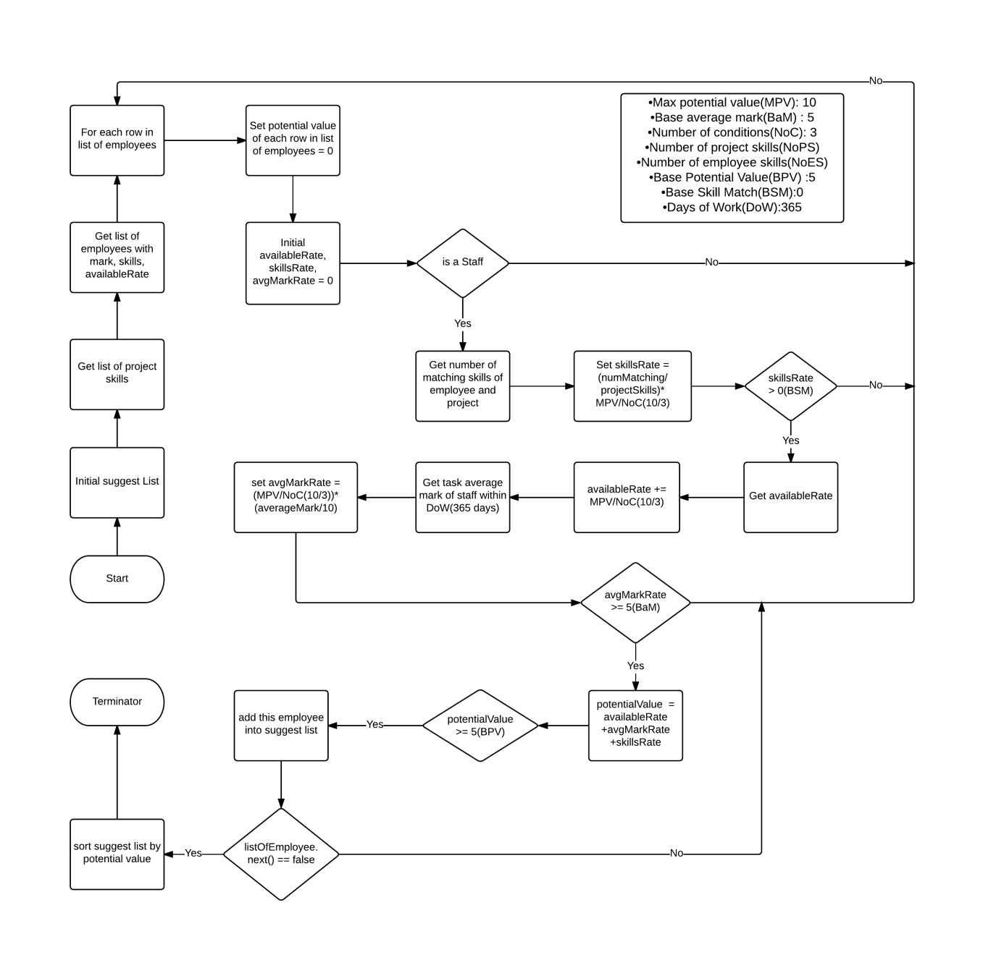

Figure : <Algorithms> Suggest Staff

#### Reference:

<https://en.wikipedia.org/wiki/Sorting_algorithm>

<https://en.wikipedia.org/wiki/Alternating_decision_tree>

# System Implementation & Test

## Introduction

### Overview

This section provides in detail all necessary information about implementation information and testing procedure of OTM includes test plans, test cases, test result and risks estimations.

### Test Approach

_ Goal is test function of system based on core-flow.

_ Method: black box testing.

## Database Relationship Diagram

### Physical Diagram

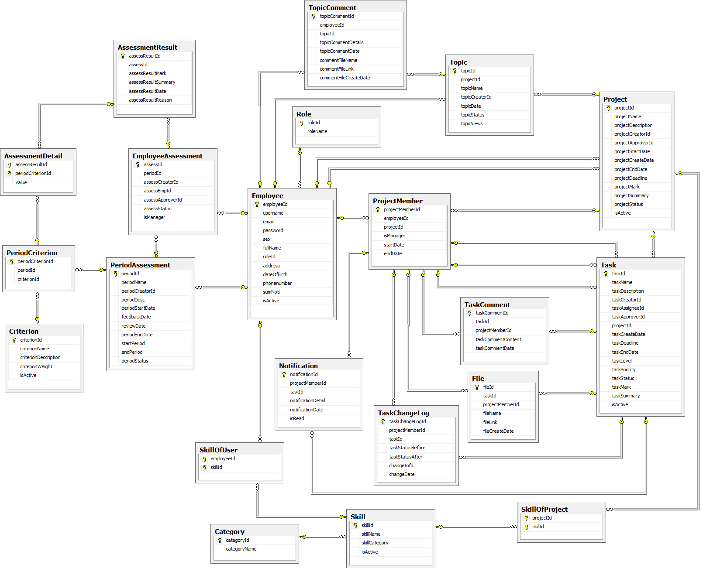

Figure : Physical Diagram

### Data Dictionary

|  |  |
| --- | --- |
| **Physical Diagram dictionary: Describe Entity** | |
| **Entity** | **Description** |
| Employee | Describe all employees that are working in the company. |
| Project | Describe all projects in the system. |
| Project Member | Describe all employees that are working in a project. |
| Task | Describe all tasks in the project. |
| Role | Describe all roles in the system. |
| Task Change log | Describe all history of tasks in the system. |
| Topic | Describe all topics in a project. |
| Topic Comment | Describe all comments in a topic |
| Task Comment | Describe all comments in a task. |
| File | Describe all files in tasks. |
| Comment File | Describe all files in a topic comment. |
| Assessment Result | Describe results of employee assessment. |
| Employee Assessment | Describe employee assessments in period assessment. |
| Period Assessment | Describe period assessments each year. |
| Skill | Describe all skills that belong to categories in the system. |
| Category | Describe all categories that skills belong to in the system. |
| Criterion | Describe criterions in period assessment |
| Notification | Describe notification of a task, which employee will receive when task is assigned to them or changed. |
| PeriodCriterion | Describe all criterions that have in period assessment. |
| AssessmentDetail | Describe detail of an assessment. |

Table : <Physical Diagram> Dictionary

## Performance Measures

### Assign Performance

The speed of assign task function based on the speed of the internet, and if the speed of the internet is good, time delay will be below 1 second.

## Test Plan

The purpose of this section is to verify and ensure that OTM meets its design specification and other requirements from user. The following part will describe which features to be tested and which will not.

Test plan will focus on mobile application with function which user usually uses View Project, View Task.

### Features to be tested

* Admin flow: manage accounts, manage skills, manage period assessments, and manage criterions.
* Project flow: create project, search projects, view project detail, edit project, view all tasks, change manager, view forum, close project, remove project, start project, add staffs into Project, remove staff from project.
* Task flow: Login with each roles, create task, assign task, view task detail, edit task, remove task, cancel task, approve and assess task, reject task, search task, comment task, upload/download file, receive task, done task.

### Features not to be tested

* User: assessment, report.

## System Testing Test Case

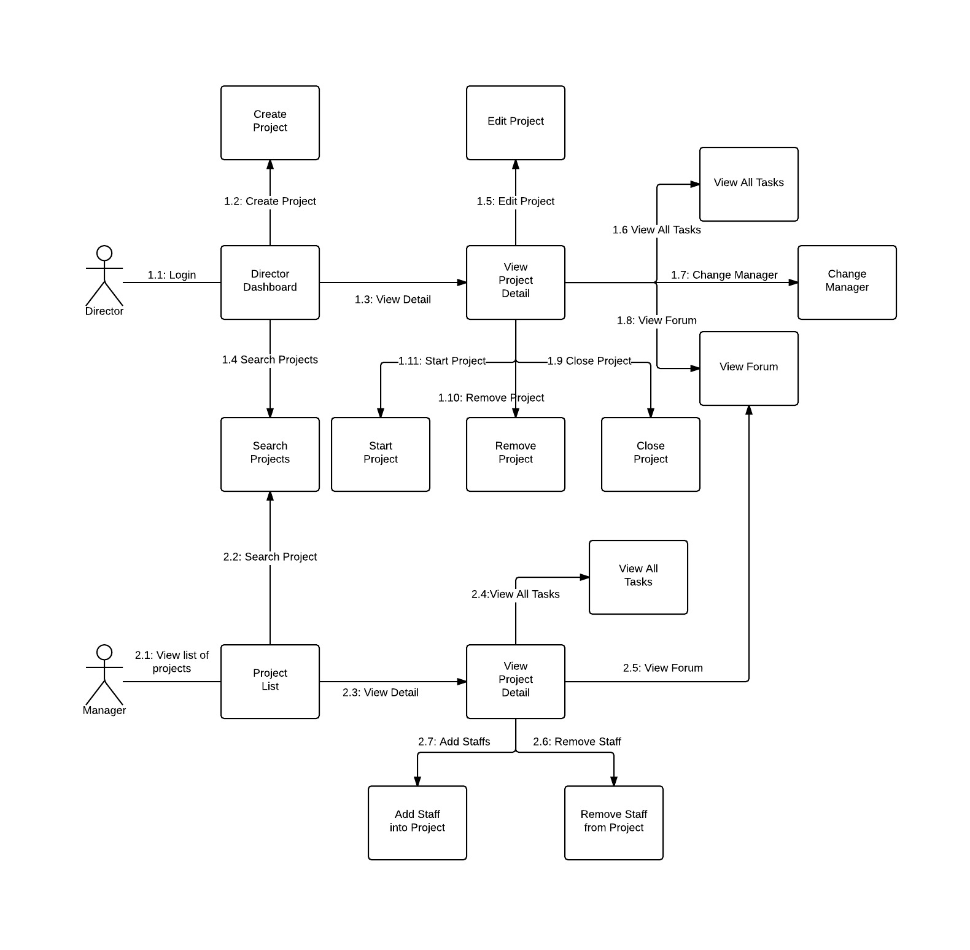

Figure : <Test case> Project Flow

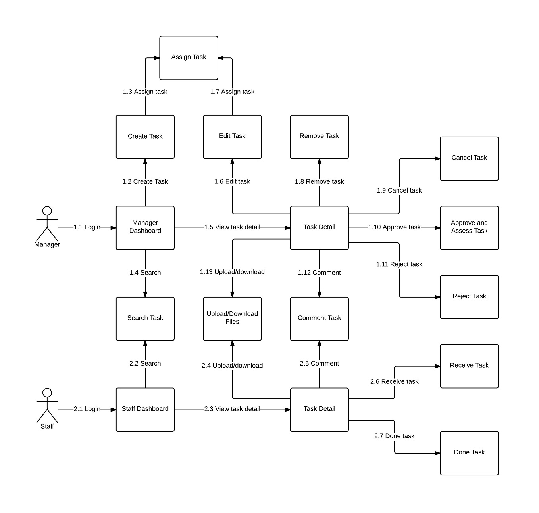

Figure : <Test case> Task Flow

### <Guest> Login

|  |  |  |  |  |  |  |  |  |
| --- | --- | --- | --- | --- | --- | --- | --- | --- |
| ID | Test Case Description | Pre-conditions | Test Case Procedure | Expected output | Inter-test Case Dependence | Result | Test Date | Note |
| LG01 | Guest log into system with Admin role. | N/A | 1 - User opens website.  2 - User inputs admin username and password.  3 - User clicks “Login” button. | After step 1, system shows Login screen.  After step 3, system navigates to Admin screen. | N/A | PASSED | 12/08/2015 |  |
| LG02 | Guest log into system with Director role. | N/A | 1 - User opens website.  2 - User inputs director username and password.  3 - User clicks “Login” button. | After step 1, system shows Login screen.  After step 3, system navigate to dashboard of director. | N/A | PASSED | 12/08/2015 |  |
| LG03 | Guest log into system with Manager role. | N/A | 1 - User opens website.  2 - User inputs manager username and password.  3 - User clicks “Login” button. | After step 1, system shows Login screen.  After step 3, system navigate to dashboard of manager. | N/A | PASSED | 12/08/2015 |  |
| LG04 | Guest log into system with Staff role. | N/A | 1 - User opens website.  2 - User inputs staff username and password.  3 - User clicks “Login” button. | After step 1, system shows Login screen.  After step 3, system navigate to dashboard of staff. | N/A | PASSED | 12/08/2015 |  |
| LG05 | Guest log into system with missing field. | N/A | 1 - User opens website.  2 - User inputs data but missing username or password.  3 - User clicks “Login” button. | After step 1, system shows Login screen.  After step 3, system shows validate message. | N/A | PASSED | 12/08/2015 |  |
| LG06 | Guest log into system with invalid account. | N/A | 1 - User opens website.  2 - User inputs incorrect username or password.  3 - User clicks “Login” button. | After step 1, system shows Login screen.  After step 3, system shows validate message. | N/A | PASSED | 12/08/2015 |  |

Table : <Test Case> Login

### <Guest> Reset Password

|  |  |  |  |  |  |  |  |  |
| --- | --- | --- | --- | --- | --- | --- | --- | --- |
| ID | Test Case Description | Pre-conditions | Test Case Procedure | Expected output | Inter-test Case Dependence | Result | Test Date | Note |
| RP01 | _Guest resets password with valid information. |  | 1 - Guest opens website.  2 - Guest presses “Reset Password” link.  3 - Guest inputs email.  4a - Guest presses “Reset” button.  4b - Guest presses “Close” button | System shows Login screen.  System opens “Reset Password” pop up.  System checks validate and send an email.  System shows success message.  System closes pop up and shows Login screen. | N/A | PASSED | 12/08/2015 |  |

Table : <Test case> Reset Password

### <User> Logout

|  |  |  |  |  |  |  |  |  |
| --- | --- | --- | --- | --- | --- | --- | --- | --- |
| ID | Test Case Description | Pre-conditions | Test Case Procedure | Expected output | Inter-test Case Dependence | Result | Test Date | Note |
| LO01 | User log out from system. | Guest logged into the system. | 1 - User clicks on username on header.  2 - User chooses “Logout”. | After step 1, system shows dropdown menu.  After step 2, system navigate to Login screen. | LG02 | PASSED | 12/08/2015 |  |

Table : <Test case> Logout

### Admin Test Case

#### <Admin> Add Account

|  |  |  |  |  |  |  |  |  |
| --- | --- | --- | --- | --- | --- | --- | --- | --- |
| ID | Test Case Description | Pre-conditions | Test Case Procedure | Expected output | Inter-test Case Dependence | Result | Test Date | Note |
| AA01 | Admin adds account. | Guest log into system with Admin role. | 1 - User clicks “Add Account” button.  2 - User inputs information.  3 - User clicks “Add” button. | After step 1, system shows Add Account screen.  After step 3, system shows success message and navigates to Account screen. | LG02 | PASSED | 12/08/2015 |  |
| AA02 | Admin adds account with invalid field. | Guest log into system with Admin role. | 1 - User clicks “Add Account” button.  2 - User inputs invalid information.  3 - User clicks “Add” button. | After step 1, system shows Add Account screen.  After step 3, system shows error message and reload Add Account screen. | LG02 | PASSED | 12/08/2015 |  |

Table : <Test case> Add Account

#### <Admin> Add Category

|  |  |  |  |  |  |  |  |  |
| --- | --- | --- | --- | --- | --- | --- | --- | --- |
| ID | Test Case Description | Pre-conditions | Test Case Procedure | Expected output | Inter-test Case Dependence | Result | Test Date | Note |
| ACa01 | Admin adds category with full fields | Guest log into system with Admin role. | 1 - Admin clicks “Add Category” button on Manage Skill screen.  2 - Admin inputs category name on Add Category pop up.  3a - Admin presses “Add” button.  3b - Admin presses “Close” button. | After step 1, system opens Add Category pop up.  After step 3a, system shows success message and navigates to Manage Category screen.  After step 3b, system navigates to Manage Skill screen | LG02 | PASSED | 12/08/2015 |  |
| ACa02 | Admin adds category with missing fields. | Guest log into system with Admin role. | 1 - Admin clicks “Add Category” button on Manage Skill screen.  2 - Admin does not input category name.  3a - Admin presses “Add” button.  3b - Admin presses  “Close” button. | After step 1, system opens Add Category pop up.  After step 3a, system shows warning message.  After step 3b, system navigate to Manage Skill screen. | LG02 | PASSED | 12/08/2015 |  |
| ACa03 | Admin add category with invalid fields | Guest log into system with Admin role. | 1 - Admin clicks “Add Category” button on Manage Skill screen.  2 - Admin inputs category name is existed.  3a - Admin presses “Add” button.  3b - Admin presses  “Close” button. | After step 1, system opens Add Category pop up.  After step 3a, system shows warning message.  After step 3b, system navigate to Manage Skill screen. | LG02 | PASSED | 12/08/2015 |  |

Table : <Test case> Add Category

#### <Admin> Add Skill

|  |  |  |  |  |  |  |  |  |
| --- | --- | --- | --- | --- | --- | --- | --- | --- |
| ID | Test Case Description | Pre-conditions | Test Case Procedure | Expected output | Inter-test Case Dependence | Result | Test Date | Note |
| AS01 | Admin adds Skill with full fields. | Guest log into system with Admin role. | 1 - Admin clicks “Add Skill” button on Manage Skill screen.  2 - Admin inputs Skill name and chooses category on Add Skill pop up.  3a - Admin presses “Add Skill” button.  3b - Admin presses “Close” button. | After step 1, system opens Add Skill pop up.  After step 3a, system shows success message and navigates to Manage Skill screen.  After step 3b, system navigate to Manage Skill screen. | LG02 | PASSED | 12/08/2015 |  |
| AS2 | Admin adds category with missing fields. | Guest log into system with Admin role. | 1 - Admin clicks “Add Skill” button on Manage Skill screen.  2 - Admin does not input skill name.  3a - Admin presses “Add” button.  3b - Admin presses  “Close” button. | After step 1, system opens Add Skill pop up.  After step 3a, system shows warning message.  After step 3b, system navigate to Manage Skill screen. | LG02 | PASSED | 12/08/2015 |  |
| AS3 | Admin add category with invalid fields | Guest log into system with Admin role. | 1 - Admin clicks “Add Skill” button on Manage Skill screen.  2 - Admin inputs skill name is existed.  3a - Admin presses “Add” button.  3b - Admin presses  “Close” button. | After step 1, system opens Add Skill pop up.  After step 3a, system shows warning message.  After step 3b, system navigate to Manage Skill screen. | LG02 | PASSED | 12/08/2015 |  |

Table : <Test case> Add Skill

#### <Admin> Add Period Assessment

|  |  |  |  |  |  |  |  |  |
| --- | --- | --- | --- | --- | --- | --- | --- | --- |
| ID | Test Case Description | Pre-conditions | Test Case Procedure | Expected output | Inter-test Case Dependence | Result | Test Date | Note |
| APA01 | Admin adds period assessment with full fields | Guest log into system with Admin role. | 1 - Admin clicks “Add Period Assessment” button on menu bar.  2 - Admin inputs period name, period description, start period date, end period date, period open date, and period close date on Add Period Assessment screen.  3a - Admin presses “Add Period Assessment” button.  3b - Admin presses “Back” button. | After step 1, system opens Add Period Assessment screen.  After step 3a, system shows success message and navigates to Manage Period Assessment screen.  After step 3b, system navigates to Manage Period Assessment screen | LG02 | PASSED | 12/08/2015 |  |
| APA02 | Admin adds period assessment with missing fields. | Guest log into system with Admin role. | 1 - Admin clicks “Add Period Assessment” button on menu bar.  2 - Admin does not input period name or period description or, start period date or, period open date or, period close date on Add Period Assessment screen.  3a - Admin presses “Add Period Assessment” button.  3b - Admin presses  “Back” button. | After step 1, system opens Add Period Assessment screen.  After step 3a, system shows warning message.  After step 3b, system navigate to Manage Period Assessment screen. | LG02 | PASSED | 12/08/2015 |  |
| APA03 | Admin adds period assessment with missing fields. | Guest log into system with Admin role. | 1 - Admin clicks “Add Period Assessment” button on menu bar.  2 - Admin inputs start period date is small period open date, or end period date is large close period.  3a - Admin presses “Add Period Assessment” button.  3b - Admin presses  “Back” button. | After step 1, system opens Add Period Assessment screen.  After step 3a, system shows warning message.  After step 3b, system navigate to Manage Period Assessment screen. | LG02 | PASSED | 12/08/2015 |  |

Table : <Test case> Add Period Assessment

#### <Admin> Add Criterion

|  |  |  |  |  |  |  |  |  |
| --- | --- | --- | --- | --- | --- | --- | --- | --- |
| ID | Test Case Description | Pre-conditions | Test Case Procedure | Expected output | Inter-test Case Dependence | Result | Test Date | Note |
| ACr01 | Admin adds criterion with full fields | Guest log into system with Admin role. | 1 - Admin clicks “Add Criterion” button on menu bar.  2 - Admin inputs criterion name, criterion description, criterion weight on Add Criterion screen.  3a - Admin presses “Add Criterion” button.  3b - Admin presses “Back” button. | After step 1, system opens Add Criterion screen.  After step 3a, system shows success message and navigates to Manage Criterion screen.  After step 3b, system navigates to Manage Criterion screen | LG02 | PASSED | 12/08/2015 |  |
| ACr02 | Admin adds criterion with missing fields | Guest log into system with Admin role. | 1 - Admin clicks “Add Criterion” button on menu bar.  2 - Admin do not input criterion name or, criterion description or, criterion weight on Add Criterion screen.  3a - Admin presses “Add Criterion” button.  3b - Admin presses  “Back” button. | After step 1, system opens Add Criterion screen.  After step 3a, system shows warning message.  After step 3b, system navigate to Manage Criterion screen. | LG02 | PASSED | 12/08/2015 |  |
| ACr03 | Admin adds criterion with invalid fields | Guest log into system with Admin role. | 1 - Admin clicks “Add Criterion” button on menu bar.  2 - Admin inputs criterion name is existed.  3a - Admin presses “Add Criterion” button.  3b - Admin presses  “Back” button. | After step 1, system opens Add Criterion screen.  After step 3a, system shows warning message.  After step 3b, system navigate to Manage Criterion screen. | LG02 | PASSED | 12/08/2015 |  |

Table : <Test case> Add Criterion

#### <Admin> Edit Account

|  |  |  |  |  |  |  |  |  |
| --- | --- | --- | --- | --- | --- | --- | --- | --- |
| ID | Test Case Description | Pre-conditions | Test Case Procedure | Expected output | Inter-test Case Dependence | Result | Test Date | Note |
| EA01 | Admin edits account with full fields | Guest log into system with Admin role. | 1 - Admin chooses role and status on Manage Account screen.  2 - Admin presses “Edit” button. | After step 2, system show success message and load page again with fields is changed. | LG02 | PASSED | 12/08/2015 |  |

Table : <Test case> Edit Account

#### <Admin> Edit Skill

|  |  |  |  |  |  |  |  |  |
| --- | --- | --- | --- | --- | --- | --- | --- | --- |
| ID | Test Case Description | Pre-conditions | Test Case Procedure | Expected output | Inter-test Case Dependence | Result | Test Date | Note |
| ES01 | Admin edits skill with full fields | Guest log into system with Admin role. | 1 - Admin chooses category and edits skill name on Manage Skill screen.  2 - Admin presses “Edit” button. | After step 2, system shows success message and load page again with fields is changed. | LG02 | PASSED | 12/08/2015 |  |

Table : <Test case> Edit Skill

#### <Admin> Edit Period Assessment

|  |  |  |  |  |  |  |  |  |
| --- | --- | --- | --- | --- | --- | --- | --- | --- |
| ID | Test Case Description | Pre-conditions | Test Case Procedure | Expected output | Inter-test Case Dependence | Result | Test Date | Note |
| EPA01 | Admin edits period assessment with full fields | Guest log into system with Admin role. | 1 - Admin edits period name, period description, start period date, end period date, period open date, and period close date on Manage Period Assessment screen.  2 - Admin presses “Edit” button. | After step 2, system shows success message and load page again with fields is changed. | LG02 | PASSED | 12/08/2015 |  |

Table : <Test case> Edit Period Assessment

#### <Admin> Edit Criterion

|  |  |  |  |  |  |  |  |  |
| --- | --- | --- | --- | --- | --- | --- | --- | --- |
| ID | Test Case Description | Pre-conditions | Test Case Procedure | Expected output | Inter-test Case Dependence | Result | Test Date | Note |
| ECr01 | Admin edits criterion with full fields | Guest log into system with Admin role. | 1 - Admin edits criterion name, criterion description, criterion weight, status on Manage Criterion screen.  2 - Admin presses “Edit” button. | After step 2, system show success message and load page again with fields is changed. | LG02 | PASSED | 12/08/2015 |  |

Table : <Test case> Edit Criterion

#### <Admin> Search Accounts

|  |  |  |  |  |  |  |  |  |
| --- | --- | --- | --- | --- | --- | --- | --- | --- |
| ID | Test Case Description | Pre-conditions | Test Case Procedure | Expected output | Inter-test Case Dependence | Result | Test Date | Note |
| SA01 | Admin search account by name | Guest log into system with Admin role. | 1 - Admin inputs user name into search box on Manage Account screen.  2 - Admin presses “Search” button. | After step 2, system shows list accounts with user name found. | LG02 | PASSED | 12/08/2015 |  |
| SA02 | Admin search account by role | Guest log into system with Admin role. | 1 - Admin chooses role in dropdown list on Manage Account screen.  2 - Admin presses “Search” button. | After step 2, system shows list accounts with role found. | LG02 | PASSED | 12/08/2015 |  |
| SA03 | Admin search account by status | Guest log into system with Admin role. | 1 - Admin chooses status in dropdown list on Manage Account screen.  2 - Admin presses “Search” button. | After step 2, system shows list accounts with status found. | LG02 | PASSED | 12/08/2015 |  |
| SA04 | Admin search account by name and role | Guest log into system with Admin role. | 1 - Admin inputs user name into search box and chooses role in dropdown list on Manage Account screen.  2 - Admin presses “Search” button. | After step 2, system shows list accounts with user name and role found. | LG02 | PASSED | 12/08/2015 |  |
| SA05 | Admin search account by role and status | Guest log into system with Admin role. | 1 - Admin choose role and status in dropdown list on Manage Account screen.  2 - Admin presses “Search” button. | After step 2, system shows list accounts with role and status found. | LG02 | PASSED | 12/08/2015 |  |
| SA06 | Admin search account by status and user name | Guest log into system with Admin role. | 1 - Admin input username and chooses status in dropdown list on Manage Account screen.  2/ Admin presses “Search” button. | After step 2, system shows list accounts with user name and status found. | LG02 | PASSED | 12/08/2015 |  |
| SA07 | _Admin search with invalid key | Guest log into system with Admin role. | 1 - Admin input username or chooses role or status in dropdown list on Manage Account screen.  2/ Admin presses “Search” button. | After step 2, system shows list empty. | LG02 | PASSED | 12/08/2015 |  |

Table : <Test case> Search Accounts

#### <Admin> Search Skills

|  |  |  |  |  |  |  |  |  |
| --- | --- | --- | --- | --- | --- | --- | --- | --- |
| ID | Test Case Description | Pre-conditions | Test Case Procedure | Expected output | Inter-test Case Dependence | Result | Test Date | Note |
| SS01 | Admin search category and skill by name | Guest log into system with Admin role.. | 1 - Admin input category name or skill name into search box on Manage Skill screen.  2 - Admin presses “Search” button. | After step 2, system shows list category and skill with category name or skill name found. | LG02 | PASSED | 12/08/2015 |  |
| SS02 | Admin search skill by category | Guest log into system with Admin role. | 1 - Admin chooses category in dropdown list on Manage Skill screen.  2 - Admin presses “Search” button. | After step 2, system shows list category and skill with category found. | LG02 | PASSED | 12/08/2015 |  |
| SS03 | Admin search with invalid key | Guest log into system with Admin role. | 1 - Admin inputs category name or skill name Manage Skill screen.  2 - Admin presses “Search” button. | After step 2, system shows list empty. | LG02 | PASSED | 12/08/2015 |  |

Table : <Test case> Search Skills

#### <Admin> Search Period Assessments

|  |  |  |  |  |  |  |  |  |
| --- | --- | --- | --- | --- | --- | --- | --- | --- |
| ID | Test Case Description | Pre-conditions | Test Case Procedure | Expected output | Inter-test Case Dependence | Result | Test Date | Note |
| SPA01 | Admin search period assessment by name | Guest log into system with Admin role. | 1 - Admin inputs period name into search box on Manage Period Assessment screen.  2 - Admin presses “Search” button. | After step 2, system shows list period assessment with period name found. | LG02 | PASSED | 12/08/2015 |  |
| SPA02 | Admin search period assessment by date | Guest log into system with Admin role. | 1 - Admin choose date on Manage Period Assessment screen.  2 - Admin presses “Search” button. | After step 2, system shows list period assessment with date found. | LG02 | PASSED | 12/08/2015 |  |
| SPA03 | Admin search period assessment by status | Guest log into system with Admin role.. | 1 - Admin choose status in dropdown list on Manage Period Assessment screen.  2 - Admin presses “Search” button. | After step 2, system shows list period assessment with status found. | LG02 | PASSED | 12/08/2015 |  |
| SPA04 | Admin search invalid key | Guest log into system with Admin role. | 1 - Admin period name on Manage Period Assessment screen.  2 - Admin presses “Search” button. | After step 2, system shows list empty. | LG02 | PASSED | 12/08/2015 |  |

Table : <Test case> Search Period Assessments

#### <Admin> Search Criterions

|  |  |  |  |  |  |  |  |  |
| --- | --- | --- | --- | --- | --- | --- | --- | --- |
| ID | Test Case Description | Pre-conditions | Test Case Procedure | Expected output | Inter-test Case Dependence | Result | Test Date | Note |
| SCr01 | Admin search criterion by name | Guest log into system with Admin role. | 1 - Admin inputs criterion name into search box on Manage Criterion screen.  2 - Admin presses “Search” button. | After step 2, system shows list criterion with criterion name found. | LG02 | PASSED | 12/08/2015 |  |
| SCr02 | Admin search criterion by weight | Guest log into system with Admin role. | 1 - Admin inputs weight into search box on Manage Criterion screen.  2 - Admin presses “Search” button. | After step 2, system shows list criterion with weight found. | LG02 | PASSED | 12/08/2015 |  |
| SCr03 | Admin search criterion by status | Guest log into system with Admin role. | 1 - Admin choose status on Manage Criterion screen.  2 - Admin presses “Search” button. | After step 2, system shows list criterion with status found. | LG02 | PASSED | 12/08/2015 |  |
| SCr04 | Admin search invalid key | Guest log into system with Admin role. | 1 - Admin inputs criterion name, weight, or choose status in dropdown list on Manage Criterion screen.  2 - Admin presses “Search” button. | After step 2, system shows list empty. | LG02 | PASSED | 12/08/2015 |  |

Table : <Test case> Search Criterions

### Project Flow:

#### <Director> View Project

|  |  |  |  |  |  |  |  |  |
| --- | --- | --- | --- | --- | --- | --- | --- | --- |
| ID | Test Case Description | Pre-conditions | Test Case Procedure | Expected output | Inter-test Case Dependence | Result | Test Date | Note |
| VP01 | Verify the Director Dashboard screen is displayed as its design. | User must login with Director role. | 1 - User input username and password on login screen and click “Sign In”.  2 - Verify the Director Dashboard screen is displayed as its design. | After step 1, Dashboard Director screen is displayed. | LG02 | PASSED | 11/08/2015 |  |
| VP02 | Project with “STARTED” status | User must login with Director role. | 1 - User input username and password on login screen and click “Sign In”. | After step 1, Dashboard Director screen is displayed with all started projects. | LG02 | PASSED | 11/08/2015 |  |
| VP03 | Project with “NEW” status | User must login with Director role. | 1 - User input username and password on login screen and click “Sign In”.  2 - Click “Advance Search” icon and choose “NEW” status and click “Search” or enter. | After step 1, Dashboard Director screen is displayed.  After step 2,  Dashboard Director screen is displayed with all new projects. | LG02 | PASSED | 11/08/2015 |  |

Table : <Test case> View Project

#### <Director> Create Project

|  |  |  |  |  |  |  |  |  |
| --- | --- | --- | --- | --- | --- | --- | --- | --- |
| ID | Test Case Description | Pre-conditions | Test Case Procedure | Expected output | Inter-test Case Dependence | Result | Test Date | Note |
| CP01 | Director creates project with all information. | User must login with Director role. | 1 - User clicks “Create project” button on Dashboard Director screen.  2 - User input all information into all fields and click “Create” button. | After step 1, Create Project screen is displayed.  After step 2,  System shows success message “Create Successfully” and navigates to Project Detail screen with “NEW” status, “Start” button and “Remove” button. | VP01 | PASSED | 11/08/2015 |  |
| CP02 | Director creates project with all empty fields. | User must login with Director role. | 1 - User clicks “Create project” button on Dashboard Director screen.  2 - User clicks “Create” button. | After step 1, Create Project screen is displayed.  After step 2, System shows error message “Please fill out this field” | VP01 | PASSED | 11/08/2015 |  |

Table : <Test case> Create Project

#### <Director> View Project Detail

|  |  |  |  |  |  |  |  |  |
| --- | --- | --- | --- | --- | --- | --- | --- | --- |
| ID | Test Case Description | Pre-conditions | Test Case Procedure | Expected output | Inter-test Case Dependence | Result | Test Date | Note |
| VPD01 | Verify the Project Detail screen is displayed as its design. | User must login with Director role. | 1 - User clicks “View Details” button on Dashboard Director screen.  2 - Verify the Project Detail screen is displayed as its design and all data are the same in the database. | After step 1, Project Detail screen is displayed. | CP01 | PASSED | 11/08/2015 |  |

Table : <Test case> Director View Project Detail

#### <Director> Edit Project

|  |  |  |  |  |  |  |  |  |
| --- | --- | --- | --- | --- | --- | --- | --- | --- |
| ID | Test Case Description | Pre-conditions | Test Case Procedure | Expected output | Inter-test Case Dependence | Result | Test Date | Note |
| EP01 | Verify the Edit Project screen is displayed as its design. | User must login with Director role.  -User must in Project Detail screen.  -Project is not closed. | 1 - User clicks “Edit” button on Project Detail screen.  2 - Verify the Edit Project screen is displayed as its design and all data is the same in the database. | After step 1, Edit Project screen is displayed. | VPD01 | PASSED | 11/08/2015 |  |
| EP02 | Director edits project with “Project Name” field blank. | User must login with Director role.  -User must in Project Detail screen.  -Project is not closed. | 1 - User clicks “Edit” button on Project Detail screen.  2 - Delete “Project Name” field data and click “Save” button. | After step 1, Edit Project screen is displayed.  After step 2,  System shows error message “Please fill out this field”. | VPD01 | PASSED | 11/08/2015 |  |
| EP03 | Director edits project with all information. | User must login with Director role.  -User must in Project Detail screen.  -Project is not closed. | 1 - User clicks “Edit” button on Project Detail screen.  2 - Input data to all field. | After step 1, Edit Project screen is displayed.  After step 2,  System show success message “Created Successfully” and navigate to Project Detail screen. | VPD01 | PASSED | 11/08/2015 |  |

Table : <Test case> Edit Project

#### <Director> Start Project

|  |  |  |  |  |  |  |  |  |
| --- | --- | --- | --- | --- | --- | --- | --- | --- |
| ID | Test Case Description | Pre-conditions | Test Case Procedure | Expected output | Inter-test Case Dependence | Result | Test Date | Note |
| EP01 | Verify if the “Date Started” field of Project Detail screen has changed. | User must login with Director role.  -User must in Project Detail screen.  -Project status is “NEW”. | 1 - User clicks “Start” button on Project Detail screen.  2 - User clicks “Start” button. | After step 1, System shows confirmation popup.  After step 2,  System closes popup and reload Project Detail screen with field “Start Date” has changed to today and status has changed to “STARTED”. | VPD01 | PASSED | 11/08/2015 |  |

Table : <Test case> Start Project

#### <Director> Close Project

|  |  |  |  |  |  |  |  |  |
| --- | --- | --- | --- | --- | --- | --- | --- | --- |
| ID | Test Case Description | Pre-conditions | Test Case Procedure | Expected output | Inter-test Case Dependence | Result | Test Date | Note |
| CPT01 | Verify if the project was closed successfully. | User must login with Director role.  -User must in Project Detail screen.  -Project status is “STARTED”. | 1 - User clicks “Close” button on Project Detail screen.  2 - User input data and click “Close project” button. | After step 1, System shows project assessment popup.  After step 2,  System shows success message “The project has been closed” and navigates to Dashboard Director screen. | VPD01 | PASSED | 11/08/2015 |  |
| CPT02 | Verify if the project was closed successfully without Manager. | User must login with Director role.  -User must in Project Detail screen.  -Project status is “STARTED”.  -Project does not have manager. | 1 - User clicks “Close” button on Project Detail screen.  2 - User input data and click “Close project” button. | After step 1, System shows project assessment popup.  After step 2,  System shows success message “The project has been closed” and navigates to Dashboard Director screen. | VPD01 | PASSED | 11/08/2015 |  |

Table : <Test case> Close Project

#### <Director> Remove Project

|  |  |  |  |  |  |  |  |  |
| --- | --- | --- | --- | --- | --- | --- | --- | --- |
| ID | Test Case Description | Pre-conditions | Test Case Procedure | Expected output | Inter-test Case Dependence | Result | Test Date | Note |
| RP01 | Verify if the project was removed successfully. | User must login with Director role.  -User must in Project Detail screen.  -Project status is “NEW”. | 1 - User clicks “Remove” button on Project Detail screen.  2 - User click “Remove” button. | After step 1, System shows confirmation popup.  After step 2,  System shows success message “The project has been removed” and navigates to Dashboard Director screen. | VPD01 | PASSED | 11/08/2015 |  |

Table : <Test case> Remove Project

#### <Director> Change Manager

|  |  |  |  |  |  |  |  |  |
| --- | --- | --- | --- | --- | --- | --- | --- | --- |
| ID | Test Case Description | Pre-conditions | Test Case Procedure | Expected output | Inter-test Case Dependence | Result | Test Date | Note |
| RP01 | Change role of staff in the project to Manager. | User must login with Director role.  -User must in Project Detail screen.  -Project must have staff in the project.  -This staff must finish all tasks. | 1 - User clicks “Member” tab and click “Change” icon.  2 - User click “Yes” button. | After step 1, System shows confirmation popup.  After step 2,  System shows success message “The Manager has been changed” and reloads to Project Detail screen. | VPD01 | PASSED | 11/08/2015 |  |

Table : <Test case> Change Manager

#### <Manager> List Project

|  |  |  |  |  |  |  |  |  |
| --- | --- | --- | --- | --- | --- | --- | --- | --- |
| ID | Test Case Description | Pre-conditions | Test Case Procedure | Expected output | Inter-test Case Dependence | Result | Test Date | Note |
| LP01 | Verify the List Project screen of Manager is displayed as its design. | User must login with Manager role. | 1 - User clicks “Project” on right navigator bar.  2 - Verify if List Project of Manager screen is displayed with all projects belongs to this logged user. | After step 1, List Project of Manager screen is displayed. | LG03 | PASSED | 11/08/2015 |  |

Table : <Test case> List Project

#### <Manager> View Project Detail

|  |  |  |  |  |  |  |  |  |
| --- | --- | --- | --- | --- | --- | --- | --- | --- |
| ID | Test Case Description | Pre-conditions | Test Case Procedure | Expected output | Inter-test Case Dependence | Result | Test Date | Note |
| MVPD01 | Verify the Project Detail screen is displayed as its design. | User must login with Manager role. | 1 - User clicks “View Details” button on List Project screen.  2 - Verify the Project Detail screen is displayed as its design and all data are the same in the database. | After step 1, Project Detail screen is displayed. | LP01 | PASSED | 11/08/2015 |  |

Table : <Test case> Manager View Project Detail

#### <Manager> Add Staffs into Project

|  |  |  |  |  |  |  |  |  |
| --- | --- | --- | --- | --- | --- | --- | --- | --- |
| ID | Test Case Description | Pre-conditions | Test Case Procedure | Expected output | Inter-test Case Dependence | Result | Test Date | Note |
| ASIP01 | Add staffs into the project. | User must login with Manager role.  User must be in Project Detail screen. | 1 - User clicks “Add Member” button.  2 – User chooses staffs and click “Add” button. | After step 1, Add Member popup is shown.  After step 2,  System shows success message “Added Successfully” and reload Project Detail screen | LP01 | PASSED | 11/08/2015 |  |

Table : <Test case> Add Staffs into Project

#### <Manager> Remove Staff from Project

|  |  |  |  |  |  |  |  |  |
| --- | --- | --- | --- | --- | --- | --- | --- | --- |
| ID | Test Case Description | Pre-conditions | Test Case Procedure | Expected output | Inter-test Case Dependence | Result | Test Date | Note |
| RSFP01 | Remove staff from the project with no task undone. | User must login with Manager role.  User must be in Project Detail screen.  Staff must not have any task undone. | 1 - User clicks “Member” tab and click “Delete” icon.  2 - User click “Yes” button. | After step 1, System shows confirmation popup.  After step 2,  System shows success message “Staff has been deleted successfully” and reloads to Project Detail screen. | MVPD01 | PASSED | 11/08/2015 |  |
| RSFP02 | Remove staff from the project with many tasks undone. | User must login with Manager role.  User must be in Project Detail screen.  Staff must have some tasks undone. | 1 - User clicks “Member” tab and click “Delete” icon.  2 - User click “Yes” button. | After step 1, System shows confirmation popup.  After step 2,  System shows error message “Please cancel all related tasks before removing this staff” and reloads to Project Detail screen. | MVPD01 | PASSED | 11/08/2015 |  |

Table : <Test case> Remove Staff from Project

### Task Flow:

#### <Manager> Create Task

|  |  |  |  |  |  |  |  |  |
| --- | --- | --- | --- | --- | --- | --- | --- | --- |
| ID | Test Case Description | Pre-conditions | Test Case Procedure | Expected output | Inter-test Case Dependence | Result | Test Date | Note |
| CT01 | Manager creates a new task with valid information. | User must login with Manager role. | 1 - Manager clicks on “Create task” button on header.  2 - Manager inputs valid information.  3 - Manager clicks “Create” button. | After step 1, system opens Create Task popup.  After step 3, system navigates to Task Detail screen and shows success message “New task has been created!” | N/A | PASSED | 12/08/2015 |  |
| CT02 | Manager creates a new task with missing field. | User must login with Manager role. | 1 - Manager clicks on “Create task” button on header.  2 - Manager inputs data but missing “Title” field.  3 - Manager clicks “Create” button. | After step 1, system opens Create Task popup.  After step 3, system focuses on “Title” field and shows error message “Please fill out this field.” | N/A | PASSED | 12/08/2015 |  |

Table : <Test case> Create Task

#### <Manager> Assign Task

|  |  |  |  |  |  |  |  |  |
| --- | --- | --- | --- | --- | --- | --- | --- | --- |
| ID | Test Case Description | Pre-conditions | Test Case Procedure | Expected output | Inter-test Case Dependence | Result | Test Date | Note |
| AT01 | Manager assign task. | User must login with Manager role.  User must be in Create Task popup or Edit Task popup. | 1 - Manager selects Assignee in Create Task popup.  2 - Manager clicks “Create” button. | After step 2, system navigates to Task Detail screen with task status is “PENDING” and assignee name is shown. | CT,ED | PASSED | 12/08/2015 |  |

Table : <Test case> Assign Task

#### <Staff> Search Task

|  |  |  |  |  |  |  |  |  |
| --- | --- | --- | --- | --- | --- | --- | --- | --- |
| ID | Test Case Description | Pre-conditions | Test Case Procedure | Expected output | Inter-test Case Dependence | Result | Test Date | Note |
| ST01 | Staff and Manager search tasks by name. | User must login with Staff or Manager role.  User must be in Dashboard screen. | 1 - User inputs task name into search box on Dashboard.  2 - User presses “Enter” key on keyboard. | After step 2, system shows list task with task name found. | N/A | PASSED | 12/08/2015 |  |

Table : <Test case> Search Task

#### <Staff> View Task Detail

|  |  |  |  |  |  |  |  |  |
| --- | --- | --- | --- | --- | --- | --- | --- | --- |
| ID | Test Case Description | Pre-conditions | Test Case Procedure | Expected output | Inter-test Case Dependence | Result | Test Date | Note |
| VTD01 | Staff views task detail. | User must login with Staff or Manager role.  User must be in Dashboard screen. | 1 – User clicks task name in task table on Dashboard. | After step 1, system navigates to the Task Detail screen with following contents:  - Task Name  - Tab Overview: Project Name, Task Description, Task Creator, Task Assignee, Task Approver, Task Created Date, Task Ended Date, Task Due Date, Task Level, Task Priority, Task Status,  Action buttons  - Tab Summary: Task Mark, Task Summary.  - Tab Comments: Comment, Comment Author, Comment Date, Write Comment.  - Tab Files: File name, File Creator, File Created Date, Upload file.  - Tab Activities: Activity Time, Activity Content. | N/A | PASSED | 12/08/2015 |  |

Table : <Test case> View Task Detail

#### <Manager> Edit Task

|  |  |  |  |  |  |  |  |  |
| --- | --- | --- | --- | --- | --- | --- | --- | --- |
| ID | Test Case Description | Pre-conditions | Test Case Procedure | Expected output | Inter-test Case Dependence | Result | Test Date | Note |
| ET01 | Manager edit task with valid information. | User must login with Manager role.  User must be in Task Detail screen.  Task status must be not “CLOSED” and “CANCELED” | 1 - Manager clicks “Edit” button in Task Detail.  2 - Manager edits task information.  3 - Manager clicks “Save” button. | After step 1, system opens Edit Task popup.  After step 3, system reload Task Detail screen. System shows success message “Task has been edited!” | VTD | PASSED | 12/08/2015 |  |
| ET02 | Manager edit task with missing field. | User must login with Manager role.  User must be in Task Detail screen.  Task status must be not “CLOSED” and “CANCELED” | 1 - Manager clicks on “Edit” button in Task Detail screen.  2 - Manager deletes data at the “Title” field.  3 - Manager clicks “Save” button. | After step 1, system opens Edit Task popup.  After step 3, system focuses on “Title” field and shows error message “Please fill out this field.” | VTD | PASSED | 12/08/2015 |  |

Table : <Test case> Edit Task

#### <Manager> Remove Task

|  |  |  |  |  |  |  |  |  |
| --- | --- | --- | --- | --- | --- | --- | --- | --- |
| ID | Test Case Description | Pre-conditions | Test Case Procedure | Expected output | Inter-test Case Dependence | Result | Test Date | Note |
| RT01 | Manager remove task. | User must login with Manager role.  User must be in Task Detail screen.  Task status must be “NEW”. | 1 - Manager clicks “Remove” button in Task Detail screen.  2 - Manager clicks “Remove” button on confirm popup. | After step 1, system opens a confirm popup.  After step 2, system navigates to Dashboard screen and shows success message “Task has been removed!” | VTD | PASSED | 12/08/2015 |  |

Table : <Test case> Remove Task

#### <Staff> Upload/Download Files

|  |  |  |  |  |  |  |  |  |
| --- | --- | --- | --- | --- | --- | --- | --- | --- |
| ID | Test Case Description | Pre-conditions | Test Case Procedure | Expected output | Inter-test Case Dependence | Result | Test Date | Note |
| UDF01 | Manager and Staff upload a file less than 10MB. | User must login with Staff or Manager role.  User must be in Task Detail screen.  Task status must be not “CLOSED” or “CANCELED”. | 1 - User clicks “Choose File” button in Task Detail screen.  2 – User selects a file less than 10MB.  3 – User clicks “Upload” button in Task Detail screen. | After step 1, system opens a window for selecting file to upload.  After step 3, system uploads the file to server and load on screen. | VTD | PASSED | 12/08/2015 |  |
| UDF02 | Manager and Staff upload a file over than 10MB. | User must login with Staff or Manager role.  User must be in Task Detail screen.  Task status must be not “CLOSED” or “CANCELED”. | 1 – User clicks “Choose File” button in Task Detail screen.  2 – User selects a file over than 10MB.  3 – User clicks “Upload” button in Task Detail screen. | After step 1, system opens a window for selecting file to upload.  After step 3, system shows error message “The file is oversize.” | VTD | PASSED | 12/08/2015 |  |
| UDF03 | Manager and Staff download a file from server. | User must login with Staff or Manager role.  User must be in Task Detail screen. | 1 – User clicks on a file name link in Task Detail screen. | After step 1, system let user download that file from server. | VTD | PASSED | 12/08/2015 |  |
| UDF04 | Manager and Staff remove a file from server. | User must login with Staff or Manager role.  User must be in Task Detail screen.  Task status must be not “CLOSED” or “CANCELED”. | 1 – User clicks “Delete” button next to the file name. | After step 1, the file on server will be deleted. | VTD | PASSED | 12/08/2015 |  |

Table : <Test case> Upload/Download Files

#### <Staff> Comment Task

|  |  |  |  |  |  |  |  |  |
| --- | --- | --- | --- | --- | --- | --- | --- | --- |
| ID | Test Case Description | Pre-conditions | Test Case Procedure | Expected output | Inter-test Case Dependence | Result | Test Date | Note |
| UDF01 | Manager and Staff comment in a task. | User must login with Staff or Manager role.  User must be in Task Detail screen.  Task status must be not “CLOSED” or “CANCELED”. | 1 - User inputs into comment box in Task.  2 – User clicks “Post Comment” button. | After step 2, the new comment will be posted to server and load on screen. | VTD | PASSED | 12/08/2015 |  |

Table : <Test case> Comment Task

#### <Manager> Cancel Task

|  |  |  |  |  |  |  |  |  |
| --- | --- | --- | --- | --- | --- | --- | --- | --- |
| ID | Test Case Description | Pre-conditions | Test Case Procedure | Expected output | Inter-test Case Dependence | Result | Test Date | Note |
| CAT01 | Manager cancel task. | User must login with Manager role.  User must be in Task Detail screen.  Task status must be “PENDING” or “INPROGRESS”. | 1 – Manager clicks “Cancel” button in Task Detail screen.  2 – Manager clicks “Cancel” on confirm popup. | After step 1, system opens a confirm popup.  After step 2, system navigates to Dashboard screen and shows success message “Task has been cancelled”. | VTD | PASSED | 12/08/2015 |  |

Table : <Test case> Cancel Task

#### <Manager> Approve and Assess Task

|  |  |  |  |  |  |  |  |  |
| --- | --- | --- | --- | --- | --- | --- | --- | --- |
| ID | Test Case Description | Pre-conditions | Test Case Procedure | Expected output | Inter-test Case Dependence | Result | Test Date | Note |
| APT01 | Manager approves and assesses task with valid information. | User must login with Manager role.  User must be in Task Detail screen.  Task status must be “DONE”. | 1 – Manager clicks “Approve” button in Task Detail screen.  2 – Manager selects mark and inputs conclusion into “Summary” textbox.  3 – Manager clicks “Close task” button on assessment task popup. | After step 1, system opens a task assessment popup.  After step 3, system navigates to Dashboard screen and shows success message “Task has been approved!” | VTD | PASSED | 12/08/2015 |  |
| APT02 | Manager approves and assesses task with missing field. | User must login with Manager role.  User must be in Task Detail screen.  Task status must be “DONE”. | 1 – Manager clicks “Approve” button in Task Detail screen.  2 – Manager selects mark and inputs nothing into “Summary” textbox.  3 – Manager clicks “Close task” button on assessment task popup. | After step 1, system opens a task assessment popup.  After step 3, system focuses to “Summary” textbox and shows error message “Please fill out this field.” | VTD | PASSED | 12/08/2015 |  |

Table : <Test case> Approve and Assess Task

#### <Manager> Reject Task

|  |  |  |  |  |  |  |  |  |
| --- | --- | --- | --- | --- | --- | --- | --- | --- |
| ID | Test Case Description | Pre-conditions | Test Case Procedure | Expected output | Inter-test Case Dependence | Result | Test Date | Note |
| RJT01 | Manager reject task. | User must login with Manager role.  User must be in Task Detail screen.  Task status must be “DONE”. | 1 – Manager clicks “Reject” button in Task Detail screen.  2 – Manager clicks “Reject” on confirm popup. | After step 1, system opens a confirm popup.  After step 2, system navigates to Dashboard screen and shows success message “Task has been rejected”. | VTD | PASSED | 12/08/2015 |  |

Table : <Test case> Reject Task

#### <Staff> Receive Task

|  |  |  |  |  |  |  |  |  |
| --- | --- | --- | --- | --- | --- | --- | --- | --- |
| ID | Test Case Description | Pre-conditions | Test Case Procedure | Expected output | Inter-test Case Dependence | Result | Test Date | Note |
| RCT01 | Staff receive task. | User must login with Staff role.  User must be in Task Detail screen.  Task status must be “PENDING”. | 1 – Staff clicks “Receive” button in Task Detail screen.  2 – Staff clicks “Receive” on confirm popup. | After step 1, system opens a confirm popup.  After step 2, system navigates to Dashboard screen and shows success message “Task has been received”. | VTD | PASSED | 12/08/2015 |  |

Table : <Test case> Receive Task

#### <Staff> Done Task

|  |  |  |  |  |  |  |  |  |
| --- | --- | --- | --- | --- | --- | --- | --- | --- |
| ID | Test Case Description | Pre-conditions | Test Case Procedure | Expected output | Inter-test Case Dependence | Result | Test Date | Note |
| DOT01 | Staff receive task. | User must login with Staff role.  User must be in Task Detail screen.  Task status must be “INPROGRESS”. | 1 – Staff clicks “Done” button in Task Detail screen.  2 – Staff clicks “Done” button on confirm popup. | After step 1, system opens a confirm popup.  After step 2, system navigates to Dashboard screen and shows success message “Task has been done”. | VTD | PASSED | 12/08/2015 |  |

Table : <Test case> Done Task

# ソフトウェアユーザーマニュアル（日本語）

## インストレーションガイド

### サーバー側で環境を設定

以下のソフトウェアがサーバーマシンにインストールする必要があります。

#### ハードウェア要件：

最小構成で開発するためのパーソナルコンピュータ。

* CPUインテルXeon Quad Core。
* 2GBのRAM。
* ハードディスクの5ギガバイト。
* 無線インターネット（WIFI）。

#### ソフトウェア要件：

* Webサーバー：Apache Tomcat 7.0.61とJRE1.7。
* Microsoft Windows Server 2008 R2 エンタープライズ（サービスパック３２ビット）：オペレーションシステム。
* SQL Server 2008 R2：Webアプリケーション用のデータベースを作成および管理するために使用する。

#### モバイル要件：

* 4.1.2アンドロイド

### サーバー側での展開

#### 展開パッケージを準備します：

* サーバー上のフォルダに展開パッケージをコピーしてください。
* 例え：**E:\Soft\apache-tomcat-7.0.61\webapps**

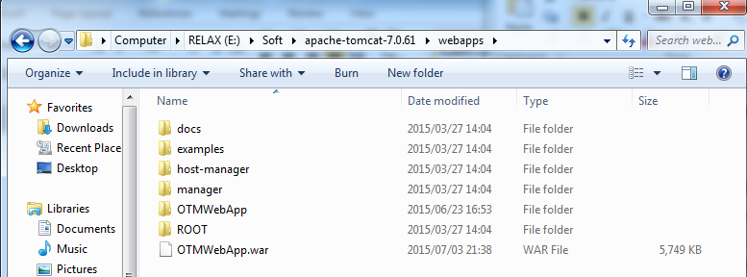

図138: 展開パッケージを準備する

#### データベースを展開する

* Microsoft SQL Server Management Studioを開きて、データベースに接続します.
* サーバー名：マシンのホストサーバのIPv4アドレスまたはSQLインスタンス名.
* ログイン：DDLとDML権限を持っているアカウント。
* パスワード：アカウントのパスワード。

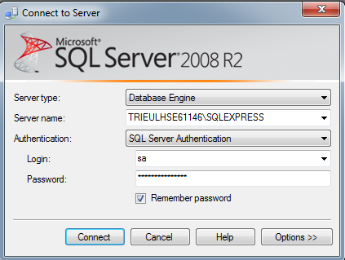

図139: データベースに接続

* リストアデータベースを選択します。

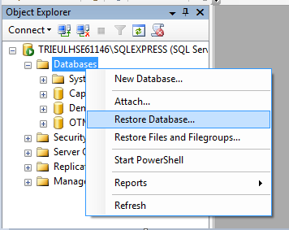

図140: リストアデータベースを選択します

* OTM_DTB.bakでデータベースを作成します。
* 完了のOTMデータベースの存在をチェックしてください。

#### サーバー上のWebアプリケーションを展開する

* サーバーを始動させて、**E:\Soft\apache-tomcat-7.0.61\webapps\OTMWebApp\WEB-INF\classes** で**dbconfig.properties**ファイルを開けてください。

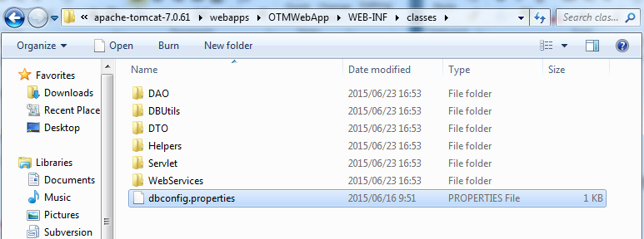

図: dbconfig.propertiesファイルを開けます

* 該当するデータで、ユーザーID、パスワード、データソースの部品を変更してください。

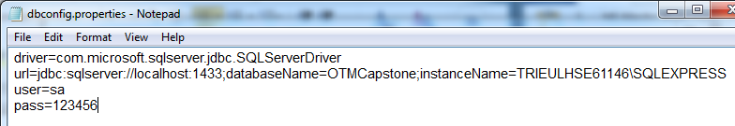

図: dbconfig.propertiesファイルを変更します

* サーバーを再始動させてください。

### クライアント側の環境を設定する

#### コンピュータに向けの設定

* Google Chrome

#### Androidデバイスに向けの設定

* 4.1.2

## アプリケーションのユーザーガイド

### ウェブサイトのガイド

#### ログイン

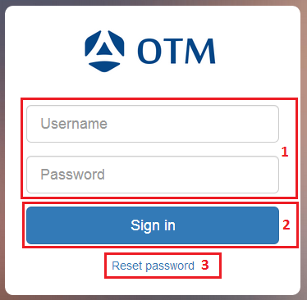

図: ログイン

|  |  |
| --- | --- |
| **段階** | **説明** |
| 1 | "Username" と "Password"に情報を入力してください。 |
| 2 | ウェブサイトにアクセスするために、"Sign in" ボタンをクリックしてください。 |
| 3 | パスワードを覚えない時は、”Reset password”リンクをクリックします。 |

#### プロジェクト

##### プロジェクトのページ

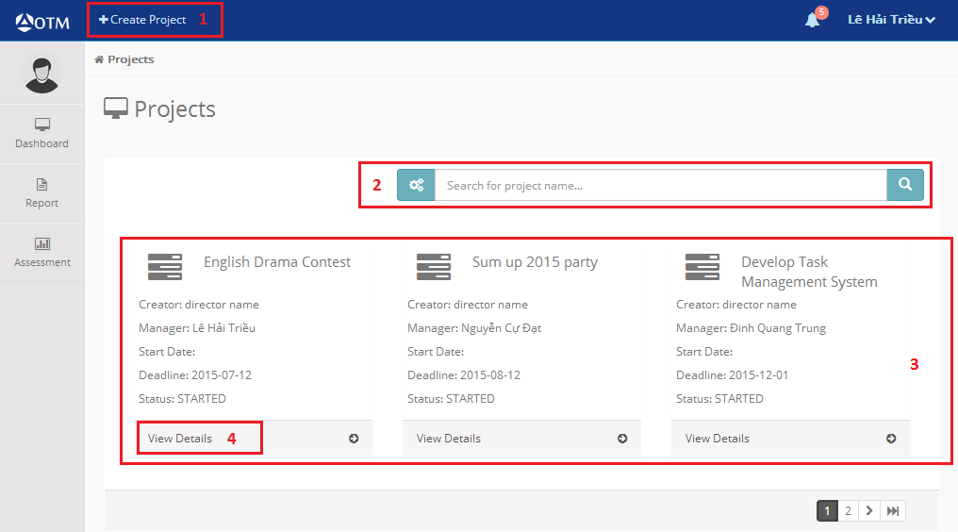

図144: プロジェクトのページ

|  |  |
| --- | --- |
| **段階** | **説明** |
| 1 | “Create Project”ボタンをクリックすると、プロジェクトの作成のページを表示します。 |
| 2 | プロジェクトを探すために、アイコンとアイコンを使用してください。 |
| 3 | 会社の現在の全部のプロジェクトを表示しています。 |
| 4 | プロジェクトの詳細を見るために、”View Details”リンクをクリックしてください。 |

##### プロジェクトを作成する

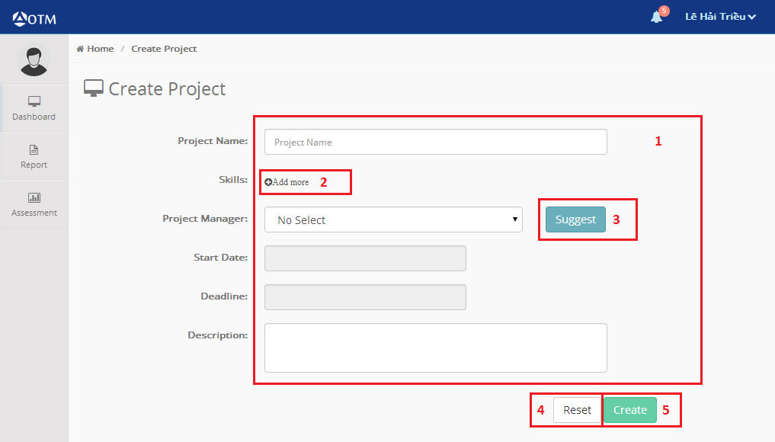

図145: プロジェクトの作成

|  |  |
| --- | --- |
| **段階** | **説明** |
| 1 | 作成するプロジェクトの詳細を入力してください。 |
| 2 | プロジェクトの技能を選択してください。 |
| 3 | 管理者に誰が良いか知りたい時は、”Suggest”ボタンをクリックします。 |
| 4 | “Reset”ボタンをクリックすると、全部のインフォを消します。 |
| 5 | 新しいプロジェクトを作成するために,”Create”ボタンをくりっくしてください。 |

##### プロジェクトの詳細

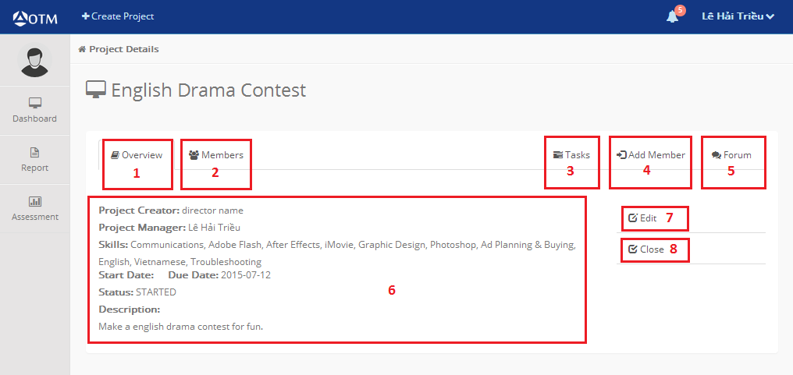

図146: プロジェクトの詳細

|  |  |
| --- | --- |
| **段階** | **説明** |
| 1 | “Overview”タブを選択すると、プロジェクトの詳細を表示します。 |
| 2 | “Member”タブを選択すると、プロジェクトのメンバーを表示します。 |
| 3 | “Task”リンクをクリックすると、プロジェクトのタスクを表示します。 |
| 4 | “Add Member”リンクをクリックすると、プロジェクトにメンバーを選択できます。 |
| 5 | “Forum”リンクをクリックすると、プロジェクトのフォーラムを表示します。 |
| 6 | プロジェクトの詳細を表示しています。 |
| 7 | “Edit”リンクをクリックすると、プロジェクトを変更できます。 |
| 8 | “Close”リンクをクリックすると、プロジェクトを終われます。 |

##### プロジェクトのメンバー

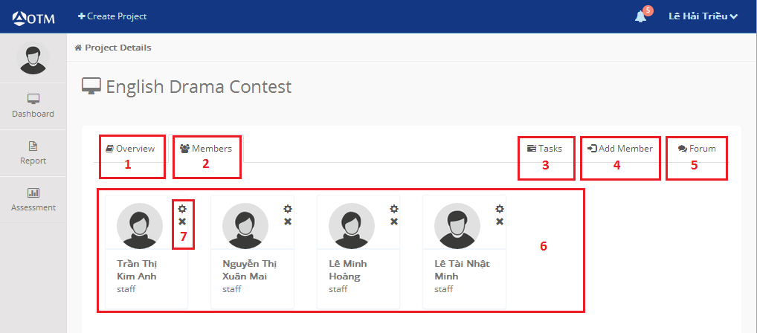

図147: プロジェクトのメンバー

|  |  |
| --- | --- |
| **段階** | **説明** |
| 1 | “Overview”タブを選択すると、プロジェクトの詳細を表示します。 |
| 2 | “Member”タブを選択すると、プロジェクトのメンバーを表示します。 |
| 3 | “Task”リンクをクリックすると、プロジェクトのタスクを表示します。 |
| 4 | “Add Member”リンクをクリックすると、プロジェクトにメンバーを選択できます。 |
| 5 | “Forum”リンクをクリックすると、プロジェクトのフォーラムを表示します。 |
| 6 | プロジェクトのメンバーを表示しています。 |
| 7 | プロジェクトの管理者を変更するために、アイコンをクリックしてください。そして、アイコンをクリックすると、プロジェクトにメンバーを削除します。 |

##### プロジェクトにメンバーを選択する



図148: プロジェクトのメンバー

|  |  |
| --- | --- |
| **段階** | **説明** |
| 1 | “Overview”タブを選択すると、プロジェクトの詳細を表示します。 |
| 2 | “Member”タブを選択すると、プロジェクトのメンバーを表示します。 |
| 3 | “Task”リンクをクリックすると、プロジェクトのタスクを表示します。 |
| 4 | “Add Member”リンクをクリックすると、プロジェクトにメンバーを選択できます。 |
| 5 | “Forum”リンクをクリックすると、プロジェクトのフォーラムを表示します。 |
| 6 | プロジェクトのメンバーを表示しています。 |
| 7 | プロジェクトの管理者を変更するために、アイコンをクリックしてください。そして、アイコンをクリックすると、プロジェクトにメンバーを削除します。 |

##### プロジェクトを評価する

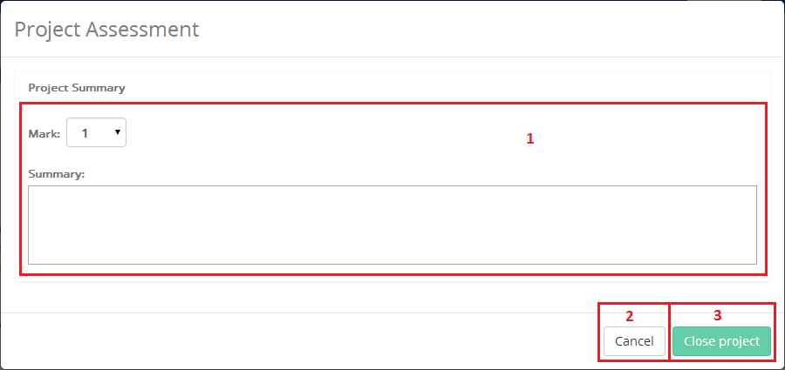

図149: プロジェクトを評価する

|  |  |
| --- | --- |
| **段階** | **説明** |
| 1 | プロジェクトの点と要約を入力してください。 |
| 2 | “Cancel”ボタンをクリックすると、プロジェクトを終わるプロセスをキャンセルします。 |
| 3 | “Close project”ボタンをクリックすると、プロジェクトの評価を保存して、プロジェクトの状態を”CLOSED”になります。 |

#### タスク

##### Dashboard

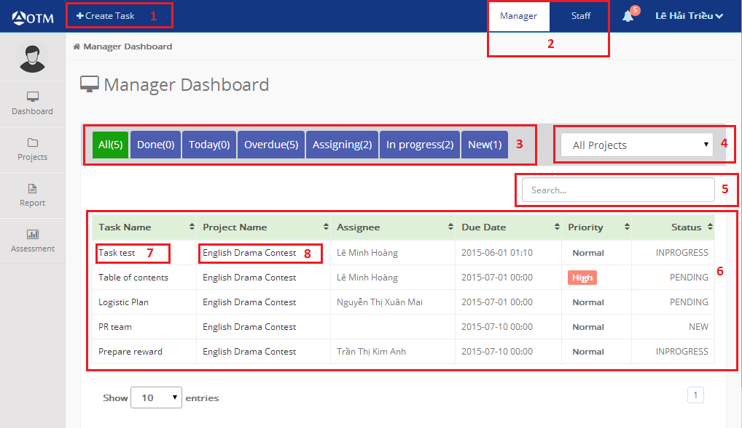

図: Dashboard

|  |  |
| --- | --- |
| **段階** | **説明** |
| 1 | “Create Task”ボタンをクリックすると、タスクを作成できます。 |
| 2 | “Staff”リンクをクリックすると、スタッフのDashboardを表示します。そして、”Manager”リンクをクリックすると、管理者のDashboardを表示します。 |
| 3 | タブを選択すると、選択した状態のタスクを表示します。 |
| 4 | 選択したプロジェクトのタスクを表示します。 |
| 5 | タスクを名前で探します。 |
| 6 | ユーザのタスクを表示します。 |
| 7 | タスクの詳細を見るために、タスクの名前をクリックしてください。 |
| 8 | プロジェクトの詳細を見るために、プロジェクトの名前をクリックしてください。 |

##### タスクの詳細

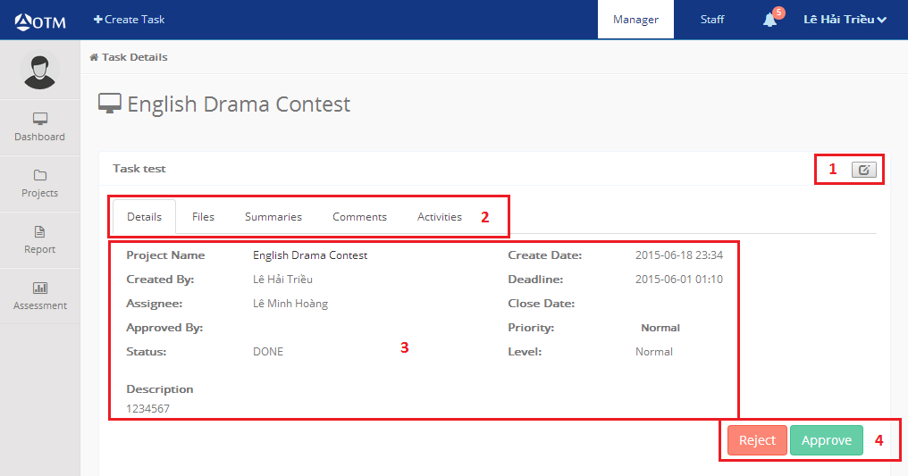

図: タスクの詳細

|  |  |
| --- | --- |
| **段階** | **説明** |
| 1 | タスクの詳細を変更するために、このアイコンをクリックしてください。 |
| 2 | 他の詳細を見るために、他のタブを選択してください。 |
| 3 | タスクの詳細を表示しています。 |
| 4 | これらのボタンをクリックすると、タスクの状態を変更します。 |

##### タスクを作成する

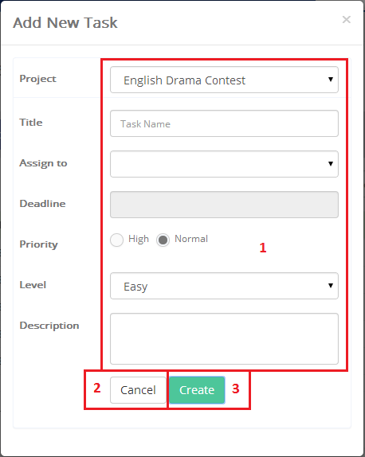

図152: タスクを作成する

|  |  |
| --- | --- |
| **段階** | **説明** |
| 1 | タスクの詳細を入力してください。 |
| 2 | “Cancel”ボタンをクリックすると、タスクを作成するプロセスをキャンセルします。 |
| 3 | “Create”ボタンをクリックすると、新しいタスクを作成します。 |

##### タスクを評価する

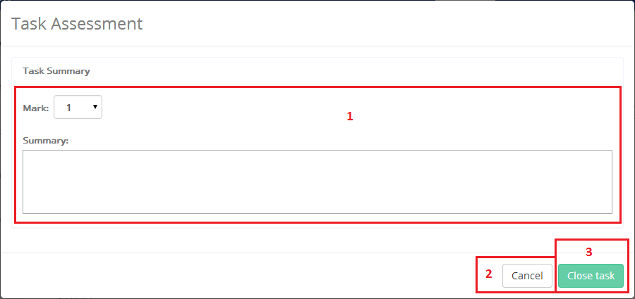

図153: タスクを評価する

|  |  |
| --- | --- |
| **段階** | **説明** |
| 1 | タスクの点と要約を入力してください。 |
| 2 | “Cancel”ボタンをクリックすると、タスクを終わるプロセスをキャンセルします。 |
| 3 | “Close task”ボタンをクリックすると、タスクの評価を保存して、タスクの状態を”CLOSED”になります。 |

### Androidデバイスのガイド

#### ログイン

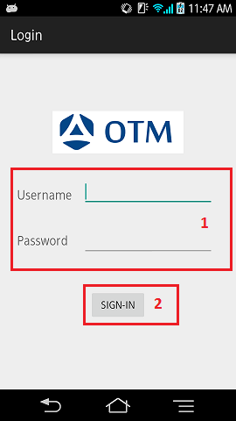

図: ログイン

|  |  |
| --- | --- |
| **段階** | **説明** |
| 1 | "Username" と "Password"に情報を入力する。 |
| 2 | ウェブサイトにアクセスするために、"Sign in" ボタンをタッチする。 |

#### 管理者とスタッフ

##### Dashboard

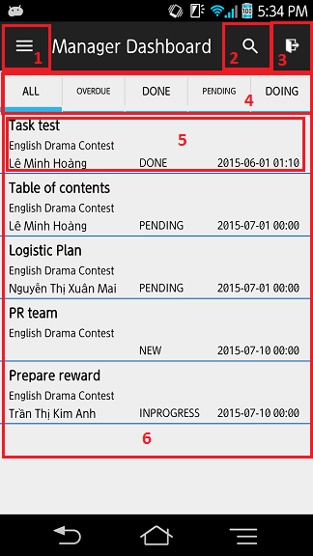

図: Dashboard

|  |  |
| --- | --- |
| **段階** | **説明** |
| 1 | このアイコンをタッチすると、役柄のDashboardを表示します。 |
| 2 | 探すアイコンをタッチすると、タスクを名前で探せます。 |
| 3 | このアイコンをタッチすると、システムをログアウトできます。 |
| 4 | タブをタッチすると、選択した状態のタスクを表示します。 |
| 5 | タスクの詳細を見るために、タスクの名前タッチしてください。 |
| 6 | ユーザのタスクを表示します。 |

##### タスクの詳細

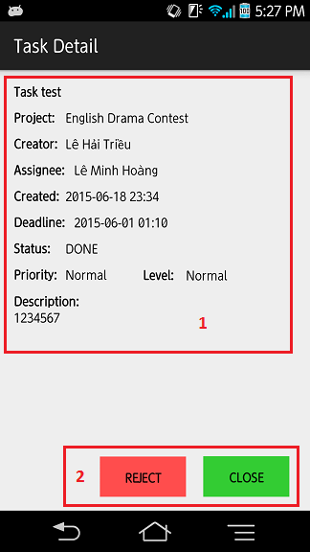

図: タスクの詳細

|  |  |
| --- | --- |
| **段階** | **説明** |
| 1 | タスクの詳細を表示しています。 |
| 2 | これらのボタンをクリックすると、タスクの状態を変更します。 |

##### タスクの評価

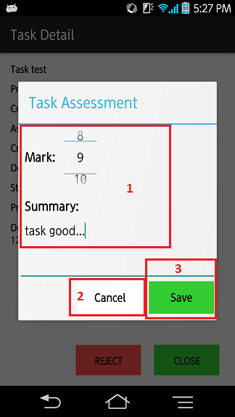

図: タスクの評価

|  |  |
| --- | --- |
| **段階** | **説明** |
| 1 | タスクの点と要約を入力してください。 |
| 2 | “Cancel”ボタンをクリックすると、タスクを終わるプロセスをキャンセルします。 |
| 3 | “Save”ボタンをクリックすると、タスクの評価を保存して、タスクの状態を”CLOSED”になります。 |

# Software User’s Manual (English)

## Installation Guide:

### Set the environment on server

You must install the following software server machine:

#### Hardware Requirement:

The minimum configure for a personal computer to develop:

* CPU Intel Xeon Quad Core.
* Ram: 2GB.
* Hard disk: 5 GB.
* Wi-Fi.

#### Software Requirement:

* Apache Tomcat 7.0.61 and JRE1.7: Web server.
* Microsoft Windows Server 2008 R2 Enterprise (Service Pack 32bit): Operation system.
* SQL Server 2008 R2: is used to create and manage a database for Web applications.

#### Mobile Requirement:

* Android 4.1.2.

### Deployment on server:

#### Preparing to deploy package:

* User copies deployment package to a folder on the server.

For example: **E:\Soft\apache-tomcat-7.0.61\webapps**



Figure : Preparing to deploy package

#### Preparing Database:

* User opens Microsoft SQL Server Manager Studio and connects to the database.
* Server name: IPv4 address or SQL instance name of the host server machine.
* Login: DDL and DML privileges with the account.
* Password: account password.



Figure : Connect to database

* User restores the database.



Figure : Select the restore database

* It will create a database with OTM_DTB.bak.
* Please check the existence of the OTM database of completion.

#### Deploying Web Application on server

* User is allowed to start the server, E: Please open the dbconfig.properties file in the \ Soft \ apache-tomcat-7.0.61 \ webapps \ OTMWebApp \ WEB-INF \ classes.



**Figure 161: Open the dbconfig.properties file**

* With the appropriate data, user ID, password, please change the data source parts.



Figure : Change the dbconfig.properties file

* Please let it restart the server.

### Configure the client environment:

#### Default client on computer:

* Google Chrome

#### Set of towards the Android environment:

* 4.1.2

## Application User Guide

### Website guide:

#### Login



Figure : <Web> Login

|  |  |
| --- | --- |
| **Stage** | **Description** |
| 1 | Please enter your information in the "Username" and "Password". |
| 2 | To access the web site, please click on the "Sign in" button. |
| 3 | If you do not remember the password, click the "Reset password" link. |

Table : <Web> Login

#### Project

##### Project Page



Figure : <Web> Project Page

|  |  |
| --- | --- |
| **Stage** | **Description** |
| 1 | When you click the "Create Project" button to display the page of the creation of the project. |
| 2 | To look for the project, please use the icons  and  "Advanced Search" button to find. |
| 3 | You have to display the current all of the projects of the company. |
| 4 | In order to view the project details, please click on the "View Details" link. |

Table : <Web> Project Page

##### Creating a Project



Figure : <Web> Create Project

|  |  |
| --- | --- |
| **Stage** | **Description** |
| 1 | Please enter project of the details that you want to create. |
| 2 | Please select the skill of the project. |
| 3 | When you want to know who is a good administrator, click on the "Suggest" button. |
| 4 | When you click the "Reset" button to turn off all of the info. |
| 5 | In order to create a new project, please click on the "Create" button. |

Table : <Web> Create Project

##### Project Detail



Figure : <Web> Project Detail

|  |  |
| --- | --- |
| **Stage** | **Description** |
| 1 | If you select the "Overview" tab to view the project details. |
| 2 | If you select "Member" tab to display the members of the project. |
| 3 | When you click the "Task" link to display the project tasks. |
| 4 | When you click the "Add Member" link, you can select the members to the project. |
| 5 | When you click the "Forum" link to view the forum project. |
| 6 | You have to view the project details. |
| 7 | When you click the "Edit" link, you can change the project. |
| 8 | When you click the "Close" link, you After completing the project. |

Table : <Web> Project Detail

##### Member of Project



Figure : <Web> Member of Project

|  |  |
| --- | --- |
| **Stage** | **Description** |
| 1 | If you select the "Overview" tab to view the project details. |
| 2 | If you select "Member" tab to display the members of the project. |
| 3 | When you click the "Task" link to display the project tasks. |
| 4 | When you click the "Add Member" link, you can select the members to the project. |
| 5 | When you click the "Forum" link to view the forum project. |
| 6 | You have to display the members of the project. |
| 7 | In order to change the administrator of the project, please click  on the icon. Then, when you click  the icon to delete the members to the project. |

Table : <Web> Member of Project

##### Project Assessment



Figure : <Web> Project Assessment

|  |  |
| --- | --- |
| **Stage** | **Description** |
| 1 | Please enter your respects to the summary of the project. |
| 2 | When you click the "Cancel" button to cancel the process of ending the project. |
| 3 | When you click the "Close project" button, save the evaluation of the project, it will be "CLOSED" the state of the project. |

Table : <Web> Project Assessment

#### Task

##### Dashboard



Figure : <Web> Dashboard Manager

|  |  |
| --- | --- |
| **Stage** | **Description** |
| 1 | When you click the "Create Task" button, you can create a task. |
| 2 | When you click the "Staff" link to display the Dashboard of staff. And, when you click the "Manager" link to display the Dashboard of the administrator. |
| 3 | When you select the tab, you can view the task of the selected state. |
| 4 | You will view the task of the selected project. |
| 5 | We are looking for a task by name. |
| 6 | It will display the user's task. |
| 7 | In order to view the task details, please click on the name of the task. |
| 8 | In order to view the project details, please click on the name of the project. |

Table : <Web> Dashboard Manager

##### Task Detail



Figure : <Web> Task Detail

|  |  |
| --- | --- |
| **Stage** | **Description** |
| 1 | To change the task details, please click on this icon. |
| 2 | To see the other details, please choose other tab |
| 3 | You have to view the task details. |
| 4 | If you click on these buttons, to change the state of the task. |

Table : <Web> Task Detail

##### Creating a Task



Figure : <Web> Create Task

|  |  |
| --- | --- |
| **Stage** | **Description** |
| 1 | Please enter the task details. |
| 2 | When you click the "Create" button to create a new task. |
| 3 | When you click the "Cancel" button to cancel the process of creating a task. |

Table : <Web> Create Task

##### Task Assessment



Figure : <Web> Task Assessment

|  |  |
| --- | --- |
| **Stage** | **Description** |
| 1 | Please enter your respects to the summary of the task. |
| 2 | When you click the "Cancel" button to cancel the process of ending the task. |
| 3 | When you click the "Close task" button, to save the evaluation of the task, it will be "CLOSED" the state of the task. |

Table : <Web> Task Assessment

### Android device:

#### Login



Figure : <Mobile> Login

|  |  |
| --- | --- |
| **Stage** | **Description** |
| 1 | Please enter your information in the "Username" and "Password". |
| 2 | To access the web site, please click on the "Sign in" button. |

Table : <Mobile> Login

#### Manager and Staff

##### Dashboard

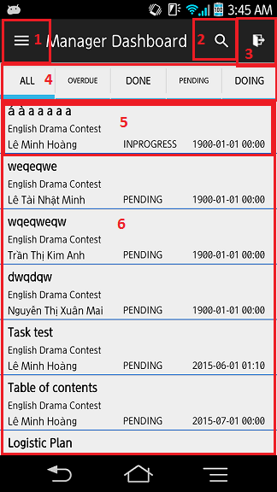

Figure : <Mobile> Dashboard of Manager

|  |  |
| --- | --- |
| **Stage** | **Description** |
| 1 | If you touch this icon to display the character of the Dashboard. |
| 2 | If you touch the icon to search, you can search the task by name. |
| 3 | If you touch this icon, you can log out of the system. |
| 4 | When you touch the tab to view the task of the selected state. |
| 5 | In order to view the task details, please name touch of the task. |
| 6 | It will display the user's task. |

Table : <Mobile> Dashboard of Manager

##### Task Detail



Figure : <Mobile> Task Detail

|  |  |
| --- | --- |
| **Stage** | **Description** |
| 1 | You have to view the task details. |
| 2 | If you click on these buttons, to change the state of the task. |

Table : <Mobile> Task Detail

##### Task Assessment



Figure : <Mobile> Task Assessment

|  |  |
| --- | --- |
| **Stage** | **Description** |
| 1 | Please enter your respects to the summary of the task. |
| 2 | When you click the "Cancel" button to cancel the process of ending the task. |
| 3 | When you click the "Save" button, to save the assessment of the task, it will be "CLOSED" the state of the task. |

Table : <Mobile> Task Assessment

# Appendix